Elisus-

I continue to have more problems login in. The new logon ID of rjanak instead of Janak you send me worked in step 4. However I was not able to do the Web install so I did the Part 1A Manual Installation as advised.  I got all the way to step 12 in manual installation and then I am unable to see the log screen as expected in step 13. Do you have any screen shots of step 13?  Attached is the screen shot in step 13.

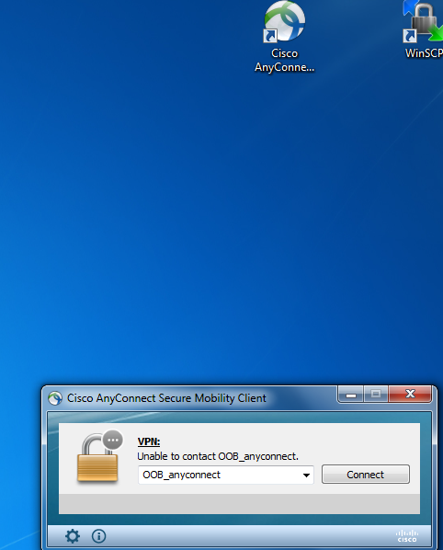

You can see the Icon for Cisco VPN and the window that it generates as I activate it.

This is a try with my log on ID &  password

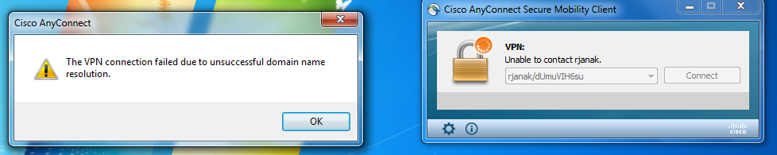

In this particular, shot I tried the OOB-anyconnect  instead of the logon / password entry and I did not get anywhere.   What am I doing wrong here.

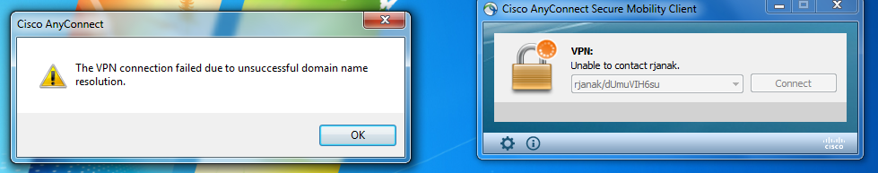

John Janak

University of Baltimore

Jacob France Institute

410-837-4728