CHAPTER 13

THE EXPENDITURE CYCLE:
PURCHASING AND CASH DISBURSEMENTS

SUGGESTED ANSWERS TO DISCUSSION QUESTIONS

13.1 In this chapter and in Chapter 12 the controller of AOE played a major role in evaluating and recommending ways to use IT to improve efficiency and effectiveness. Should the company’s chief information officer make these decisions instead? Should the controller be involved in making these types of decisions? Why or why not?

There are several reasons why accountants should be involved in decisions about investing in IT and not leave such decisions solely to IS professionals.

First, the economic merits of proposed IT investments need to be subjected to the same kind of detailed analysis as any other major capital investment (e.g., plant expansions). Accountants are skilled in making such analyses.

Second, the operational feasibility of IT investments must also be evaluated. How will the investment affect daily operating procedures? Will the system be able to adapt as the company changes the nature of its operations? As one of the major users of the information system, accountants need to participate in these analyses.

Third, what is the long-run viability of the proposed supplier? Here again accountants can make a valuable contribution by analyzing the long-run economic viability of proposed vendors.

13.2 Companies such as Wal-Mart have moved beyond JIT to VMI systems. Discuss the potential advantages and disadvantages of this arrangement. What special controls, if any, should be developed to monitor VMI systems?

Vendor Managed Inventory (VMI) is essentially Electronic Data Interchange (EDI) where the retailer has given their vendor access rights to their point-of-sale (POS) system. Some of the potential advantages and disadvantages of moving to a VMI are:

Advantages:

- Lower cost. Retailers are able to “outsource” their inventory management to their vendors.

- Potentially reduced lost sales. – When vendors are able to meet product demand, the company can minimize lost sales due to stockouts.

- More accurate forecasts. Since vendors have more data from the retailers, they are able to more accurately forecast and meet demand for their products.

Disadvantages:

- Cost. Retailers and vendors must incur the costs of acquiring the technology and changing the organization to a VMI arrangement.

- Security. –. The retailer puts one of their most valuable assets, their sales data, in the hands of their vendors. Such significant access to retailer data opens the door to a myriad of data and system security issues such as data alteration and deletion, unauthorized access to non-sales related data, inadvertent loss of data, and corporate espionage.

- Over supply. The vendor can ship more inventory than the retailer needs to meet the demand.

Controls:

The following controls could be implemented to monitor VMI systems:

- Monitor inventory levels. At least at first, and then periodically thereafter, the retailer should monitor inventory levels to determine whether the vendor is sending enough inventory to prevent stock outs but not too much inventory that is slow to sell.

- Analyze inventory costs. If VMI is working, then overall inventory costs should decline.

- Intrusion detection systems. To determine if the vendor has compromised the security of the retailer’s system.

- Monitor unauthorized access attempts. All attempts by vendors to access non-VMI related areas of the retailer’s system should be investigated.

13.3 Procurement cards are designed to improve the efficiency of small noninventory purchases. What controls should be placed on their use? Why?

Since the primary benefit of procurement cards is to give employee’s the ability to make small non-inventory purchases necessary for their area of responsibility -- be it office supplies, computer or office equipment, or meals and/or travel expenses -- a formal approval process for all purchases would negate the benefit of the procurement card. Therefore, the focus of procurement card controls should be on the initial issuance of the card and subsequent reviews and audits of purchases made by employees entrusted with procurement cards.

Employees receiving cards must be properly trained in their proper use and in the procurement card controls implemented by the organization. If employees know that any purchase they make can be the subject of subsequent review and audit, they are more likely to make legitimate purchases.

Subsequent reviews and audits must also require proper documentation related to each purchase made with the procurement card. During procurement card training, it should be emphasized that employees will be required to produce original receipts or other formal documentation for all items purchased.

Budgets and detailed variance analyses are an important detective control to identify potential problems before they get too large.

13.4 In what ways can you apply the control procedures discussed in this chapter to paying personal debts (e.g., credit card bills)?

Many people do not keep their credit card receipts as evidenced by receipts left at “pay-at-the-pump” gas stations. If consumers do not keep their receipts, how do they know whether their credit card bill is accurate? Thus, consumers should verify each charge on their bill to each receipt.

In addition, credit card bill should be reviewed for accurate refunds for returned merchandise or cancelled services.

Just as businesses should take advantage of discounts for prompt payment, consumers should attempt to always pay the balance due in full because the interest rate on outstanding balances can result in significantly greater total payments.

Finally, consumers need to shred all statements prior to disposal, to reduce the risk of identity theft. If consumers engage in online banking, they should vigilantly monitor their account for signs of compromise. Ideally, they should only do online banking from one computer and use a different browser than is used for all other online activities.

13.5 Should every company switch from the traditional 3-way matching process (purchase orders, receiving reports, and supplier invoices) to the 2-way match (purchase orders and receiving reports) used in Evaluate Receipt Settlement (ERS)? Why (not)?

Switching to ERS simplifies accounts payable and eliminates a major source of problems: inconsistency between supplier invoices and prices quoted when placing the order. However, ERS requires firm commitments to prices by suppliers – which may not be feasible for certain types of products like commodities.

ERS also requires that receiving dock employees exercise great care in counting merchandise received.

It also requires configuring the information system to automatically calculate and track payment due dates without the benefit of a reminder provided by receiving a supplier invoice.

13.6 Should companies allow purchasing agents to start their own businesses that produce goods the company frequently purchases? Why? Would you change your answer if the purchasing agent’s company was rated by an independent service, like Consumer Reports, as providing the best value for price? Why?

The primary issue here is conflict of interest. If a purchasing manager owns a business that supplies goods to his employer, how does the employer know that they are receiving the best quality goods for the lowest prices? By allowing a purchasing manager to own an independent company that supplies his employer, the employer is in effect dis-aligning the interests of the purchasing manager with the interests of the employer. The higher the prices the supply company charges, the more money the purchasing manager makes.

The employer may find some comfort if the purchasing manager’s supply business is reviewed or audited by some independent organization. However, independent rating organizations cannot audit every transaction. Since the purchasing manager has intimate knowledge of the employer’s operations and cost structure, he has the ability to structure transactions that could conceal purchases that were favorable to the purchasing manager’s business and unfavorable to the employer.

Given the degree of oversight that any prudent employer would have to implement to make sure the purchasing manager provided the best quality for the best price, why would an employer want to allow such an arrangement?

SUGGESTED ANSWERS TO THE PROBLEMS

13.1 a. A purchasing agent orders materials from a supplier that he partially owns.

- Require a purchase requisition from an operating department as authorization for preparation of all purchase orders.
- Require purchasing manager, before approving PO, to
  - Review the purchase requisition
  - Ensure that orders are placed only with approved vendors.
- Require purchasing agents to disclose any financial interest in supplier companies, though this may be difficult to enforce.
- Ensure that purchasing agents do not have investments in vendors on the approved vendor list.

b. Receiving-dock personnel steal inventory and then claim the inventory was sent to the warehouse.
- Count all deliveries and record counts on a receiving report.
- Require warehouse personnel to count the goods received when they are transferred to the warehouse and acknowledge receipt of the specified quantity by signing the receiving report.
- Have accounts payable personnel review the signed receiving report copy (signed by both the receiving department and the warehouse personnel) prior to approving payment.

c. An unordered supply of laser printer paper delivered to the office is accepted and paid for because the “price is right.” After jamming all of the laser printers, however, it becomes obvious that the “bargain” paper is of inferior quality.

- The problem here is that office employees are seldom trained about proper procedures for receiving, because it is assumed that all goods are delivered only to the warehouse. Office employees, like receiving employees, need to be trained not to accept deliveries unless they can verify the existence of an approved purchase order for those goods.
- In addition, companies should not approve and pay invoices unless they can match the invoice to an approved purchase order and receiving report.

d. The company fails to take advantage of a 1% discount for promptly paying a vendor invoice.

  - File invoices by discount date
  - Maintain a cash budget

e. A company is late in paying a particular invoice. Consequently, a second invoice is sent, which crosses the first invoice’s payment in the mail. The second invoice is submitted for processing and also paid.

- Review related supporting voucher package or records (receiving report and purchase order) before approving an invoice for payment.
- Change the status of the invoice and its supporting records from "pending" to "paid" after payment is made.
- Deface the invoice and all supporting documents (such as marking them paid) so they cannot be used to support the payment of a duplicate invoice.

f. Inventory records show that an adequate supply of copy paper should be in stock, but none is available on the supply shelf.

- Count physical inventory periodically.
- Correct system records using the count.

g. The inventory records are incorrectly updated when a receiving-dock employee enters the wrong product number at the terminal.

- Use closed loop verification – The item number is entered as input, the system displays the corresponding item description, and the user is asked to verify that it is the desired item.
- Use bar-codes or RFID tags to eliminate the need to enter the item number manually.

h. A clerical employee obtains a blank check and writes a large amount payable to a fictitious company. The employee then cashes the check.

- Store unused blank company checks in a secure location.
- Segregate duties by having the person reconciling the bank account be different from the person making payments
- Segregate duties by having the person signing checks be different from the person authorizing disbursements and preparing checks
- Ensure that the check signer reviews the documentation (purchase order and receiving report) supporting each disbursement prior to signing each check.

- A fictitious invoice is received and a check is issued to pay for goods that were never ordered or delivered.

- Program the system so that it only prints checks to approved suppliers listed in the database
- Restrict access to the supplier master data.
- Require appropriate background checks and management approvals before adding a new supplier to the supplier master data
- Review changes to the supplier master data periodically
- Require supporting documents (purchase order and receiving report) for each invoice that is paid
- Require the person who authorizes disbursements to review the purchase order and receiving report, as well as the invoice.
- Segregate duties by having the person signing checks be different from the person authorizing disbursements and preparing checks
- Ensure that the check signer reviews the invoice, purchase order, and receiving report supporting each disbursement prior to signing a check.
- Deface the invoice and all supporting documents (such as marking them paid) so they cannot be used to support the payment of a duplicate invoice.

- The petty cash custodian confesses to having “borrowed” $12,000 over the last five years.

- Create a petty cash imprest fund and only replenish it based on receipts documenting how the funds were used
- Conduct periodic surprise counts of petty cash on hand to verify that the total of cash plus receipts equals the fund amount.

- A purchasing agent adds a new record to the supplier master file. The company does not exist. Subsequently, the purchasing agent submits invoices from the fake company for various cleaning services. The invoices are paid.

- Restrict access to the supplier master file
- Require appropriate background checks and management approvals before adding a new supplier to the supplier master data
- Monitor on a regular basis all changes made to the supplier master data
- Implement budgetary controls and regular analyses of expenses related to services to detect this type of problem, as well as higher-than-expected expenses for a particular department.

- A clerk affixes a price tag intended for a low-end flat panel TV to a top-of-the-line model. The clerk’s friend then purchases that item, which the clerk scans at the checkout counter.

- Restrict access to price tags so that cashiers do not have access to price tags
- Segregate duties by not letting stocking clerks work as cashiers.
- Monitor check-out clerks, either live or by closed-circuit cameras, to deter fraud.
- Hire honest and ethical employees by conducting effective interviews, checking references, and conducting background checks if cost effective.
13.2 Match the terms in the left column with their appropriate definition in the right column.

Terms | Definitions
- _n__ economic order quantity | - A document that creates a legal obligation to buy and pay for goods or services.
- __f_ materials requirements planning (MRP) | - The method used to maintain the cash balance in the petty cash account.
- _e__ Just-in-time (JIT) inventory system | - The time to reorder inventory based on the quantity on hand falling to predetermined level.
- __g_ purchase requisition | - A document used to authorize a reduction in accounts payable when merchandise is returned to a supplier.
- __b_imprest fund | - An inventory control system that triggers production based upon actual sales.
- __a_ purchase order | - An inventory control system that triggers production based on forecasted sales.
- _s__ kickbacks | - A document only used internally to initiate the purchase of materials, supplies, or services.
- __r_ procurement card | - A process for approving supplier invoices based on a two-way match of the receiving report and purchase order.
- __p_ blanket purchase order | - A process for approving supplier invoices based on a three-way match of the purchase order, receiving report, and supplier invoice.
- _h__ evaluated receipts settlement (ERS) | - A method of maintaining accounts payable in which each supplier invoice is tracked and paid for separately.
- __m_ disbursement voucher | - A method of maintaining accounts payable which generates one check to pay for a set of invoices from the same supplier.
- _q_ receiving report | - Combination of a purchase order, receiving report, and supplier invoice that all relate to the same transaction.
- __d_ debit memo | - A document used to list each invoice being paid by a check.
- _o__ vendor managed inventory | - An inventory control system that seeks to minimize the sum of ordering, carrying, and stockout costs.
- __l_ voucher package | - A system whereby suppliers are granted access to point-of-sale (POS) and inventory data in order to automatically replenish inventory levels.
- _j__ non-voucher system | - An agreement to purchase set quantities at specified intervals from a specific supplier.
- _k__ voucher system | - A document used to record the quantities and condition of items delivered by a supplier.
 | - A special purpose credit card used to purchase supplies.
 | - A fraud in which a supplier pays a buyer or purchasing agent in order to sell its products or services.

13.3 Excel Project. Using Benford’s Law to Detect Potential Disbursements Fraud.
- Read the article “Using Spreadsheets and Benford’s Law to Test Accounting Data,” by Mark G. Simkin in the ISACA Journal, Vol. 1, 2010, available at www.isaca.org.
- Follow the steps in the article to analyze the following set of supplier invoices:

Invoice  Number | Amount
2345 | $7,845
2346 | $2,977
2347 | $1,395
2348 | $3,455
2349 | $7,733
2350 | $1,455
2351 | $6,239
2352 | $2,573
2353 | $1,862
2354 | $1,933
2355 | $7,531
2356 | $4,400
2357 | $5,822
2358 | $7,925
2359 | $2,100
Invoice  Number | Amount
2360 | $8,256
2361 | $1,863
2362 | $3,375
2363 | $6,221
2364 | $1,799
2365 | $1,450
2366 | $7,925
2367 | $2,839
2368 | $1,588
2369 | $2,267
2370 | $7,890
2371 | $7,945
2372 | $1,724
2373 | $9,311
2374 | $4,719

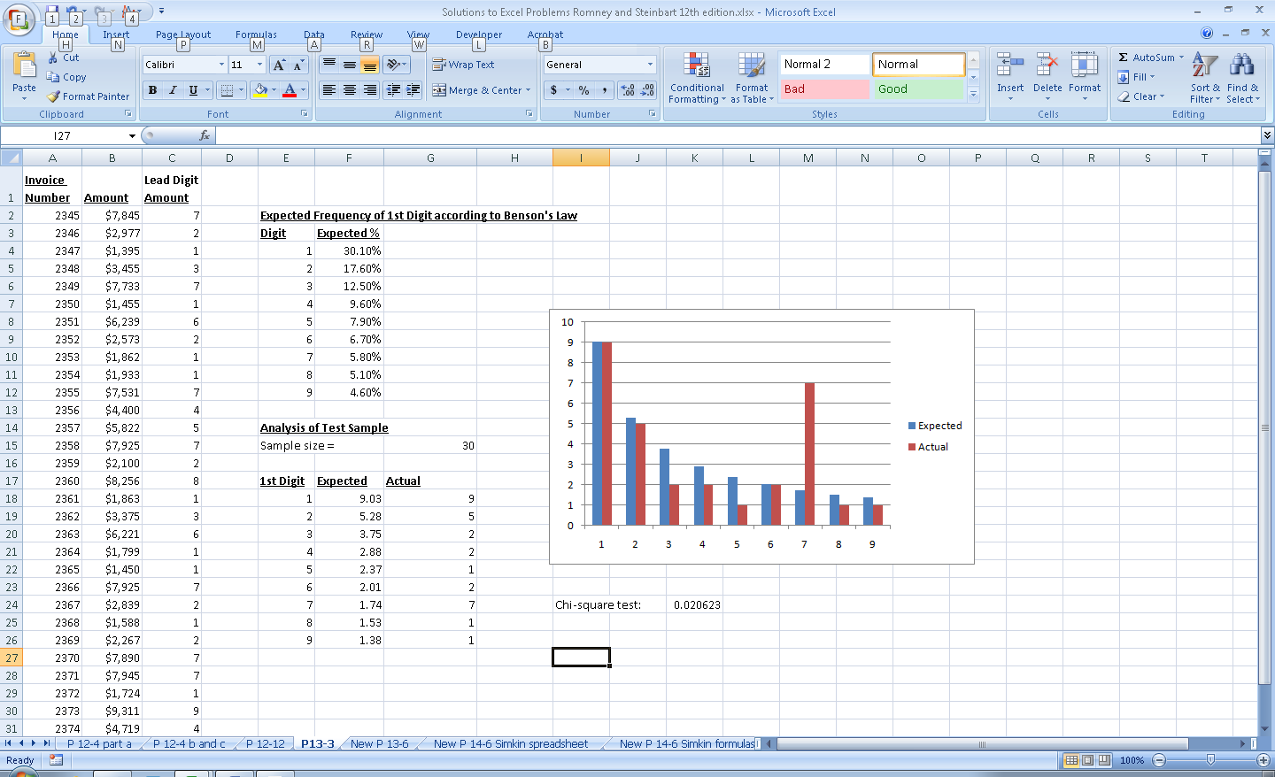
Hint: You may need to use the VALUE function to transform the results of using the LEFT function to parse the lead digit in each invoice amount.

To apply Benford’s law, we need to write a formula that extracts the left-most digit from an invoice number. Excel has a number of built-in functions that can parse characters in a string. The function LEFT(cell, n) returns the left n characters from the specified cell. Thus, in our case, Left (C4,1) returns the left-most digit from cell C4.

However, the various character-parsing functions (LEFT, RIGHT, MID) all return their results as text. Therefore, we need to transform that result back into a number by using the VALUE function.

Therefore, the formula in column C is: =VALUE(LEFT(C4,1))

The formula for the sample size is: =COUNT(C2:C31)

The formula in the “expected” column multiplies the values in cells F4:F12 by the count result in Cell G15

The formula in the “actual” column uses the COUNTIF function: =COUNTIF($C$2:$C$31,E18) – which counts the column of lead digits to see how many of them have the value in cell E18. Copying this formula down will yield counts of the number of lead digits equal to the value in cell E19, then E20, etc.

13.4 Match threats in the first column to appropriate control procedures in the second column. More than one control may be applicable.

Threat | Control Procedure
- _d,e__ Failing to take available purchase discounts for prompt payment. | - Only accept deliveries for which an approved purchase order exists.
- _f__ Recording and posting errors in accounts payable. | - Document all transfers of inventory.
- _l__ Paying for items not received. | - Restrict physical access to inventory.
- __h,o_ Kickbacks. | - File invoices by due date.
- _b,c,g_ Theft of inventory. | - Maintain a cash budget.
- _m,l_ Paying the same invoice twice. | - Automated comparison of total change in cash to total changes in accounts payable.
- _g,b,c_ Stockouts. | - Adopt a perpetual inventory system.
- __h,i,j,o_ Purchasing items at inflated prices. | - Require purchasing agents to disclose financial or personal interests in suppliers.
- __k,q_ Misappropriation of cash. | - Require purchases to be made only from approved suppliers.
- _h,i,o,p__ Purchasing goods of inferior quality. | - Restrict access to the supplier master data.
- __a_ Wasted time and cost of returning unordered merchandise to suppliers. | - Restrict access to blank checks.
- __n_ Accidental loss of purchasing data. | - Only issue checks for a complete voucher package (receiving report, supplier invoice, and purchase order).
- __j_ Disclosure of sensitive supplier information (e.g., banking data). | - Cancel or mark “Paid” all supporting documents in a voucher package when a check is issued.
 | - Regular backup of the expenditure cycle database.
 | - Train employees how to respond properly to gifts or incentives offered by suppliers.
 | - Hold purchasing managers responsible for costs of scrap and rework.
 | - Reconciliation of bank account by someone other than the cashier.

13.5 Use Table 13-2 to create a questionnaire checklist that can be used to evaluate controls for each of the basic activities in the expenditure cycle (ordering goods, receiving, approving supplier invoices, and cash disbursements).
- For each control issue, write a Yes/No question such that a “No” answer represents a control weakness. For example, one question might be “Are supporting documents, such as purchase orders and receiving reports, marked “paid” when a check is issued to the vendor?”
A wide variety of questions is possible. Below is a sample list:
Question | Yes | No
- Is access to supplier master data restricted?
- Are additions to supplier master data regularly reviewed and all changes investigated?
- Is sensitive data encrypted while stored in the database?
- Does a backup and disaster recovery plan exist?
- Have backup procedures been tested within the past year?
- Are appropriate data entry edit controls used?
- Is a perpetual inventory maintained?
- Are physical counts of inventory taken regularly and used to adjust the perpetual inventory records?
- Are competitive bids used when ordering expensive items?
- Are purchasing agents required to disclose financial interests in suppliers?
- Are budgets set for service expenses and are variances investigated?
- Is the system configured to generate purchase orders only to suppliers listed in the database?
- Are receiving dock employees trained to accept deliveries only when an approved purchase order exists?
- Are receiving dock employees trained about the importance of accurately counting all items delivered?
- Do receiving dock employees inspect all deliveries for quality?
- Do both receiving dock employees and inventory control employees sign off on the transfer of items?
- Is physical access to inventory restricted?
- Are invoices only approved for payment when accompanied by both a purchase order and receiving report?
- Is supporting documentation cancelled or marked “Paid” when a check is generated?
- Are invoices filed by due date (adjusted for any discounts for early payment)?
- Is access to blank checks restricted?
- Is access to the EFT system restricted?
- Is the bank account regularly reconciled by someone not involved in issuing checks?

b. For each Yes/No question, write a brief explanation of why a “No” answer represents a control weakness.

Question | Reason a “No” answer represents a weakness
1 | Unrestricted access to supplier master data could facilitate fraud by allowing the creation of fake suppliers to whom checks can be issued.
2 | Failure to investigate all changes to supplier master data may allow fraud to occur because unauthorized suppliers may not be detected.
3 | Failure to encrypt sensitive data can result in the unauthorized disclosure of banking-related information about suppliers.
4 | If a backup and disaster recovery plan does not exist, the organization may lose important data.
5 | If the backup plan is not tested regularly, it may not work.
6 | Without proper data entry edit controls, errors in purchasing, receiving, and paying suppliers can occur.
7 | Without a perpetual inventory system, shortages and excess inventory is more likely.
8 | Without periodic physical counts, the perpetual inventory records are likely to be incorrect.
9 | Without competitive bids, purchases may be at higher than necessary prices.
10 | Non-disclosure of personal interests in suppliers creates a conflict of interest and may lead to kickbacks and other forms of fraud.
11 | Without budgets and analyses of services expenses, these expenses can be fraudulently inflated to cover up fraud.
12 | If generating purchase orders is not restricted to suppliers in the database, purchases may be made from unauthorized suppliers which may result in paying too much, receiving inferior quality goods, or violating laws.
13 | If receiving dock employees accept deliveries without an approved purchase order, this may result in higher costs and wasted time processing deliveries and then returning those unordered items.
14 | Failure to count deliveries accurately will create errors in inventory records and may result in paying for goods not received.
15 | Failure to inspect the quality of goods at the receiving dock increases the risk of production delays when the problem is discovered later.
16 | Failure to acknowledge the transfer of goods increases the risk of loss and precludes assigning responsibility for any shortages.
17 | Inadequate physical security increases the risk of theft of inventory.
18 | Failure to require a voucher package can result in paying for items not ordered or not received.
19 | Failure to cancel supporting documents can result in paying the same invoice twice.
20 | Failure to file invoices by due date increases the risk of not taking advantage of discounts for prompt payment.
21 | Unrestricted access to blank checks increases the risk of misappropriation of funds.
22 | Unrestricted access to the EFT system increases the risk of misappropriation of funds.
23 | Lack of an independent bank account reconciliation increases the risk of fraud going undetected. It also precludes the timely identification of unauthorized disbursements, possibly resulting in the bank refusing to correct the problem.

13.6 EXCEL Project
a. Expand the cash budget you created in Problem 12.4 to include a row for expected cash outflows equal to 77% of the current month’s sales.
b. Also add a row to calculate the amount of cash that needs to be borrowed, in order to maintain a minimum cash balance of $50,000 at the end of each month.
c. Add another row to show the cash inflow from borrowing.
d. Add another row to show the cumulative amount borrowed.
e. Add another row to show the amount of the loan that can be repaid, being sure to maintain a minimum ending balance of $50,000 each month.

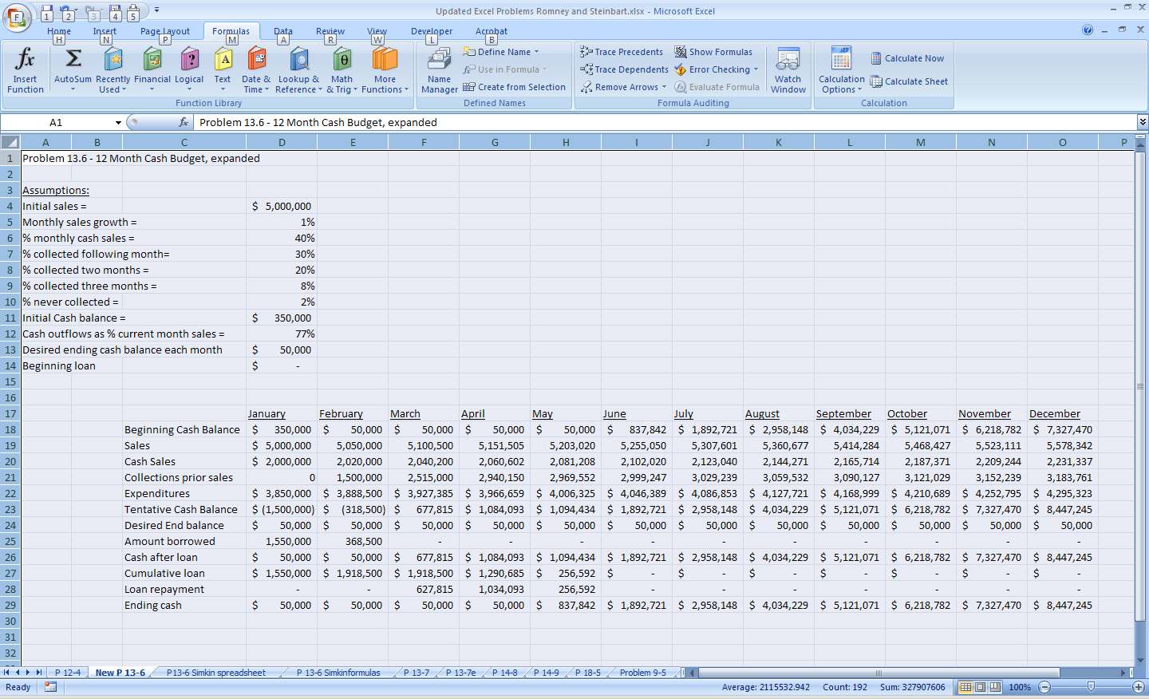

Explanation of solution:

- Always use references to assumption cells in the formulas. For example, the cash sales row formulas should be that column’s sales times cell D6 (e.g., in February, cash sales cell has this formula: =E19*$D$6
- The solution rounds sales to the nearest dollar, to keep it looking clean, using this formula in February: =ROUND(D19*(100%+$D$5),0)
- Collections from prior sales row is set to zero in January; then it gets progressively more complex as follows:
  - February: =D19*$D$7
  - March: =(D19*$D$8)+(E19*$D$7)
  - April: =(D19*$D$9)+(E19*$D$8)+(F19*$D$7)
- Tentative cash balance = beginning balance + cash sales that month + collections of prior month’s cash sales – current expenditures: =D18+D20+D21-D22
- Amount borrowed = zero if tentative balance >= desired balance, otherwise the amount of the shortfall: =IF(D23>=D24,0,(D24-D23))
- Cumulative loan initially = starting loan balance plus that month’s borrowing: =$D$14+D25. Subsequently, it equals prior month’s balance plus new borrowing less repayments: =D27+E25-D28
- Loan repayment is calculated as the excess of cash available over desired ending balance, but never more than the amount of the loan. Therefore, need a nested if statement in which first test whether tentative cash balance exceeds desired balance and then if it does, compares excess cash available to outstanding loan balance: =IF(D26>50000,IF(D26-50000>D27,D27,D26-50000),0)
Problem 13-6 continued
f. Add appropriate data validation controls to ensure spreadsheet accuracy.
The solutions manual for chapter 10 discussed data validation controls in detail. Possible solutions include the following:
- Limit initial sales to the range $1,000,000 - $10,000,000

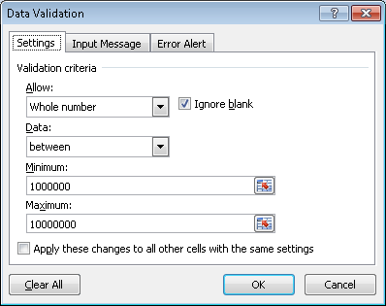

Also, include an appropriate input message:

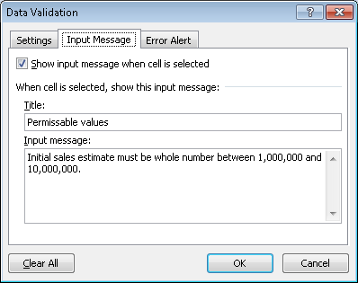

And an appropriate error message:

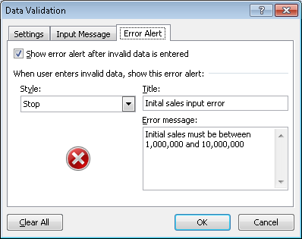

- Limit the sales growth, the percentage of sales made for cash, the percentages collected in subsequent months, the percentage never collected, and expenditures as a percentage of sales to reasonable ranges. For example, sales growth may be constrained to be between 1% and 10%; expenditures may be constrained to be between 50% and 90%, etc.
- Limit desired ending cash balance to be greater than zero.
- Students should also lock all the cells in the body of the spreadsheet so that users can only change the assumption cells.

  - For each of the following activities, identify the data that must be entered by the employee performing that activity and list the appropriate data entry controls:

- Purchasing agent generating a purchase order

Data that must be entered | Appropriate Data Entry Edit Controls
User ID | Validity check  Compatibility test (is user authorized to perform this task?)
Password | Validity check  Compatibility test (is user authorized to perform this task?)
Supplier name | Choose from pull-down list of approved suppliers
Delivery method | Choose from pull-down list of options
Desired delivery date | Field check (date)  Reasonableness check (compare difference between desired date and today’s date to preset tolerance limit)
Item number | Field check  Validity check
Item quantity | Field check  Reasonableness check

Notes:

- All other fields on the sample purchase order (see Figure 13-5) can be completed by the system.

- In addition to the specific edit controls listed above, a completeness check should be done to ensure all data is entered.

- Receiving clerk completing a receiving report
Data that must be entered | Appropriate Data Entry Edit Controls
User ID | Validity check  Compatibility test (is user authorized to perform this task?)
Password | Validity check  Compatibility test (is user authorized to perform this task?)
Supplier name | Choose from pull-down list of approved suppliers
Purchase Order number | Choose from pull-down list of open purchase orders from that supplier
Delivery method | Choose from pull-down list of options
Item number | Field check  Validity check
Item quantity | Field check  Reasonableness check – compare to quantity ordered and tolerance limits
Remarks (quality inspection) | Completeness check

Notes:

- All other fields on the sample receiving report (see Figure 13-6) can be completed by the system.

- In addition to the specific edit controls listed above, a completeness check should be done to ensure all data is entered.

13.8 The following list identifies several important control features. For each control, (1) describe its purpose and (2) explain how it could be best implemented in an integrated ERP system.
a. Cancellation of the voucher package by the cashier after signing the check
b. Separation of duties of approving invoices for payment and signing checks
c. Prenumbering and periodically accounting for all purchase orders.
d. Periodic physical count of inventory.
e. Requiring two signatures on checks for large amounts
f. Requiring that a copy of the receiving report be routed through the inventory stores department prior to going to accounts payable.
g. Requiring a regular reconciliation of the bank account by someone other than the person responsible for writing checks
h. Maintaining an approved supplier list and checking that all purchase orders are issued only to suppliers on that list

Item | Part I - Purpose | Part II – ERP System Control
a. | Prevent resubmission of invoices for double payment | Control field in supplier invoice record to indicate the document has been used  Control field in purchase order and receiving report records to indicate the document has been used to support payment.
b. | Prevent payment of fictitious invoices | System matches all invoices to corresponding receiving reports and purchase orders  Checks signed by cashier.
c. | Prevent unauthorized purchases. | Sequence check of all purchase orders.
d. | Verify the accuracy of recorded amounts and detect losses. | Still need to count physical inventory periodically.
e. | Prevent large disbursements for questionable reasons. | Still need two signatures.
f. | Verifies that items received were placed in inventory and were not stolen. | Receiving clerks enter that goods were transferred to inventory.  Inventory clerks acknowledge receipt of goods via terminals. System configured so that voucher package requires that the receiving report include the acknowledgement of receipt by inventory control.
g. | Detect unauthorized disbursements. | Still required.
h. | Ensure the purchase of quality goods and prevent violations of laws or company policies. | Validity check of supplier number on all purchase orders.  Restrict access to the supplier master file  Verify all changes to the supplier master file  Restrictions on who can make changes to the supplier master file.

13.9 For good internal control, which of the following duties can be performed by the same individual?
- Approve purchase orders
- Negotiate terms with suppliers
- Reconcile the organization’s bank account
- Approve supplier invoices for payment
- Cancel supporting documents in the voucher package
- Sign checks
- Mail checks
- Request inventory to be purchased
- Inspect quantity and quality of inventory received

The cells in the following table marked with an X indicate duties that can be performed by the same individual without creating an internal control weakness:

Duty | 1 | 2 | 3 | 4 | 5 | 6 | 7 | 8 | 9
1
2 | X
3
4
5
6 |  |  |  |  | X
7 |  |  |  |  | X | X
8
9

Rationale:

- The person who approves purchase orders should be in the purchasing function, which is also the function with the knowledge and skill to negotiate terms with supplierrs. However, the same person should not both initiate and approve purchases.

- The cashier should sign checks, cancel the supporting documents before returning them to A/P, and mail the checks. However, the person performing these three duties should not also reconcile the bank account nor should that person approve payment of supplier invoices.

13.10 Last year the Diamond Manufacturing Company purchased over $10 million worth of office equipment under its “special ordering” system, with individual orders ranging from $5,000 to $30,000. Special orders are for low-volume items that have been included in a department manager’s budget. The budget, which limits the types and dollar amounts of office equipment a department head can requisition, is approved at the beginning of the year by the board of directors. The special ordering system functions as follows:

Purchasing A purchase requisition form is prepared and sent to the purchasing department. Upon receiving a purchase requisition, one of the five purchasing agents (buyers) verifies that the requester is indeed a department head. The buyer next selects the appropriate supplier by searching the various catalogs on file. The buyer then phones the supplier, requests a price quote, and places a verbal order. A prenumbered purchase order is processed, with the original sent to the supplier and copies to the department head, receiving, and accounts payable. One copy is also filed in the open-requisition file. When the receiving department verbally informs the buyer that the item has been received, the purchase order is transferred from the open to the filled file. Once a month, the buyer reviews the unfilled file to follow up on open orders.

Receiving The receiving department gets a copy of each purchase order. When equipment is received, that copy of the purchase order is stamped with the date and, if applicable, any differences between the quantity ordered and the quantity received are noted in red ink. The receiving clerk then forwards the stamped purchase order and equipment to the requisitioning department head and verbally notifies the purchasing department that the goods were received.

Accounts Payable Upon receipt of a purchase order, the accounts payable clerk files it in the open purchase order file. When a vendor invoice is received, it is matched with the applicable purchase order, and a payable is created by debiting the requisitioning department’s equipment account. Unpaid invoices are filed by due date. On the due date, a check is prepared and forwarded to the treasurer for signature. The invoice and purchase order are then filed by purchase order number in the paid invoice file.

Treasurer Checks received daily from the accounts payable department are sorted into two groups: those over and those under $10,000. Checks for less than $10,000 are machine signed. The cashier maintains the check signature machine’s key and signature plate and monitors its use. Both the cashier and the treasurer sign all checks over $10,000.

a. Describe the weaknesses relating to purchases and payments of “special orders” by the Diamond Manufacturing Company.
b. Recommend control procedures that must be added to overcome weaknesses identified in part a.
c. Describe how the control procedures you recommended in part b should be modified if Diamond reengineered its expenditure cycle activities to make maximum use of current IT (e.g., EDI, EFT, bar-code scanning, and electronic forms in place of paper documents). (CPA Examination, adapted)

Weakness | Control | Effect of new IT
1. Buyer does not verify that the department head’s request is within budget. | Compare requested amounts to total budget and YTD expenditures. | System can automatically compare the requested amount to the remaining budget.
2. No procedures established to ensure the best price is obtained. | Solicit quotes/bids for large orders. | EDI and Internet can be used to solicit bids.
3. Buyer does not check vendor’s past performance. | Prepare a vendor performance report and use it when selecting vendors. | Vendor performance ratings can be updated automatically and made available to buyer.
4. Blind counts not made by receiving. | Black out quantities ordered on copy of Purchase Order sent to receiving  Provide incentives if discrepancies between packing slip and actual delivery are detected. | Do not permit receiving clerks to access quantities on purchase orders.  Request bar coding or RFID tagging of all items and use readers to check in all deliveries.  Still provide incentives to detect discrepancies.
5. Written notice of equipment receipt not sent to purchasing. | Send written notice of equipment receipt to purchasing. | Receiving data and comments entered via on-line terminals and routed to purchasing.
6. Written notice of equipment receipt not sent to accounts payable | Send written notice of equipment receipt to accounts payable | Configure system to notify accounts payable automatically of equipment receipt.
7. Mathematical accuracy of vendor invoice is not verified. | Verify mathematical accuracy of vendor invoice. | Automatic verification of mathematical accuracy of vendor invoice.
8. Invoice quantity not compared to receiving report quantity. | Compare/verify invoiced quantity with quantity received. | System verifies invoice quantity with quantity received.
9. Notification of acceptability of equipment from requesting department not obtained prior to recording payable. | Obtain confirmation from requisitioner of the acceptability of equipment ordered prior to recording payable. | Configure system to require confirmation of equipment acceptability prior to approving invoice for payment.
10. Voucher package not sent to Treasurer. | Send voucher package (purchase order and receiving report) to Treasurer along with approved invoice. | Configure system to match invoices automatically with supporting documents.
11. Voucher package not cancelled when invoice paid. | Treasurer should mark voucher package as PAID when check is signed. | Configure system to mark supporting documents as used when invoice is paid.
12. No mention of bank reconciliation. | Bank account should be reconciled by someone other than Accounts Payable or the treasurer. | Bank account should be reconciled by someone other than Accounts Payable or the treasurer.

13.11 The ABC Company performs its expenditure cycle activities using its integrated ERP system as follows:
- Employees in any department can enter purchase requests for items they note as being either out of stock or in small quantity.
- The company maintains a perpetual inventory system.
- Each day, employees in the purchasing department process all purchase requests from the prior day. To the extent possible, requests for items available from the same supplier are combined into one larger purchase order in order to obtain volume discounts. Purchasing agents use the Internet to compare prices in order to select suppliers. If an Internet search discovers a potential new supplier, the purchasing agent enters the relevant information in the system, thereby adding the supplier to the approved supplier list. Purchase orders above $10,000 must be approved by the purchasing department manager. EDI is used to transmit purchase orders to most suppliers, but paper purchase orders are printed and mailed to suppliers who are not EDI capable.
- Receiving department employees have read-only access to outstanding purchase orders. Usually, they check the system to verify existence of a purchase order prior to accepting delivery, but sometimes during rush periods they unload trucks and place the items in a corner of the warehouse where they sit until there is time to use the system to retrieve the relevant purchase order. In such cases, if no purchase order is found, the receiving employee contacts the supplier to arrange for the goods to be returned.
- Receiving department employees compare the quantity delivered to the quantity indicated on the purchase order. Whenever a discrepancy is greater than 5%, the receiving employee sends an email to the purchasing department manager. The receiving employee uses an online terminal to enter the quantity received before moving the material to the inventory stores department.
- Inventory is stored in a locked room. During normal business hours an inventory employee allows any employee wearing an identification badge to enter the storeroom and remove needed items. The inventory storeroom employee counts the quantity removed and enters that information in an online terminal located in the storeroom.
- Occasionally, special items are ordered that are not regularly kept as part of inventory, from a specialty supplier who will not be used for any regular purchases. In these cases, an accounts payable clerk creates a one-time supplier record.
- All supplier invoices (both regular and one-time) are routed to accounts payable for review and approval. The system is configured to perform an automatic 3-way match of the supplier invoice with the corresponding purchase order and receiving report.
- Each Friday, approved supplier invoices that are due within the next week are routed to the treasurer’s department for payment. The cashier and treasurer are the only employees authorized to disburse funds, either by EFT or by printing a check. Checks are printed on dedicated printer located in the treasurer’s department, using special stock paper that is stored in a locked cabinet accessible only to the treasurer and cashier. The paper checks are sent to accounts payable to be mailed to suppliers.
- Monthly, the treasurer reconciles the bank statements and investigates any discrepancies with recorded cash balances.

Identify weaknesses in ABC’s expenditure cycle procedures, explain the resulting problems, and suggest how to correct those problems.

Weakness/Problem | Applicable Control
Purchase requests are not reviewed and approved prior to submission. This can result in ordering unnecessary items. | Purchase requisitions should be reviewed and approved by the originating department’s manager prior to being processed.
A formal inventory control system (EOQ, MRP, or JIT) is not used. This is likely to result in both shortages and excess inventory. | A formal inventory control system should be used to plan purchases to minimize the combined costs of stock outs, excess inventory, and ordering costs.
There is no mention of periodic physical counts of inventory. Thus, the perpetual inventory records are likely to become inaccurate over time. It will also not be possible to detect theft of inventory in a timely manner. | Regular physical counts of inventory need to be conducted.  Discrepancies with the perpetual inventory records need to be promptly investigated.
Any purchasing agent can add new suppliers to the approved supplier master file without approval. As a result, the approved supplier master file may contain unreliable or non-existent suppliers. | Restrict the number of employees who can make changes to the approved supplier list. Periodically print a report of all changes and review them to ensure that they have all been approved.
Selection of suppliers is based solely on price. As a result, inferior quality products could be purchased, resulting in increased costs due to warranty repairs, scrap, or rework. | Criteria for selecting suppliers should include information on supplier reliability and product quality.  The system should be configured to track actual supplier performance against promised delivery dates.
Receiving department employees have access to the quantities ordered on purchase orders. This may lead them to not actually count every delivery, especially during busy times, but instead simply visually compare the quantity delivered to the quantity ordered. | Reconfigure the system and do not permit receiving department employees’ to access quantity ordered information.
Receiving department employees sometimes unload deliveries without verifying the existence of an approved purchase order. This wastes time in unloading and then subsequently contacting the supplier to return the unordered items. | Create a policy requiring receiving department employees to always verify the existence of a valid purchase order before accepting delivery.  Publish and enforce sanctions for violating this policy.  Schedule additional help during busy periods.
Receiving department employees inform purchasing of discrepancies between quantities received and ordered greater than 5%. They may fail to do this during busy periods, resulting in failure to timely resolve problems. | Configure the system to compare quantities received to quantities ordered. The system should send discrepancies exceeding a tolerable deviation directly to the purchasing manager.
The identity of employees removing inventory from the storeroom is not recorded. This makes it difficult to investigate the cause of any discrepancies between recorded and actual counts of inventory. | The identity of employees removing inventory should be recorded. This can be done either by swiping an ID badge or by entering a user ID in an online terminal.
Accounts payable clerks can create one-time supplier records without review and subsequently approve payments to those suppliers. This creates the possibility of fraudulent disbursements. | The system should be configured to print a list of all one-time suppliers. Management should review that list regularly.  Accounts payable should not be able to create any new supplier records – that task should only be done by the purchasing manager.
There is no indication that supporting documents in the voucher package are marked “cancelled” or “paid” after being used to issue a check. This can result in duplicate payments. | The system should be configured to mark supporting documents in a voucher package as PAID when used to generate a check or EFT payment.
Checks are returned to accounts payable to be mailed to suppliers. This provides an opportunity to intercept and alter a check. | Checks should be mailed by the cashier or the cashier’s assistant.
The treasurer, who has the ability to write checks and authorize EFT payments, also reconciles the bank account. This provides an opportunity to commit fraud and cover up the discrepancy by altering the reconciliation. | Someone other than the cashier or treasurer should reconcile the bank account statement.

13.12 Alden, Inc. has hired you to review its internal controls for the purchase, receipt, storage, and issuance of raw materials. You observed the following:
• Raw materials, which consist mainly of high-cost electronic components, are kept in a locked storeroom. Storeroom personnel include a supervisor and four clerks. All are well trained, competent, and adequately bonded. Raw materials are removed from the storeroom only upon written or oral authorization by a production supervisor.
• No perpetual inventory records are kept; hence, the storeroom clerks do not keep records for goods received or issued. To compensate, the storeroom clerks perform a physical inventory count each month.
• After the physical count, the storeroom supervisor matches the quantities on hand against a predetermined reorder level. If the count is below the reorder level, the supervisor enters the part number on a materials requisition list that is sent to the accounts payable clerk. The accounts payable clerk prepares a purchase order for each item on the list and mails it to the supplier from whom the part was last purchased.
• The storeroom clerks receive the ordered materials upon their arrival. The clerks count all items and verify that the counts agree with the quantities on the bill of lading. The bill of lading is then initialed, dated, and filed in the storeroom to serve as a receiving report.

a. Describe the weaknesses that exist in Alden’s expenditure cycle.
b. Suggest control procedures to overcome the weaknesses noted in part a.

Weaknesses | Recommended Improvements
1. Raw materials may be removed from the storeroom upon oral authorization from one of the production foremen. | Raw materials should be removed from the storeroom only upon written authorization from an authorized production foreman.  Authorization forms should be prenumbered and accounted for, list quantities and job or production number, and be signed and dated.
2. Alden’s practice of monthly physical inventory counts does not compensate for the lack of a perpetual inventory system. Quantities on hand at the end of one month may not be sufficient to last until the next month’s count. If the company has taken this into account in establishing reorder levels, then it is carrying too large an investment in inventory. | A perpetual inventory system should be established under the control of someone other than the storekeepers. The system should include quantities and values for each item of raw material.  Total inventory value per the perpetual records should be agreed to the general ledger at reasonable intervals.  When physical counts are taken, they should be compared to the perpetual records. Where differences occur, they should be investigated. If the perpetual records are in error they should be adjusted.  Controls should be established over obsolescence of stored materials.
- Raw materials are purchased at a predetermined reorder level and in predetermined quantities. Since production levels may often vary during the year, quantities ordered may be either too small or too great for the current production demands. | Requests for purchases of raw materials should come from Production department management and be based on production schedules and quantities on hand per the perpetual records.
4. The accounts payable clerk handles both the purchasing function and payment of invoices. This is not a satisfactory separation of duties. | The purchasing function should be centralized in a separate department.  Prenumbered purchase orders should originate from and be controlled by this department.  A copy of the purchase order should be sent to the accounting and receiving departments (with the quantity ordered blacked out on the copy sent to receiving).
5. Raw materials are always purchased from the same vendor. | The purchasing department should obtain competitive bids on all purchases over a specified amount.
6. There is no receiving department or receiving report. For proper separation of duties, the individuals responsible for receiving should be separate from the storeroom clerks. | A receiving department should be established. Personnel in this department should count or weigh all goods received and prepare a prenumbered receiving report.  A copy of the receiving report should accompany the inventory when it is transferred to storage and be signed there by the inventory staff.  The copy signed by storage personnel should be sent to Accounts Payable to show that the items have been received and placed into inventory.
7. There is no inspection of the merchandise received. Since high-cost electronic components usually must meet certain specifications, they should be tested for these requirements when received. | The goods need to be inspected for quality standards promptly upon receipt.

c. Discuss how those control procedures would be best implemented in an integrated ERP system using the latest developments in IT.
(CPA Examination, adapted)

- The system can be configured to restrict access to only the information needed to perform assigned functions. For example, the receiving dock employees would not be able to create purchase orders, nor see the quantity ordered.

- The system can automatically assign numbers to all documents and track them to identify unfilled orders. Sequence checks can automatically be performed on all electronic documents assigned numbers by the system.

- Removal of inventory from the storeroom can be documented by having the employee removing the inventory swipe his or her ID badge (or by manually entering their user ID and password via a terminal).

- The system can automatically maintain the perpetual inventory records. Periodic physical counts of inventory will continue to be necessary, however, and any discrepancies with recorded amounts investigated.

- The company should adopt either MRP or JIT inventory to improve the efficiency of ordering inventory.

- Digital signatures and digital time stamps can be used to verify the authenticity of all electronic documents.

- EDI and the Internet can be used to solicit and receive competitive bids.

- Suppliers should be asked to bar code or RFID-tag all items so that receiving can use IT to check in all deliveries.

- Comments by inspectors should be entered via on-line terminals.
SUGGESTED ANSWERS TO THE CASES

Case 13-1 Research project: impact of it on expenditure cycle activities, threats, and controls

Search popular business and technology magazines (Business Week, Forbes, Fortune, CIO, etc.) to find an article about an innovative use of IT that can be used to improve one or more activities in the expenditure cycle. Write a report that:

- Explains how IT can be used to change expenditure cycle activities

Solutions will vary depending upon articles read.

- Discusses the control implications. Refer to Table 13-2 and explain how the new procedure changes the threats and appropriate control procedures for mitigating those threats.

Be sure that the report adequately addresses the relevant issues from Table 13-2.

