CHAPTER 14

THE PRODUCTION CYCLE

SUGGESTED ANSWERS TO DISCUSSION QUESTIONS

14.1. When activity-based cost reports indicate that excess capacity exists, management should either find alternative revenue-enhancing uses for that capacity or eliminate it through downsizing. What factors influence management’s decision? What are the likely behavioral side effects of each choice? What implications do those side effects have for the long-run usefulness of activity-based cost systems?

It will often be easier to identify opportunities to downsize and eliminate jobs than to find creative value-adding activities for excess capacity. Thus, management may be more likely to eliminate excess capacity than to redirect it to new tasks. This can have serious negative effects on both employee morale and the long-run survival of the firm. When employees are let go, their knowledge and customer relationships go with them. Some consultants argue that such soft knowledge is a company’s most valuable asset and, therefore, that downsizing is likely to have negative long-run consequences. If management uses ABC systems to justify downsizing, there is likely to be a backlash against and distrust of such systems by many managers.

Instead, managers should seek to find new opportunities to productively make use of excess capacity. This can involve creating teams to look for ways to improve processes and cut costs. It is also useful to build-in resources for ongoing maintenance.

Finally, it is critical to focus on “practical” capacity rather than “theoretical” capacity, recognizing that neither humans nor machines can function productively 100% of the time – there needs to be “slack” built in to accommodate breaks, maintenance, and unexpected interruptions.

14.2. Why should accountants participate in product design? What insights about costs can accountants contribute that differ from the perspectives of purchasing managers and engineers?

Product design is concerned with designing a product that meets customer requirements in terms of quality, durability, and functionality while also minimizing costs. Accountants can add value to the production team by using their expertise to help properly track and minimize costs. Accountants can collect past data and use it to project potential warranty and repair costs. They can also help analyze components used to identify those used in multiple products and those that are unique. They can then provide cost data about the unique products and ask engineering whether those parts can be replaced with components used on other products. Doing so will reduce a number of indirect product costs, especially those related to purchasing and carrying inventory.

Most important, accountants provide a different perspective and may notice things or question assumptions that engineers and product designers take for granted.

14.3. Some companies have eliminated the collection and reporting of detailed analyses on direct labor costs broken down by various activities. Instead, first-line supervisors are responsible for controlling the total costs of direct labor. The justification for this argument is that labor costs represent only a small fraction of the total costs of producing a product and are not worth the time and effort to trace to individual activities. Do you agree or disagree with this argument? Why?

This question should create some debate. The important issues to keep in mind are:

* How will management use detailed labor data?
* What actions can be taken based on such data?
* How do the potential benefits of collecting and reporting detailed labor costs compare to the costs of processing that data?

The answers to these questions will determine whether the cost of collecting the data is less than its value.

14.4. Typically, McDonald’s produces menu items in advance of customer orders based on anticipated demand. In contrast, Burger King produces menu items only in response to customer orders. Which system (MRP-II or lean manufacturing) does each company use? What are the relative advantages and disadvantages of each system?

McDonald’s uses MRP-II; Burger King uses JIT.

An advantage of MRP-II is that customer orders can be filled with less delay. A disadvantage is the potential for over-producing items that are not in high demand (in the case of McDonald’s, this could be either cold or stale food).

An advantage of JIT is that it facilitates customization. A disadvantage is delay in filling customer orders (i.e., longer wait times) if there is an unanticipated large increase in demand.

The two systems also differ in terms of implications for the supply chain: because MRP-II systems rely on maintaining a larger supply of raw materials than JIT systems, they are less vulnerable to short-term interruptions in the supply chain due to strikes or natural disasters that may disrupt deliveries.

14.5 Some companies have switched from a “management by exception” philosophy to a “continuous improvement” viewpoint. The change is subtle, but significant. Continuous improvement focuses on comparing actual performance to the ideal (i.e., perfection). Consequently, all variances are negative (how can you do better than perfect?). The largest variances indicate the areas with the greatest amount of “waste,” and, correspondingly, the greatest opportunity for improving the bottom line. What are the advantages and disadvantages of this practice?

An advantage of continuous improvement reports is that they combat the tendency for complacency.

A disadvantage is that they can create too much pressure if expectations for improvement are unrealistic. Accountants can help avoid this by becoming involved in collecting and analyzing performance data to ensure that targets are realistic.

SUGGESTED ANSWERS TO THE PROBLEMS

14.1. Match the terms in the left column with their definitions from the right column:

|  |  |
| --- | --- |
| 1. _c__ Bill of materials | a. A factor that causes costs to change. |
| 2. _k__ Operations list | b. A measure of the number of good units produced in a period of time. |
| 3. _l__ Master Production Schedule | c. A list of the raw materials used to create a finished product. |
| 4. _m_ Lean manufacturing | d. A document used to authorize removal of raw materials from inventory. |
| 5. _j__ Production order | e. A cost-accounting method that assigns costs to products based on specific processes performed. |
| 6. _d__ Materials requisition | f. A cost accounting method that assigns costs to specific batches or production runs and is used when the product or service consists of uniquely identifiable items. |
| 7. _i__ Move ticket | g. A cost accounting method that assigns costs to each step or work center and then calculates the average cost for all products that passed through that step or work center. |
| 8. _h__ Job-time ticket | h. A document that records labor costs associated with manufacturing a product. |
| 9. _f__ Job-order costing | i. A document that tracks the transfer of inventory from one work center to another. |
| 10. _a_ Cost driver | j. A document that authorizes the manufacture of a finished good. |
| 11. _b_ Throughput | k. A document that lists the steps required to manufacture a finished good. |
| 12. _o_ Computer-integrated manufacturing | l. A document that specifies how much of a finished good is to be produced during a specific time period. |
|  | m. A production planning technique that is an extension of the just-in-time inventory control method. |
|  | n. A production planning technique that is an extension of the Materials Requirement Planning inventory control method. |
|  | o. A term used to refer to the use of robots and other IT techniques as part of the production process. |

14.2 What internal control procedure(s) would best prevent or detect the following problems?

a. A production order was initiated for a product that was already overstocked in the company’s warehouse.

Base the master production schedule on

* + Current data on product sales
  + Product sales forecasts
  + Quantities on hand
  + Quantity scheduled or under production

Maintain accurate perpetual inventory records.

b. A production employee stole items of work-in-process inventory.

* Ensure good supervision by factory supervisors.
* Implement documentary control over quantities of in-process inventories and their movement through the factory (e.g., move tickets).
* Count/record quantities at each workstation and have both parties to any transfer acknowledge the transaction..

c. The “rush-order” tag on a partially completed production job became detached from the materials and lost, resulting in a costly delay.

* Use rush order tags
* Have production schedules indicate the high priority jobs.
* Configure the ERP system to prepare status reports of production so that failure to complete portions of the MPS will be detected on a timely basis.
* Use expediters to monitor work on high priority jobs.

d. A production employee entered a materials requisition form into the system in order to steal $300 worth of parts from the raw materials storeroom.

* Limit authority to prepare or authorize materials requisitions to production planning personnel and perhaps factory supervisors.
* Have recipient sign a copy of the requisition at the point of issue and send it to the accounting department for subsequent posting to the work-in-process records.
* Investigate significant unexplained variances between actual and recorded work in process.

e. A production worker entering job-time data on an online terminal mistakenly entered 3,000 instead of 300 in the “quantity-completed” field.

* Validate input by comparing the quantity entered with the quantity scheduled during the elapsed time.
* Flag any amounts that are unreasonably high or low and have the system display a request that the worker reenter the quantity.

f. A production worker entering job-time data on an online terminal mistakenly posted the completion of operation 562 to production order 7569 instead of production order 7596.

* Have the system keep track of which order each employee is working on and
  + - Verify that the production order number properly corresponds to the employee number.
    - Verify that the operation number entered corresponds to the production order number entered.
* Have any lack of correspondence cause the system to request reentry of the input data.

g. A parts storeroom clerk issued parts in quantities 10% lower than those indicated on several materials requisitions and stole the excess quantities.

The discrepancy should show up in an unfavorable materials usage variance, since the shortage will necessitate requesting additional goods. To deter this type of problem:

* Require the recipient of inventories from stores to sign a requisition for the exact quantities received
* Hold the recipient responsible for shortages to provide an incentive to accurately count what is received.

h. A production manager stole several expensive machines and covered up the loss by submitting a form to the accounting department indicating that the missing machines were obsolete and should be written off as worthless.

* Limit authority to write off expensive machines to management
* Document all transactions involving the acquisition or disposal of fixed assets.
* Require a dual authorization; that is, two separate members of management must authorize the disposal of obsolete machinery.
  + Have someone not involved in the transaction review it prior to disposing of the equipment.

i. The quantity-on-hand balance for a key component shows a negative balance.

* Use sign checks on master file balances after every file update
* Reconcile recorded amounts with a physical count of inventory
* Determine cause of errors and take corrective action to eliminate it.

j. A factory supervisor accessed the operations list file and inflated the standards for work completed in his department. Consequently, future performance reports show favorable budget variances for that department.

* Restrict update access to operations list to a limited number of authorized supervisors of the engineering and product design teams.
* Review all changes to the operations list on a regular and timely basis
* Use variance analysis to determine the difference between standard and actual usage and investigate any material differences

k. A factory supervisor wrote off a robotic assembly machine as being sold for salvage, but actually sold the machine and pocketed the proceeds.

* Limit authority to write off machines to management
* Document all transactions involving the acquisition or disposal of fixed assets.
* Require a dual authorization; that is, two separate members of management must authorize the disposal of obsolete machinery.
* Have someone not involved in the transaction review it prior to disposing of the equipment.

l. Overproduction of a slow-moving product resulted in excessive inventory that had to eventually be marked down and sold at a loss.

* Create a Master Production Schedule based on information from sales forecasts and customer orders, taking into account inventory on hand.

14.3 Use Table 14-1 to create a questionnaire checklist that can be used to evaluate controls for each of the basic activities in the production cycle (product design, planning and scheduling, production operations, and cost accounting).

a. For each control issue, write a Yes/No question such that a “No” answer represents a control weakness.

A wide variety of questions is possible. Below is a sample list:

|  |  |  |
| --- | --- | --- |
| Question | Yes | No |
| 1. Is access to production master data (production orders, inventory, master production schedule, etc.) restricted? |  |  |
| 1. Is the production master data regularly reviewed and all changes investigated? |  |  |
| 1. Is production data encrypted while stored in the database? |  |  |
| 1. Does a backup and disaster recovery plan exist? |  |  |
| 1. Have backup procedures been tested within the past year? |  |  |
| 1. Are appropriate data entry edit controls used? |  |  |
| 1. Is a perpetual inventory of raw materials components maintained? |  |  |
| 1. Are physical counts of raw materials inventory taken regularly and used to adjust the perpetual inventory records? |  |  |
| 1. Are competitive bids used when ordering fixed assets? |  |  |
| 1. Are reports prepared showing the number of unique components for each finished product? |  |  |
| 1. Are warranty and repair costs tracked for each finished product? |  |  |
| 1. Is a Master Production Schedule (MPS) created and followed? |  |  |
| 1. Are materials requisitions used to authorize and document removal of raw materials from inventory? |  |  |
| 1. Are move tickets used to document transfers of raw materials and work-in-process in the factory? |  |  |
| 1. Are the disposals of fixed assets documented? |  |  |
| 1. Is there insurance against losses due to fire, flood, or other disaster? |  |  |

b. For each Yes/No question, write a brief explanation of why a “No” answer represents a control weakness.

|  |  |
| --- | --- |
| Question | Reason a “No” answer represents a weakness |
| 1 | Unrestricted access to the production master data could result in disclosure of trade secrets or creation of unauthorized production orders. |
| 2 | Failure to investigate all changes to production master data may allow errors to remain undetected that result in over- or under-production of finished goods. |
| 3 | Failure to encrypt production data can result in the unauthorized disclosure of sensitive information. |
| 4 | If a backup and disaster recovery plan does not exist, the organization may lose important data. |
| 5 | If the backup plan is not regularly tested, it may not work. |
| 6 | Without proper data entry edit controls, errors may occur in recording production operations, which may result in inventory valuation errors, over- or under-production, or poor pricing decisions. |
| 7 | Without a perpetual inventory system, shortages and excess inventory is more likely. |
| 8 | Without periodic physical counts and any necessary inventory records adjustments, the perpetual inventory records are likely to be incorrect. |
| 9 | Without competitive bids, purchases may be at higher than necessary prices. |
| 10 | Failure to track the number of common and unique components used can result in poor product design or excessive costs of production and inventory. |
| 11 | Failure to trace warranty and repair costs to specific finished products precludes correcting poor product designs. |
| 12 | Without a Master Production Schedule, unauthorized production orders could result in over-production of finished goods. There could also be underproduction of finished goods. |
| 13 | Failure to document transfer of raw materials from inventory stores can lead to theft. |
| 14 | Not documenting the transfer of raw materials and work-in-process can prevent discovery of theft and make it difficult to identify the perpetrator. |
| 15 | Not documenting the disposal of fixed assets can cover up theft and make it difficult to identify the perpetrator. |
| 16 | Lack of adequate insurance exposes the organization to the risk of substantial monetary loss in the event of an insurable incident. |

14.4 You have recently been hired as the controller for a small manufacturing firm that makes high-definition televisions. One of your first tasks is to develop a report measuring throughput.

Describe the data required to measure throughput and the most efficient and accurate method of collecting that data.

Throughput = A x B x C where

A = total production (units) / processing time

B = processing time / total elapsed real time

C = good units / total production (units)

A x B x C reduces down to good units/total elapsed real time

The key data needed are:

* + total production in units
  + good units produced (i.e., those without defects)
  + time spent performing production tasks
  + total time

The AIS can calculate total time by recording 1) the time when the production order was released and 2) the time when it was completed and the products were placed into finished goods inventory.

Total time spent in operations (processing time) can be collected by measuring the time spent on each operation. This can be most accurately done with badge or card readers at each station.

Total production can be recorded by counting (with bar-code scanners or using RFID tags , if possible) all units produced at each step of the manufacturing process.

Subtracting defective units from total production yields good production.

Production in multi-stage processes is probably the most difficult to measure accurately, especially if defects are identified continuously because then it is necessary to track all such partially completed work to obtain a more accurate measure of throughput.

14.5 The Joseph Brant Manufacturing Company makes athletic footwear. Processing of production orders is as follows: At the end of each week, the production planning department prepares a master production schedule (MPS) that lists which shoe styles and quantities are to be produced during the next week. A production order preparation program accesses the MPS and the operations list (stored on a permanent disk file) to prepare a production order for each shoe style that is to be manufactured. Each new production order is added to the open production order master file stored on disk.

Each day, parts department clerks review the open production orders and the MPS to determine which materials need to be released to production. All materials are bar-coded. Factory workers work individually at specially designed U-shaped work areas equipped with several machines to assist them in completely making a pair of shoes. Factory workers scan the bar-codes as they use materials. To operate a machine, the factory workers swipe their ID badge through a reader. This results in the system automatically collecting data identifying who produced each pair of shoes and how much time it took to make them.

Once a pair of shoes is finished, it is placed in a box. The last machine in each work cell prints a bar-code label that the worker affixes to the box. The completed shoes are then sent to the warehouse.

a. Prepare a data flow diagram of all operations described.



b. What control procedures should be included in the system?

A large number of controls are possible, including the following:

* Access Control - User ID and Password
* Compatibility Test - Password
* Preformatting or Prompting -All Data Entered
* Record Count - # of Transactions
* Validity Check - Product Code Number
* Limit Check - Production Quantity
* Field Check - Production Date
* Field Check - Quantity
* Completeness Test - Each Record
* File Library - Log Master Files
* External Labels - Master Files
* Header Labels - Master Files
* Backup Copy - Operations List and Bill of Materials
* Backup Copy - Production Orders
* Record Count - # of Operations
* Sequentially Numbered Product Orders
* Reasonableness Check - Date Completed versus date started
* Validity Check - Employee Number
* Reasonableness Test - Elapsed Time

14.6 The XYZ company’s current production processes have a scrap rate of 15% and a return rate of 3%. Scrap costs (wasted materials) are $12 per unit; warranty/repair costs average $60 per unit returned. The company is considering the following alternatives to improve its production processes:

* Option A: Invest $400,000 in new equipment. The new process will also require an additional $1.50 of raw materials per unit produced. This option is predicted to reduce both scrap rates return rates by 40% from current levels.
* Option B: Invest $50,000 in new equipment, but spend an additional $3.20 on higher quality raw materials per unit produced. This option is predicted to reduce both scrap and return rates by 90% from current levels.
* Option C: Invest $2,000,000 in new equipment. The new process will require no change in raw materials. This option is predicted to reduce both scrap and return rates by 50% from current levels.

1. Assume that current production levels of 1,000,000 units will continue. Which option do you recommend? Why?

At current production levels of 1,000,000 units, none of the options reduce total costs, but option B results in the smallest increase in total costs.

Option A:

Investment = $400,000 + $1.5 x 1,000,000 units = $1,900,000.

Savings = $1,440,000:

Reduced scrap costs = 40% x 15% x $12 x 1,000,000 units = $720,000

Reduced warranty/repair costs = 40% x 3% x $60 x 1,000,000 units = $720,000

Option B:

Investment = $50,000 + $3.2 x 1,000,000 units = $3,250,000

Savings = $3,240,000:

Reduced scrap costs = 90% x 15% x $12 x 1,000,000 units = $1,620,000

Reduced warranty/repair costs = 90% x 3% x $60 x 1,000,000 units = $1,620,000

Option C:

Investment = $2,000,000

Savings = $1,800,000:

Reduced scrap costs = 50% x 15% x $12 x 1,000,000 units = $900,000

Reduced warranty/repair costs = 50% x 3% x $60 x 1,000,000 units = $900,000

1. Assume that because all of the proposed changes will increase product quality, that production will jump to 1,500,000 units. Which option do you recommend? Why?

At production levels of 1,500,000 units, options B and C both reduce total costs. Option C, however, reduces them the most.

Option A:

Investment = $400,000 + $1.5 x 1,500,000 units = $2,650,000.

Savings = $2,160,000:

Reduced scrap costs = 40% x 15% x $12 x 1,500,000 units = $1,080,000

Reduced warranty/repair costs = 40% x 3% x $60 x 1,500,000 units = $1,0800,000

Option B:

Investment = $50,000 + $3.2 x 1,500,000 units = $4,850,000

Savings = $4,860,000:

Reduced scrap costs = 90% x 15% x $12 x 1,500,000 units = $2,430,000

Reduced warranty/repair costs = 90% x 3% x $60 x 1,500,000 units = $2,430,000

Option C:

Investment = $2,000,000

Savings = $2,700,000:

Reduced scrap costs = 50% x 15% x $12 x 1,500,000 units = $1,350,000

Reduced warranty/repair costs = 50% x 3% x $60 x 1,500,000 units = $1,350,000

14.7 Excel Problem

1. Create the following spreadsheet

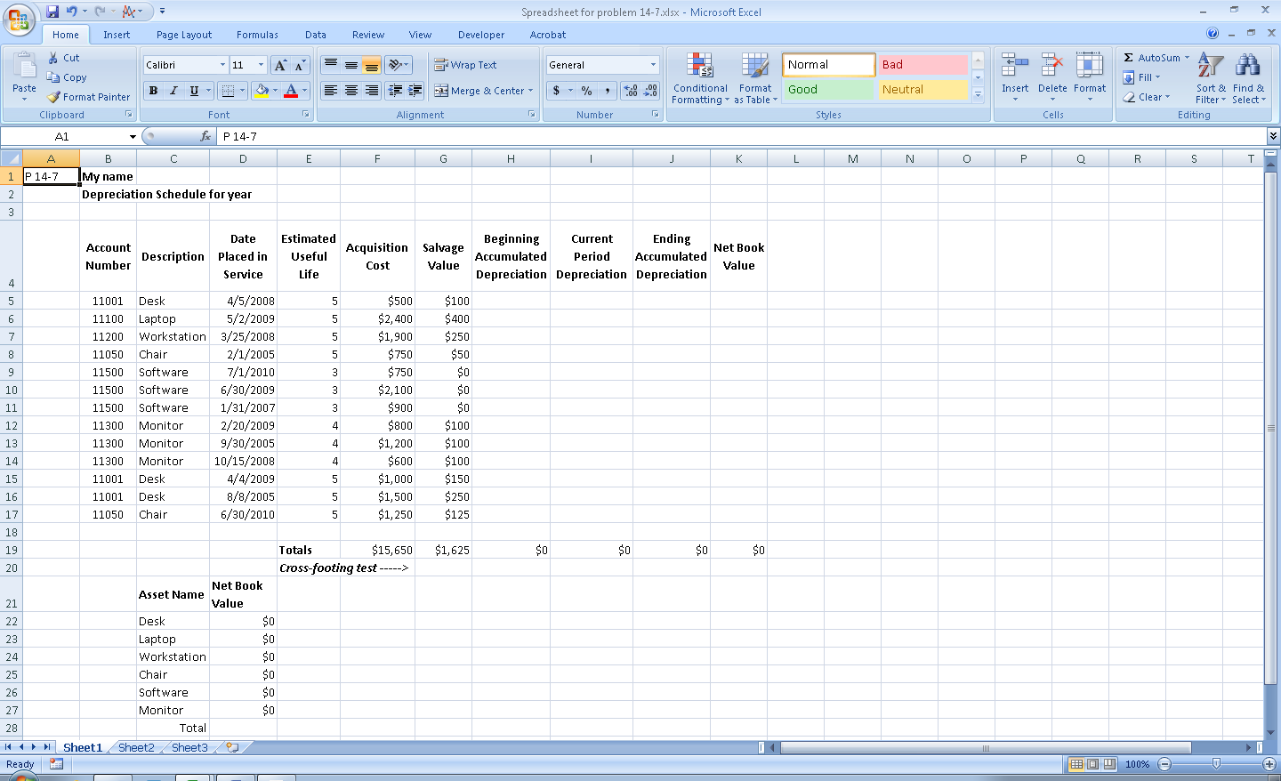

1. Create formulas to calculate
   * Accumulated depreciation (all assets use the straight line method; all assets acquired any time during the year get a full year’s initial depreciation)
   * Current year’s depreciation (straight-line method, full amount for initial year in which asset acquired)
   * Ending accumulated depreciation
   * Net book value at end of period
   * Current year in the cell to the right of the phrase “Depreciation schedule for year”
   * Column totals for acquisition cost, beginning depreciation, current depreciation, ending accumulated depreciation, net book value
   * In the cell to the right of the arrow following the text “Cross-footing test” create a formula that checks whether the sum of the net book value column equals the sum of acquisition costs minus the sum of ending accumulated depreciation. If the two values match, the formula should display the text “Okay” otherwise it should display the text “Error”

c. Create a table at the bottom of your worksheet that consists of two columns:

• Asset name (values should be chair, desk, laptop, monitor, software, and workstation)

• Net book value (create a formula to calculate this number) assuming that the current date is 06/30/2010

* Create a formula that sums the total net book values for all classes of assets
* In the cell to the right of the total net book values for all asset classes, create a formula that compares the total net book values for all classes of assets to the sum of all net book values in the top portion of the spreadsheet. The formula should return “Okay” if the two totals match or “Error: Sum of net book values by asset class does not equal sum of all net book values” if the two totals do not equal one another.

1. Enter your name in row 1 in the cell to the right of the text “Name”

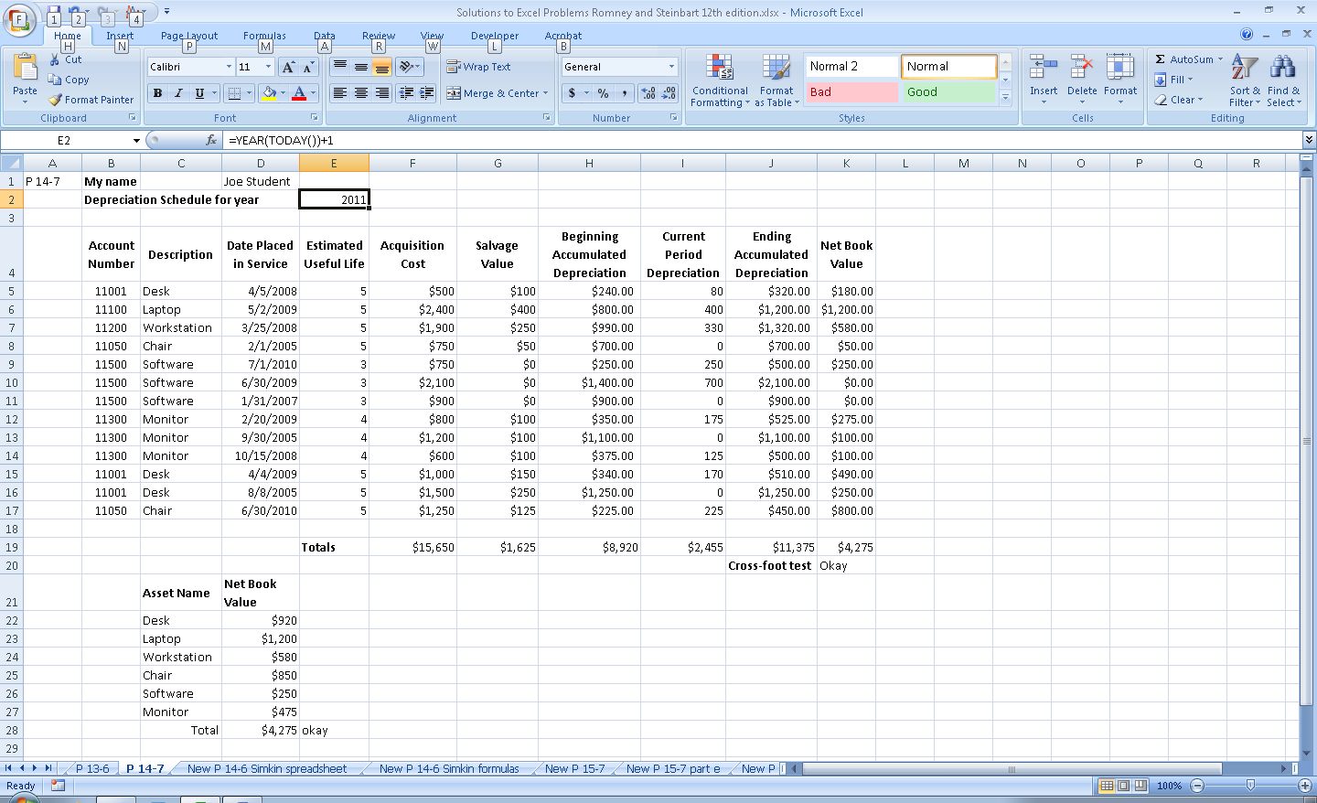

Note: this solution was created assuming that the current year is 2011. Therefore, when using the problem in subsequent years, you may want to have students increment all years initially placed in service by one.

Useful formulas:

* Current year: =YEAR(TODAY()) – this calculates the current year. In cell E2, it is currently set to increment by 1 because the solution was created in 2010, but designed to mimic 2011. Therefore, when using this problem in 2011 and subsequent years, students should not increment it by 1, but simply have the formula =YEAR(TODAY()) to return the value of the current year.
* Excel has a built-in function for computing straight-line depreciation: SLN. The SLN function takes three arguments: cost, salvage value, and estimated life: SLN(cell with cost, cell with salvage value, cell with estimated life).
* Beginning accumulated depreciation equals the minimum of actual accumulated depreciation, if the asset is not yet at the end of its useful life, or acquisition cost minus salvage value if it is past the end of its useful life. In the solution, beginning accumulated depreciation is based on running the spreadsheet in 2011. When using this problem in 2012 and subsequent years, you should have students increment the acquisition years by one so that the answer remains the same as shown. Note that the formula references cell E2 to facilitate use in any year: =MIN(VALUE($E$2-YEAR(D5))*SLN(F5,G5,E5),F5-G5). IMPORTANT: be sure that student formulas reference only cell E2 ($E$2), but use relative references for all other terms.
* Current period depreciation is either the result of the straight-line depreciation calculation, if the asset has not yet been fully depreciated, or zero: =IF(F5-H5=G5,0,SLN(F5,G5,E5))
* Ending Accumulated depreciation: =H5+I5
* Net book value equals acquisition cost less accumulated depreciation. Thus for the desk (account 11001) the formula is =F5-J5.
* Cross-foot test: =IF(K19=F19-J19,"Okay","Error")
* Net book values for asset classes: =SUMIF($C$5:$C$17,C22,$K$5:$K$17) – copy down, note that second entry does NOT use absolute cell references
* Cross-foot check of net book values by class versus by asset: =IF(D28=K19,"okay","Error: Sum of net book values by asset category does not equal total net book values")

14.8 Excel Problem

Task: Use Excel and the Solver add-in to explore the effect of various resource constraints on the optimal product mix.

a. Read the article “Boost Profits With Excel,” by James A. Weisel in the December 2003 issue of the *Journal of Accountancy* (available online at the AICPA’s Web site, www.aicpa.org

b. Download the sample spreadsheet discussed in the article and print out the screenshots showing that you used the Solver tool as discussed in the article.

To load Solver in Excel 2007, click on the “Microsoft Office Button” in the upper left corner of an Excel spreadsheet. Then click on Excel Options to open the following screen, select Add-Ins, highlight “Solver Add-in” and click the “Go” button:

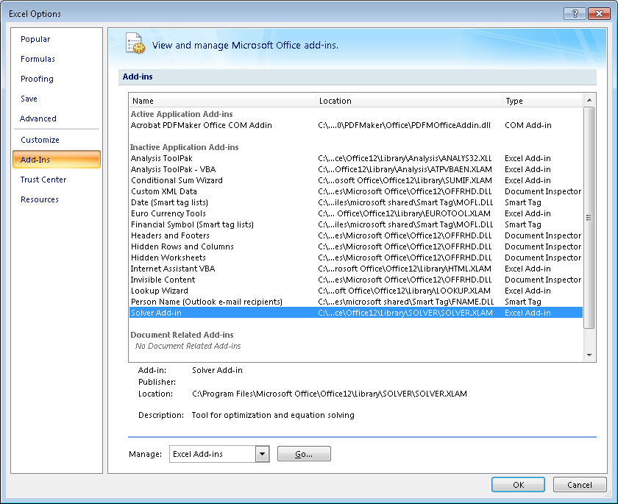

This brings up the following pop-up window. Select the “Solver Add-in” and click OK.

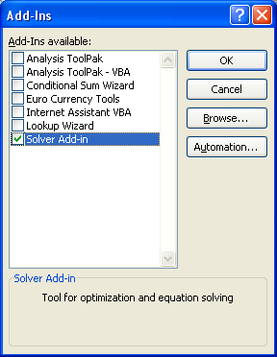

Then, to use Solver:

1. Move to the Data tab and then click on ?/arrow symbol in the Solver

Click on the ?/arrow symbol

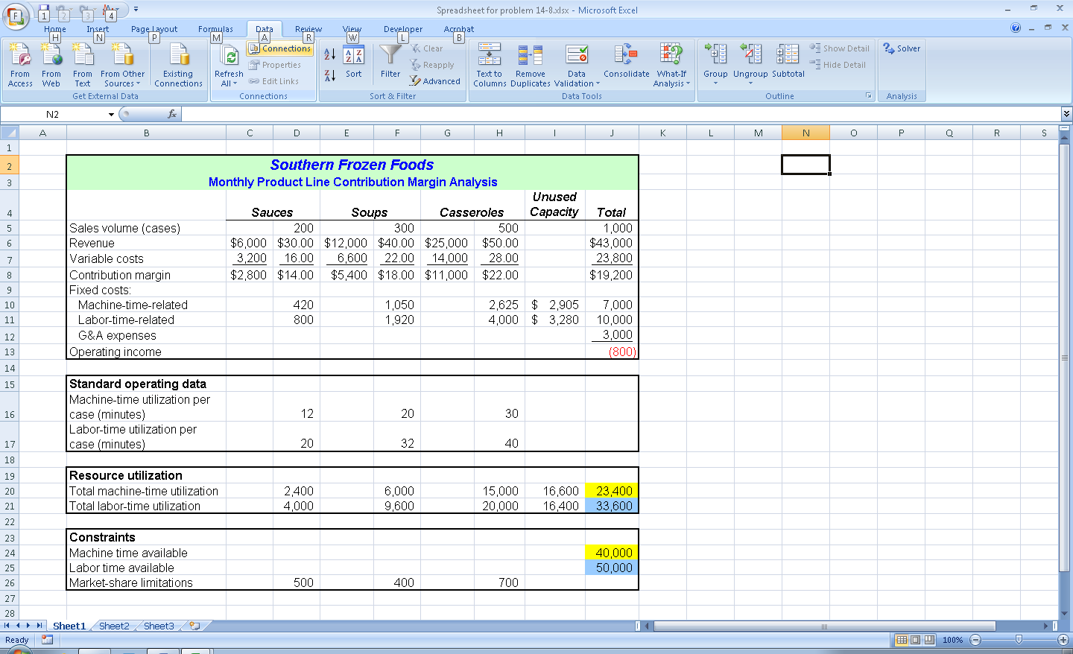

1. Then enter the values in the cells in the Solver pop-up window as instructed in the article :

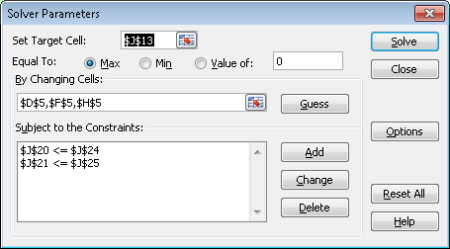

1. Choose “Keep Solver Solution” and click OK

4. The result is the following spreadsheet as shown in the article:

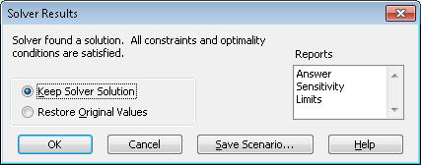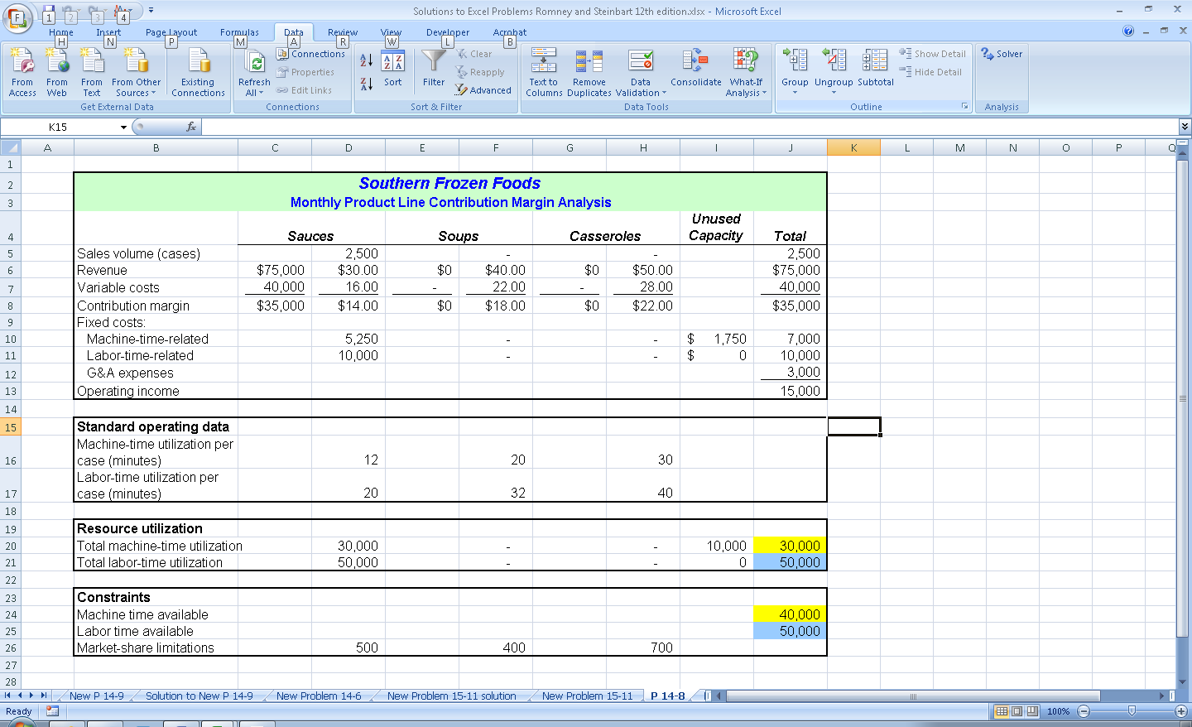

1. Students should save screen shots to show that they have followed the remaining steps in the article.

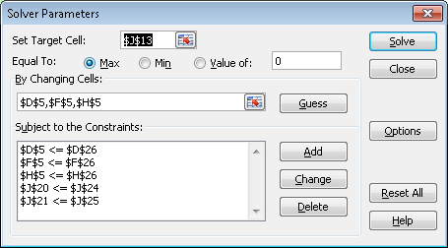

Clicking “Solve” and then “Keep the Solver Solution” yields the following spreadsheet, as shown in the article:

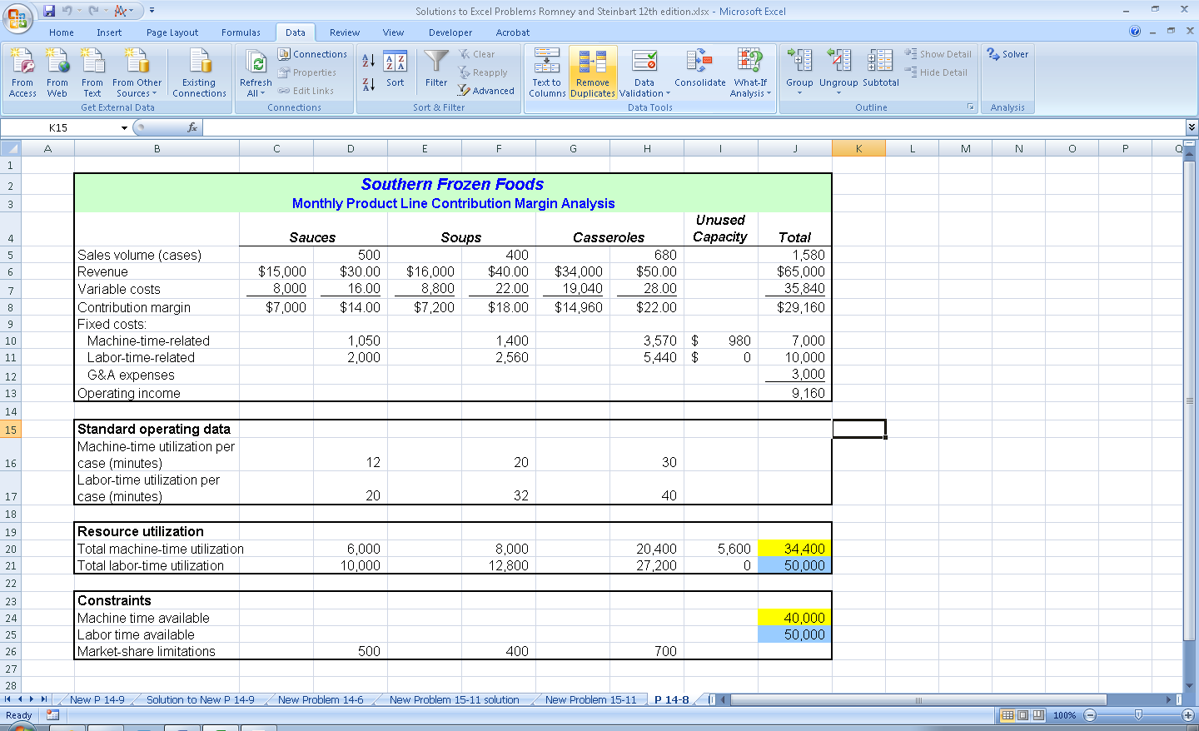

Finally, adjusting the total amount of labor hours and dollars and re-running the Solver yields the final spreadsheet depicted in the article:

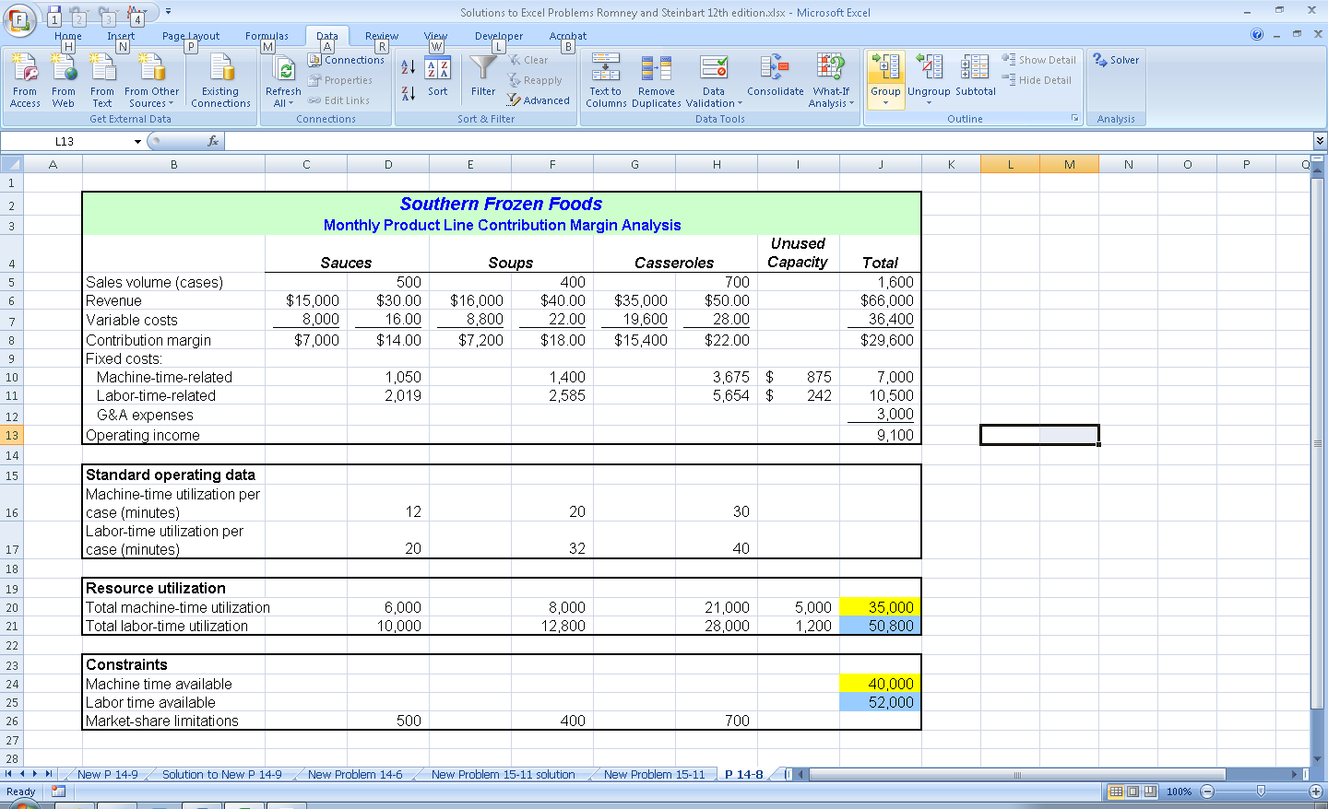

c. Rerun the Solver program to determine the effect of the following actions on income (print out the results of each option):

• double market share limitations for all three products

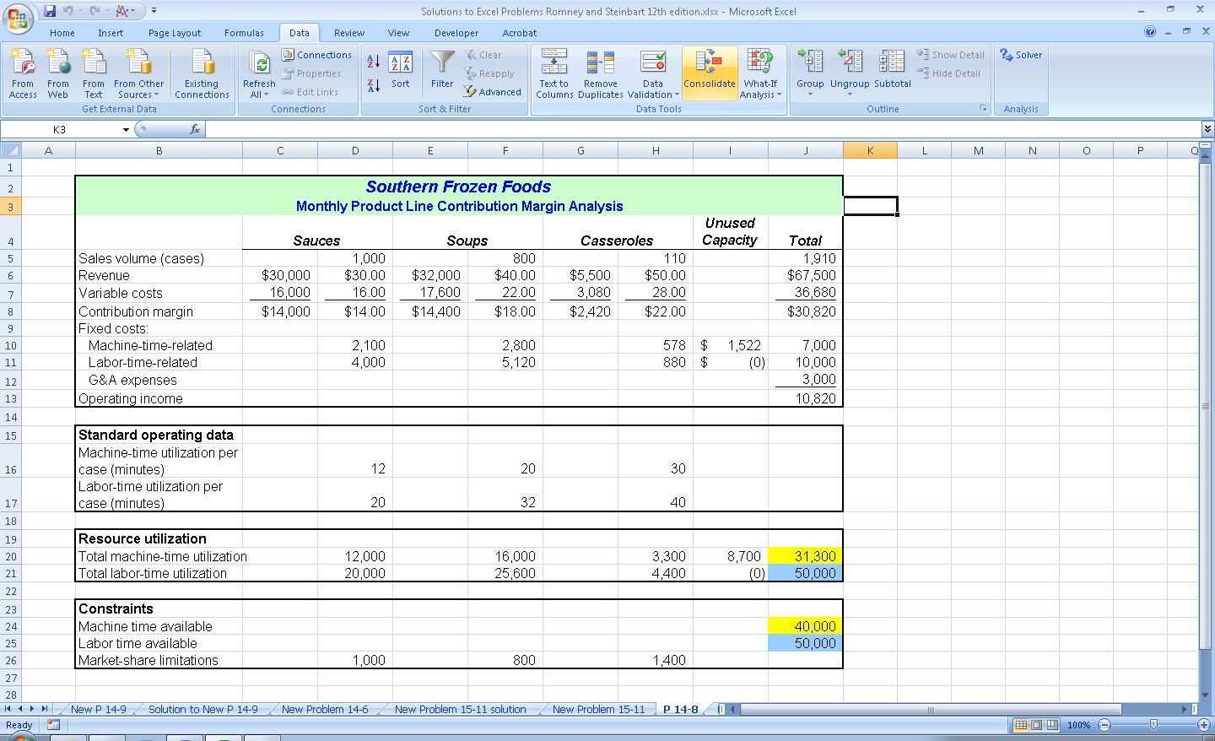

* Double market share limitations for all three products plus the following constraint: sauce case sales cannot exceed 50% of the sum of soup and casserole case sales

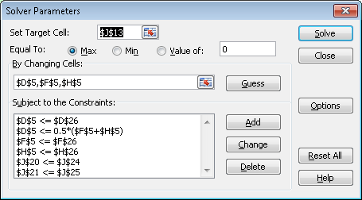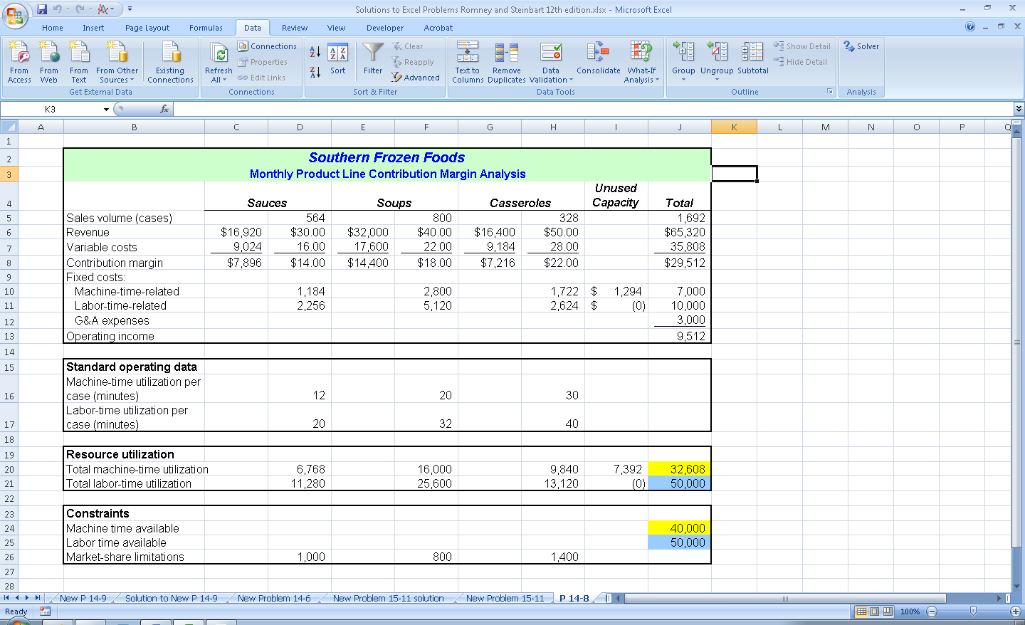

14.9 EXCEL PROBLEM

Create the spreadsheet shown in Figure 14-11. Write formulas to calculate the total depreciation expense and to display the correct values in the following three columns: Age, Depreciation Rate, and Depreciation Expense. (*Hint*: You will need to use the VLOOKUP and MATCH functions to do this. You may also want to read the article “Double-Teaming In Excel,” by Judith K. Welch, Lois S. Mahoney, and Daniel R. Brickner, in the November 2005 issue of the *Journal of Accountancy*, from which this problem was adapted).

Solution is on next page:

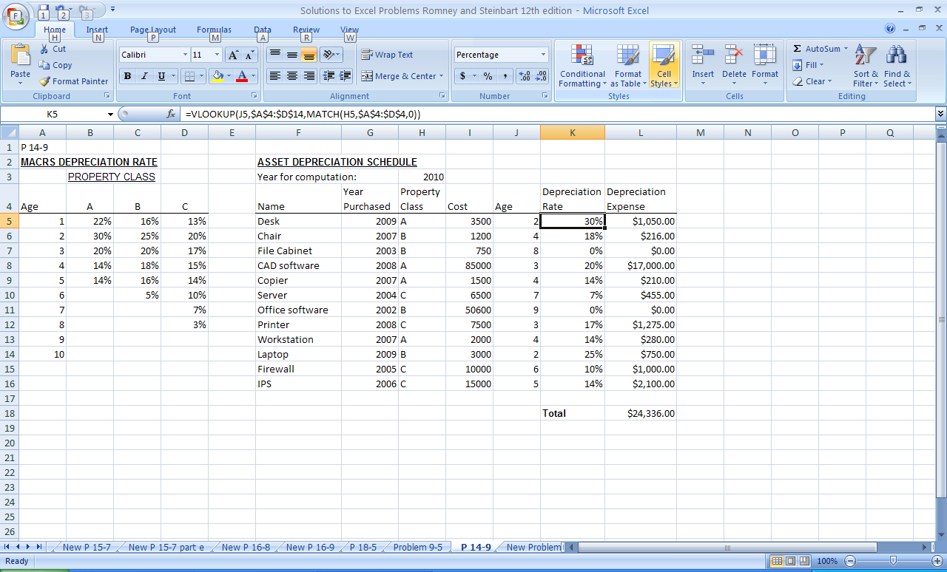

Depreciation expense formula: =VLOOKUP(J5,$A$4:$D$14,MATCH(H5,$A$4:$D$4,0))

- explanation of formula:

* The age column subtracts the year the asset was purchased from the reference year in cell H3. It then adds one to that value because the year the asset is purchased is its first year of depreciation.
* The VLOOKUP function extracts tax rate from the tax table. The first argument to the VLOOKUP function is the asset’s age. The second argument is the location of the vlookup table (cells A14 to D14, using absolute references so that the formula can be correctly copied). The third argument is the row in which to find the answer. In this case, the row is given by the result of the MATCH function.
* The first argument of the MATCH function is the cell which contains the asset class (column H). The second argument indicates where the column headings are for the different classes (A4:D4). The third argument (0) indicates the match type where 0 means an exact match.

# **SUGGESTED ANSWERS TO THE CASES**

CASE 14-1 The Accountant and CIM

Examine issues of the *Journal of Accountancy*, *Strategic Finance*, and other business magazines for the past three years to find stories about current developments in factory automation. Write a brief report that discusses the accounting implications of one development: how it affects the efficiency and accuracy of data collection and any new opportunities for improving the quality of performance reports. Also discuss how the development affects the risks of various production cycle threats and the control procedures used to mitigate those risks.

There is no one correct answer. In addition to grading on writing quality, be sure that students fulfill task requirements (i.e., describe the development, the controller’s role, and the effect on production cycle threats). The logical reasoning used to support any analysis should also be evaluated.