**CHAPTER 16**

**GENERAL LEDGER AND REPORTING SYSTEM**

**SUGGESTED ANSWERS TO DISCUSSION QUESTIONS**

**16.1** **Although XBRL facilitates the electronic exchange of financial information, some external users do not think it goes far enough. They would like access to the entire general ledger, not just to XBRL-tagged financial reports that summarize general ledger accounts. Should companies provide external users with such access? Why or why not?**

No, companies should not provide access to their general ledger. Providing external users access to a company’s general ledger opens the company up to significant competitive and financial risk.

**16.2 How can responsibility accounting and flexible budgets improve morale?**

Responsibility accounting improves morale by holding managers accountable only for the activities over which they have control. In this way, they are not unfairly “punished” for poor performance that they could not alter.

Flexible budgeting enables more accurate interpretation of deviations from budget. For example, if activity levels are higher than planned, then costs should also increase. Therefore, costs higher than the original budget may not be “bad” if they have risen at a rate less than or equal to the proportionate increase in activity.

**16.3** **Why is the audit trail an important control?**

The audit trail is a detective control used to verify the accuracy and completeness of transaction processing. Tracing a set of source documents forward through the journal entries that updated the general ledger verifies that the transactions were actually recorded. Tracing changes in general ledger accounts back to source documents provides a way to verify that the transactions did indeed occur and that they were recorded correctly.

Although an accounting system should employ a variety of processing integrity controls to prevent errors from occurring, preventive controls are never 100% effective. Therefore, they need to be supplemented with detective controls like an audit trail.

**16.4 The balanced scorecard measures organizational performance along four dimensions. Is it possible that measures on the customer, internal operations, and innovation and learning dimensions could be improving without any positive change in the financial dimension? If so, what are the implications of such a pattern?**

It may indeed be possible for measures on three dimensions of the balanced scorecard to improve, but for financial results to deteriorate. This may occur because the 3 other areas are leading indicators of financial performance. If so, the latter should soon begin to improve.

On the other hand, it may be that the measures developed for the other areas are flawed in that they do not address activities that customers value. Consequently, improved performance on those dimensions does not translate into improved profitability. In this case, management needs to redesign the nonfinancial dimensions of the Balanced Scorecard to include items that are causally related to future financial performance.

Yet another possibility is that macroeconomic factors could be depressing earnings.

Clearly, a company cannot continue indefinitely with declining financial performance. Top management needs to investigate the underlying causes of this pattern.

**16.5** **Do you think that mandatory standards should be developed for the design of graphs of financial data that are included in annual reports and other periodic communications to investors? Why or why not?**

There is no right answer here but it should generate a good discussion. It may be helpful to start the discussion off by talking about the reporting standards of the SEC and FASB.

It may also be useful to find annual reports or other financial news stories that contain graphs which violate one or more of the rules presented in this chapter, and ask students to discuss the effects, if any, of such violations.

Should students support standards, a good follow-up topic concerns the type of audit guidance that would be helpful.

**SUGGESTED ANSWERS TO THE PROBLEMS**

**16.1 Match the term in the left column with its appropriate definition from the right column:**

|  |  |
| --- | --- |
| 1. __d__ journal voucher file | a. an individual financial statement item |
| 2. __k__ instance document | b. evaluating performance based on controllable costs |
| 3. __a__ XBRL element | c. evaluating performance by computing standards in light of actual activity levels |
| 4. __f__ Balanced Scorecard | d. the set of journal entries that updated the general ledger |
| 5. __l__ XBRL extension taxonomy | e. a set of files that defines XBRL elements and specifies the relationships among them |
| 6. __i__ audit trail | f. a multi-dimensional performance report |
| 7. __e__ XBRL taxonomy | g. a file that defines relationships among XBRL elements |
| 8. __g__ XBRL linkbase | h. a file that defines the attributes of XBRL elements |
| 9. __h__ XBRL schema | i. a detective control that can be used to trace changes in general ledger account balances back to source documents |
| 10. __j__ XBRL style sheet | j. a file that explains how to display an XBRL instance document |
| 11. __b__ responsibility accounting | k. a file that contains specific data values for a set of XBRL elements for a specific time period or point in time |
| 12. __c__ flexible budget | l. a file containing a set of customized tags to define new XBRL elements that are unique to a specific organization |

**16.2** **Which control procedure would be most effective in addressing the following problems?**

**a. When entering a journal entry to record issuance of new debt, the treasurer inadvertently transposes two digits in the debit amount.**

* Use a cross-footing balance check to test the equality of debits and credits

**b. The spreadsheet used to calculate accruals had an error in a formula. As a result, the controller’s adjusting entry was for the wrong amount.**

Audit spreadsheets used to support journal entries

**c. The controller forgot to make an adjusting entry to record depreciation.**

* Create a set of standard adjusting entries

**d. A sales manager tipped off friends that the company’s financial results, to be released tomorrow, were unexpectedly good.**

* Implement access controls to prevent the sales manager from obtaining access to the general ledger and reporting system.

**e. The general ledger master file is stored on disk. For some reason, the disk is no longer readable. It takes the accounting department a week to reenter the past month’s transactions from source documents in order to create a new general ledger master file.**

* Backup files more frequently.
* Create two copies of the backup files and store one on-site and the other off-site.

**f. The controller sent a spreadsheet containing a preliminary draft of the income statement to the CFO by e-mail. An investor intercepted the e-mail and used the information to sell his stock in the company before news of the disappointing results became public.**

* Encrypt sensitive financial information when it is transmitted over the Internet.

**g. A company’s XBRL business report was incorrect because the controller selected the wrong element from the taxonomy.**

* Train users on the proper use of the taxonomy to prevent this..
* Audit or validate the instance document prior to submission to detect this.

**h. Instead of a zero, the letter o was entered when typing in data values in an XBRL instance document.**

* Use processing integrity controls when entering data in instance documents.
* Use a field check to detect this kind of error.

**16.3** **Explain the components of an audit trail for verifying changes to accounts payable. Your answer should specify how those components can be used to verify the accuracy, completeness, and validity of all purchases, purchase returns, purchase discounts, debit memos, and cash disbursements.**

The sum of all amounts owed to individual vendors would be computed and compared to the balance in the general ledger accounts payable control account.

To verify all transactions, you would follow the audit trail to identify the voucher numbers, purchase order numbers, and receiving report numbers for all approved vendor invoices and use that list to select all source documents.

You could then recalculate the total amount purchased and the total cash disbursed. You could also recalculate all purchase discounts available and compare that to the amount taken.

To verify vendor balances, you could recompute the effects of all purchases and payments on the beginning balance; this calculated figure should equal the new ending balance.

**16.4 As manager of a local pizza parlor, you want to develop a balanced scorecard so you can more effectively monitor the restaurant’s performance.**

**a. Propose at least two goals for each dimension, and explain why those goals are important to the overall success of the pizza parlor. One goal should be purely performance-oriented and the other should be risk-related.**

**b. Suggest specific measures for each goal developed in part a.**

Below is a sample of a balanced scorecard containing goals and measures.

|  |  |  |  |
| --- | --- | --- | --- |
| **Dimension Goals** | **Measure** | Target | **Actual** |
| **Financial**  Increase sales  Profitability | Percentage change in sales  Operating margin | 5%  12% | 4%  13.5% |
| **Customer**  Customer satisfaction  Attract new customers  Fast service | Customer satisfaction rating  Percentage of sales to first time  customers  Average time to serve food | 9.5  10%  15 minutes | 9.6  3%  14 minutes |
| **Internal** **operations**  Reduce waste  Reduce mistakes | Food waste (% of sales)  Percentage of orders with mistakes | 3%  1% | 4%  2% |
| **Innovation and learning**  Develop new products  Improve employee skills | Number of new products this year  Number of cooking classes attended  this year  Percentage of cooks who attended at  least one cooking class this year | 2  25  85% | 2  18  75% |

**c. Explain how to gather the data needed for each measure developed in part b.**

Financial measures would be generated by the accounting system.

Customer satisfaction and first-time customers could be measured through in-store surveys.

The other measures would have to be collected as part of performing the activities.

**16.5** **Use Table 16-1 to create a questionnaire checklist that can be used to evaluate controls in the general ledger and reporting cycle.**

1. **For each control issue, write a Yes/No question such that a “No” answer represents a control weakness. For example, one question might be “Is access to the general ledger restricted?”**

A wide variety of questions is possible. Below is a sample list:

|  |  |  |
| --- | --- | --- |
| **Question** | **Yes** | **No** |
| 1. Is access to the general ledger restricted? |  |  |
| 1. Is the general ledger regularly reviewed and all changes investigated? |  |  |
| 1. Is sensitive data encrypted while stored in the database? |  |  |
| 1. Does a backup and disaster recovery plan exist? |  |  |
| 1. Have backup procedures been tested within the past year? |  |  |
| 1. Are appropriate data entry edit controls used for journal entries? |  |  |
| 1. Is an audit trail maintained and regularly reviewed? |  |  |
| 1. Are the spreadsheets used to calculate amounts for adjusting journal entries audited to verify that the formulas are correct? |  |  |
| 1. Has the controller or person responsible for mapping the organization’s data to an XBRL taxonomy attended XBRL training? |  |  |
| 1. Are XBRL instance documents validated by someone not involved in their creation? |  |  |
| 1. Have employees responsible for creating graphs been trained in the principles of graph design? |  |  |

1. **For each Yes/No question, write a brief explanation of why a “No” answer represents a control weakness.**

|  |  |
| --- | --- |
| **Question** | **Reason a “No” answer represents a weakness** |
| 1 | Unrestricted access to the general ledger could facilitate fraud or the unauthorized disclosure of sensitive data |
| 2 | Failure to investigate all changes to the general ledger may allow fraud to occur because unauthorized master records (e.g., fake suppliers, non-existent employees, etc.) may not be detected. Also, unauthorized changes to account balances may not be detected. |
| 3 | Failure to encrypt sensitive data can result in unauthorized disclosure of financial results by someone who obtains access to the data |
| 4 | If a backup and disaster recovery plan does not exist, the organization may suffer the loss of important data. |
| 5 | If the backup plan is not regularly tested, it may not work. |
| 6 | Without proper data entry edit controls, errors in journal entries used to update the general ledger may occur |
| 7 | Without an audit trail, it is not possible to verify the completeness and accuracy of all changes to the general ledger. |
| 8 | Failure to audit spreadsheets for errors increases the risk of erroneous adjusting entries |
| 9 | Training in XBRL is necessary to avoid making errors in the mapping of the organization’s data to taxonomy elements or the unnecessary creation of taxonomy extensions |
| 10 | Failure to validate an instance document by someone not involved in its creation increases the risk of submitting inaccurate instance documents. |
| 11 | If employees have not been trained in the principles of proper graph design, they may create misleading graphs. |

**16.6 Visit the SEC website (**[**www.sec.gov**](http://www.sec.gov)**) and explore what is available in terms of interactive data (the SEC’s term for XBRL reports). Use the SEC’s viewer software and examine the annual reports for two companies.**

There is no “solution” per se – the objective of this problem is to introduce students to XBRL filings and the use of viewer software.

**16.7** **Obtain the annual report of a company assigned by your professor. Read the management discussion and analysis section, and develop a balanced scorecard that reflects that company’s vision, mission, and strategy. Create both performance-oriented and risk-based goals and measures for each section of the balanced scorecard.**

The key to this assignment is the appropriateness of the goals and measures developed for the Balanced Scorecard in light of management’s discussion about the mission, vision, and values of the company. This requires inferring from management’s discussion in the annual report the company’s strategy (low-cost or product differentiation) and strategic position (variety-based, needs-based, or access-based).

You should probably develop your own grading key, based on what you expect from the students. At a minimum, students need to develop multiple goals for each of the four dimensions of the Balanced Scorecard. They also need to present quantifiable measures for each goal.

To facilitate grading, ask them to turn in both the annual report they used and a list of references to specific points in the management discussion that they used to justify their choice of goals and measures.

**16.8 Excel Problem Objective: Practice graph design principles.**

**Use the data in Table 16-3 to create the following graphs:**



1. **Sales**



1. **Sales and Gross Margin**



1. **Earnings per share**



1. **Which principles of graph design, if any, did you have to manually implement to over-ride the default graphs created by Excel?**
   1. Students had to reverse the x-axis, which automatically followed the sequence of years in the spreadsheet.
   2. Students had to adjust the y-axis to begin at zero for earnings per share. However, if variations in EPS are important to monitor, then the default graph below may be preferred.



**16.9 Excel Problem Objective: Create pivot tables for what-if analysis**

**.**

**Read the article “Make Excel an Instant Know-It-All” by Roberta Ann Jones in the March 2004 issue of the *Journal of Accountancy*. (Available at** [**www.aicpa.org**](http://www.aicpa.org)**)**

**).**

**a. Follow the instructions in the article to create a spreadsheet with pivot tables.**

First, create the spreadsheet. Then, to create the Pivot Table, position your cursor in a cell where you want the Pivot Table to appear. Then click on the Insert Tab, and then click on the Pivot Table choice.

Click on PivotTable option

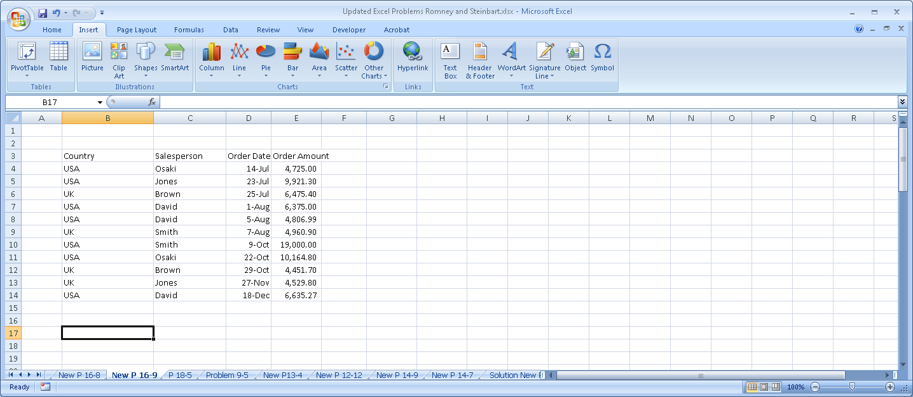

Next, highlight the cells containing the data as shown:

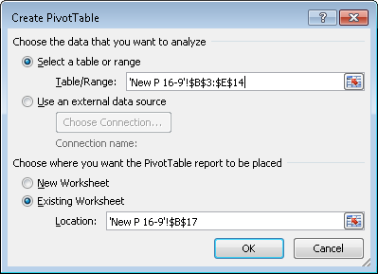

Clicking OK yields the following blank skeleton outline of a PivotTable which we will use in parts b and c to create PivotTables:

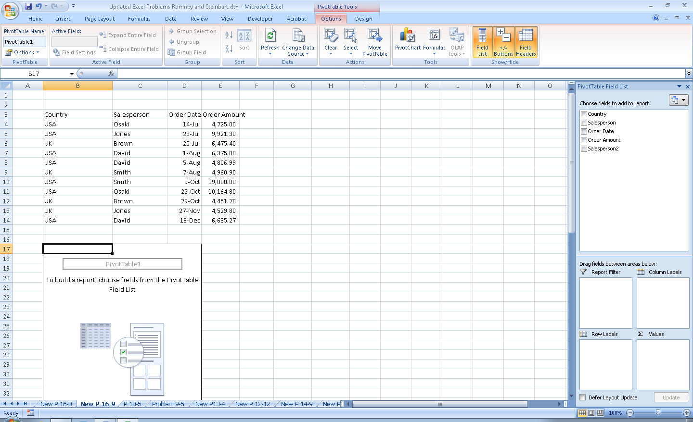

1. **Print out a report that shows sales by month for each salesperson.**

Step1: select the salesperson, order date, and order amount fields in the window in the upper right corner that says “Choose Fields to add to Report.”

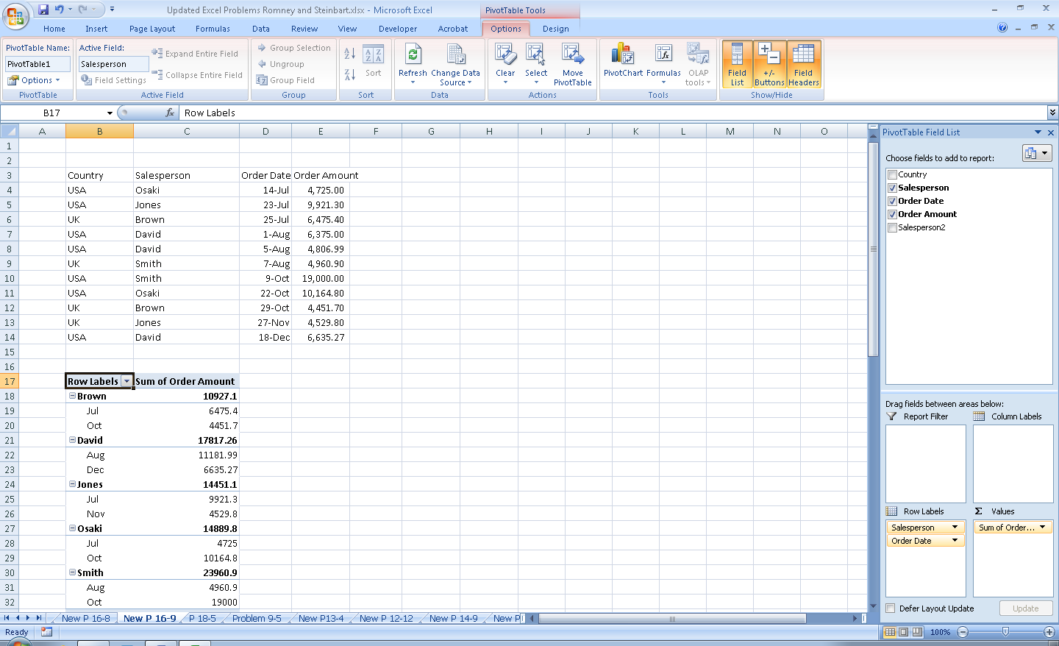

Step 2: Then click on the salesperson entry and move it from the “Row Labels” window to the “Column Labels” window.

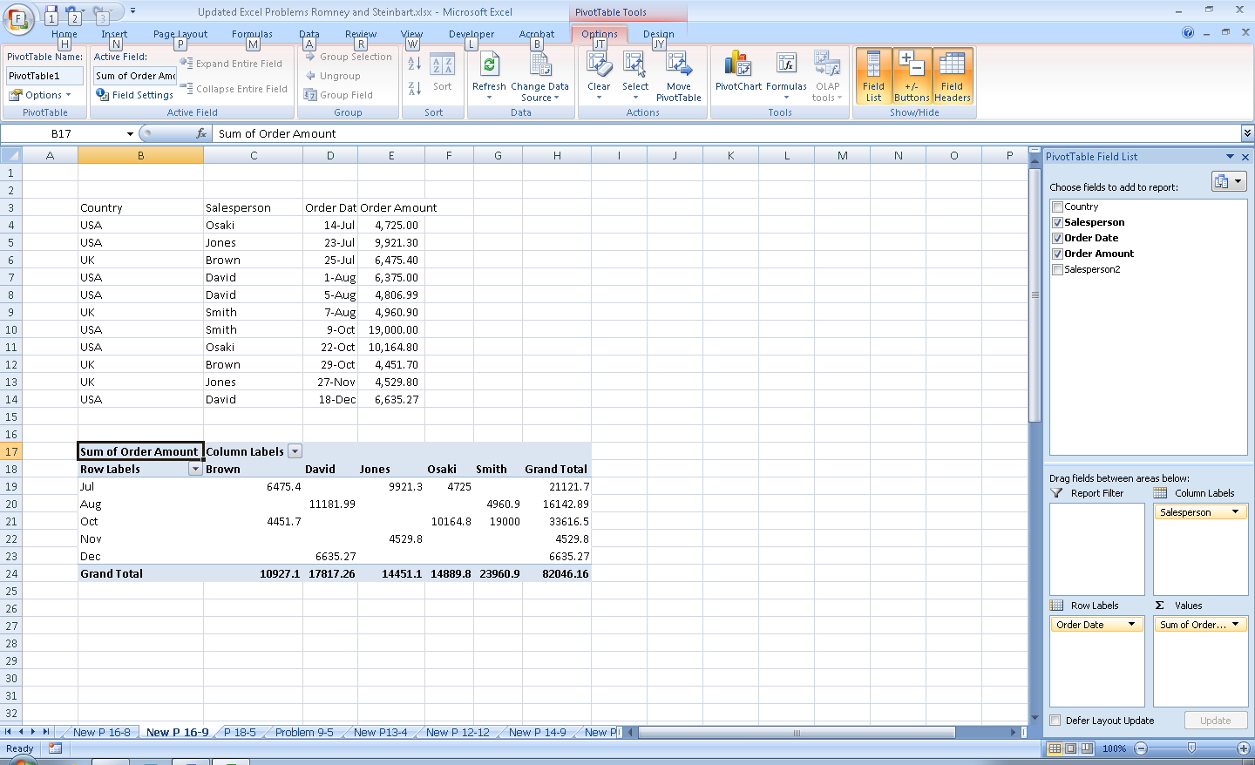

Step 3: Highlight all the cells in the PivotTable and format them to display currency with two decimals.

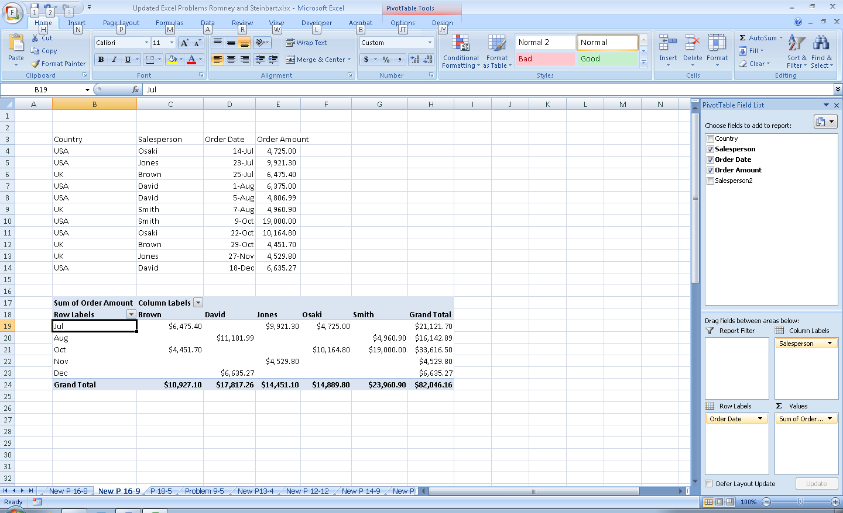

**c. Assume that Brown and David are in sales group 1 and the other three salespeople are in sales group 2. Print out a report that shows monthly sales for each group.**

Step 1: To separate the sales people into groups, click on the sales person row in the Pivot Table and highlight Brown and David.

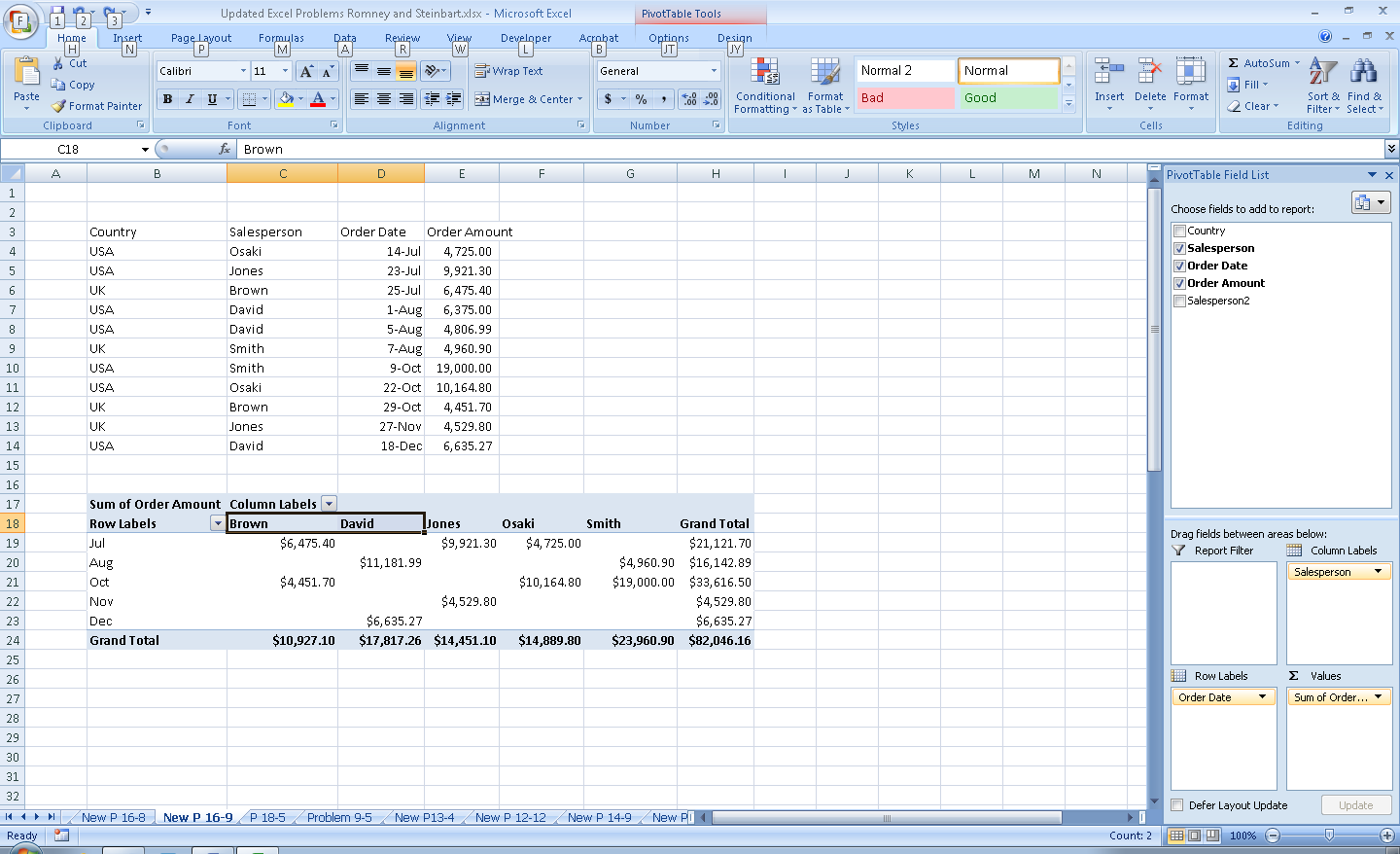

Step 2: Right click the two highlighted cells and select “Group”. They will now have a super-title called “Group 1”. Do the same for the other three sales people to form group 2. The spreadsheet should look like this:

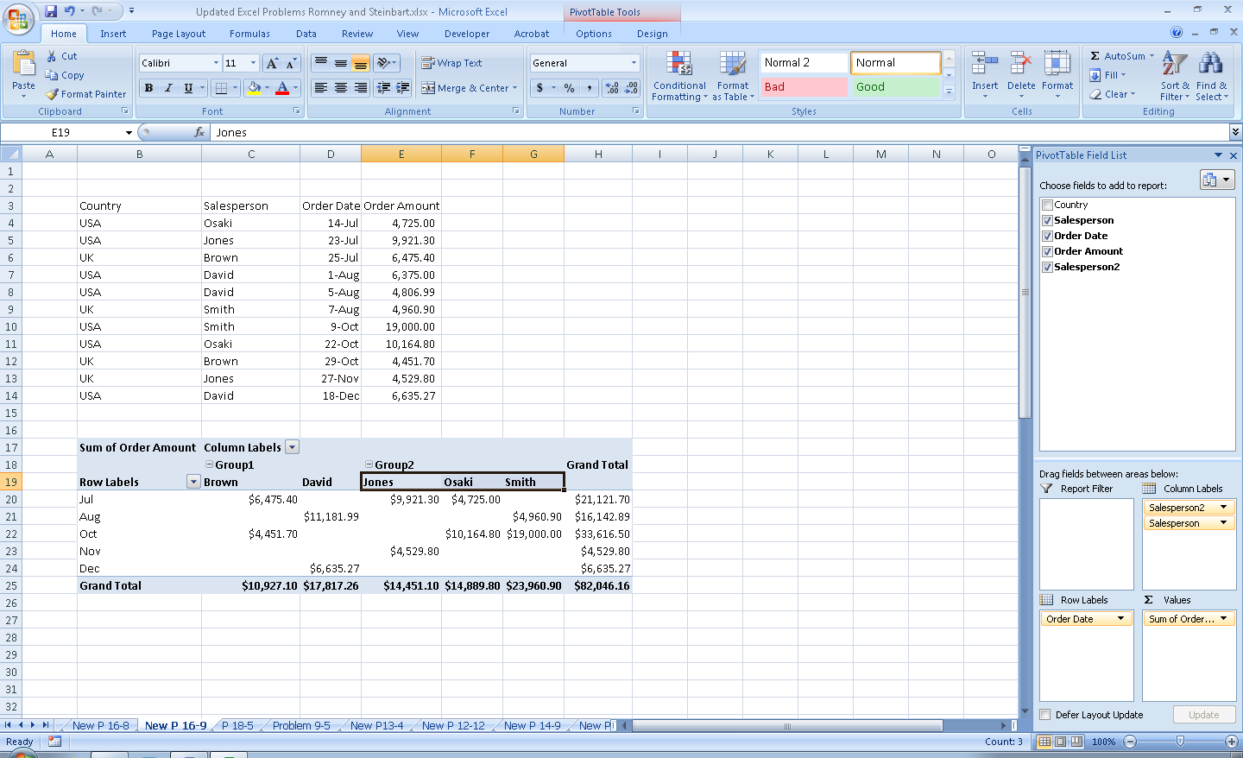

Step 3: You can collapse and display the groups by clicking on the button to the left of each group name. The preceding screen shot showed all members of each group (note the minus signs to the left of the labels “Group1” and “Group2”). Clicking those to change to a plus sign produces the following:

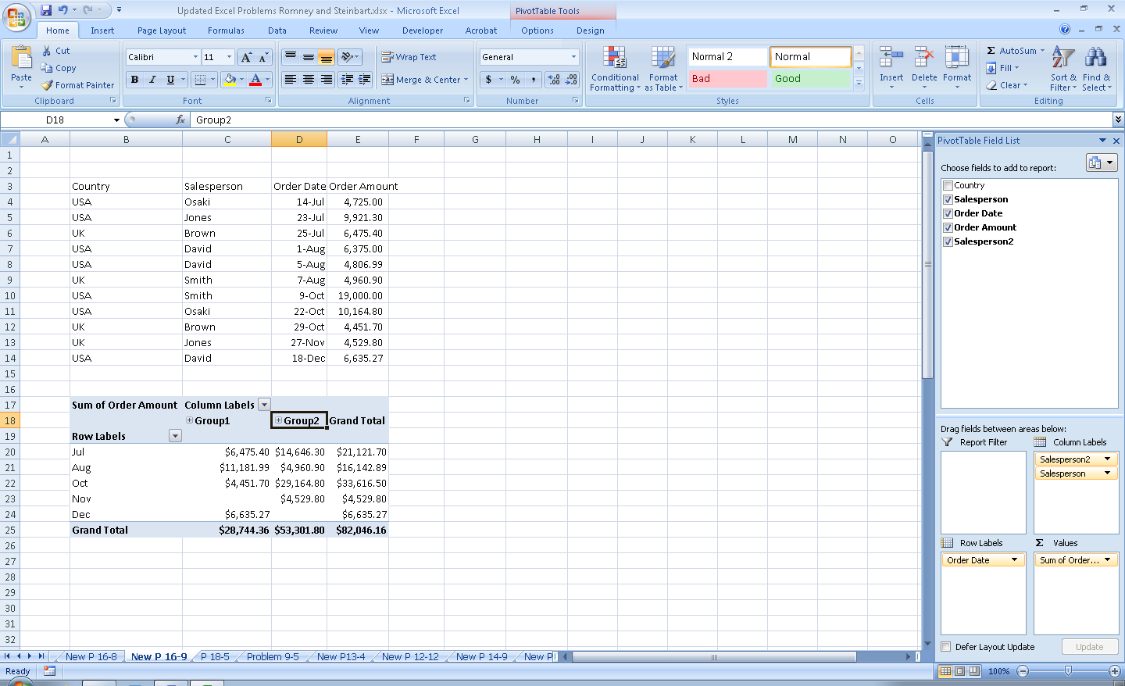

**16.10 Excel Problem Objective: How to do what-if analysis with graphs.**

**a. Read the article “Tweaking the Numbers,” by Theo Callahan in the June 2001 issue of the *Journal of Accountancy* (either the print edition, likely available at your school’s library, or access the Journal of Accountancy archives at www.aicpa.org). Follow the instructions in the article to create a spreadsheet with graphs that do what-if analysis.**

Most of the steps in the article can be done as indicated. One difference is finding the control toolbox to create a spin button. This requires that the “Developer” tab is available as shown below.

Click on “Design Mode” to toggle

Click on Insert to add spin buttons and other Active X controls

The Developer tab normally appears to the right of the View tab

The Microsoft Office Button is in the far upper left

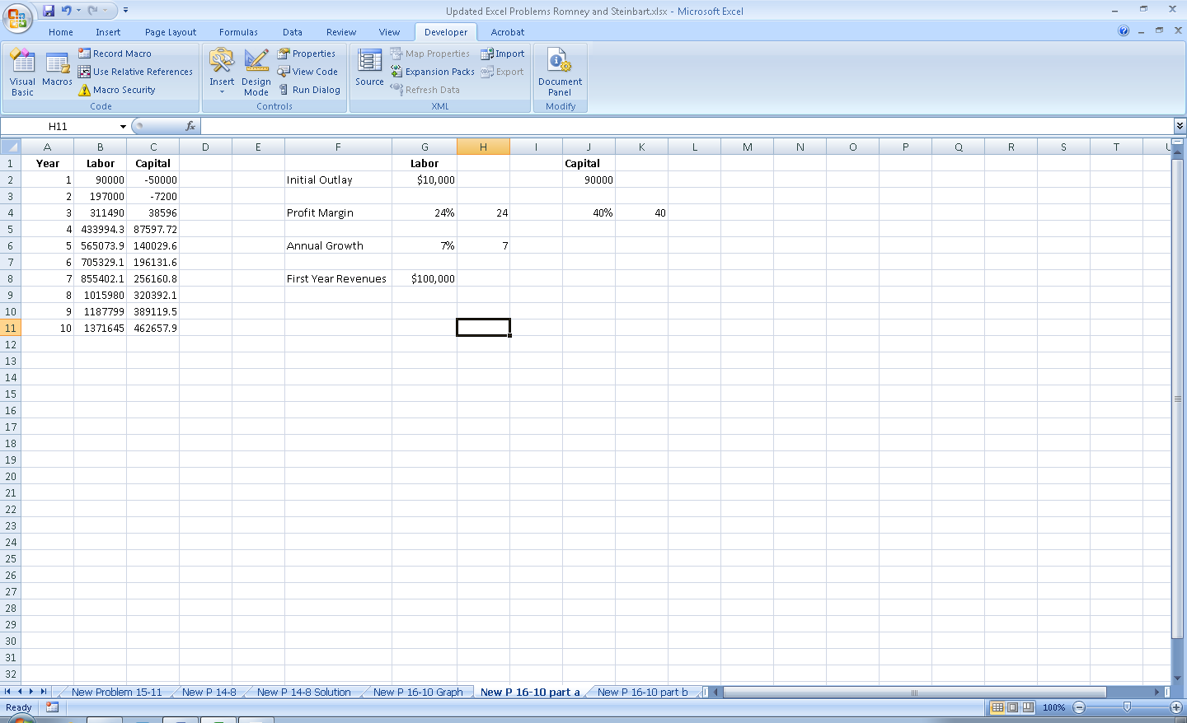

If the developer tab is not available, follow these steps (for Excel 2007):

* + 1. Click the Microsoft Office Button (in far upper left corner – see prior screenshot)
    2. Click Excel Options
    3. In the “Popular” category, under “Top options for working with Excel” select the “Show Developer tab in the Ribbon” check box and click OK

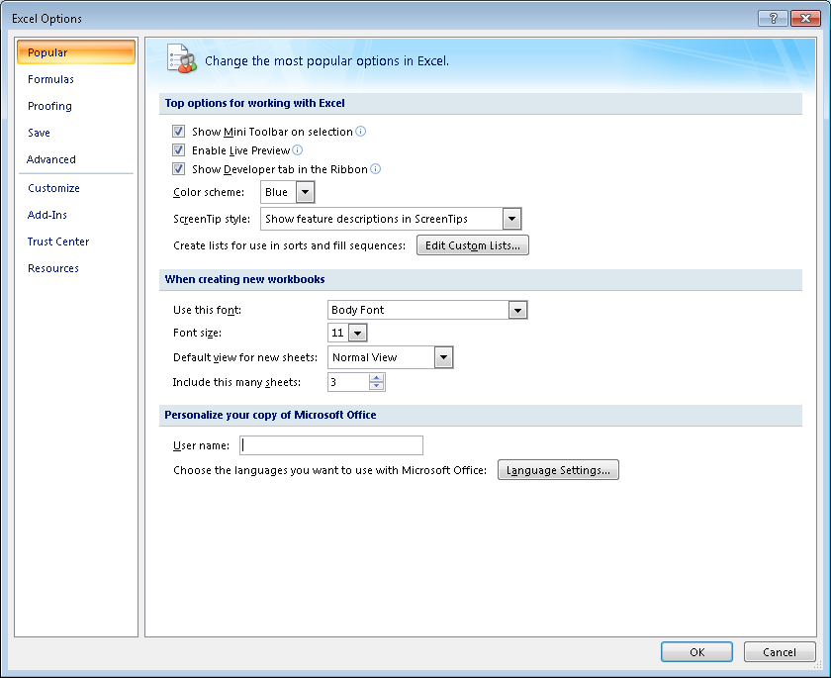

On the Developer tab you then click insert and select the “spin box” option from the list of choices of Active X controls. Then position your cursor in the cell where you want to insert a spin button and left-click once. You can now right-click on the spin-button and fill in the values for the spin buttons as indicated in the article.

Hint: it may help to increase the height of the rows before trying to add more spin buttons.

The rest of the article steps work as described.

1. **Now create a spreadsheet to do graphical what-if analysis for the “cash gap.” Cash gap represents the number of days between when a company has to pay its suppliers and when it gets paid by its customers. Thus, Cash gap = Inventory days on hand + Receivables collection period – Accounts payable period.**

The “cash gap” formula indicates how much of a cushion a company has, given a set of assumptions about inventory, receivables, and payables. If the projected cash gap is too small, management can increase it by instituting changes that either increase the delay in paying suppliers, speeding up collections from customers, or reducing inventory levels.

**The purpose of your spreadsheet is to display visually what happens to cash gap when you “tweak” policies concerning inventory, receivables, and payables. Thus, you will create a spreadsheet that looks like Figure 16-11.**

1. **Set the three spin buttons to have the following values:**

|  |  |  |  |
| --- | --- | --- | --- |
|  | **Spin button for Inventory** | **Spin button for Receivables** | **Spin button for Payables** |
| **Linked cell** | **C2** | **C3** | **C4** |
| **Maximum** | **120** | **120** | **90** |
| **Minimum** | **0** | **30** | **20** |
| **Value** | **30** | **60** | **20** |
| **Small change** | **10** | **10** | **10** |

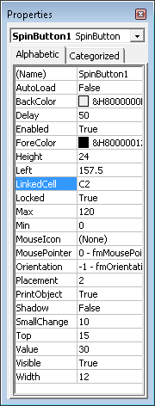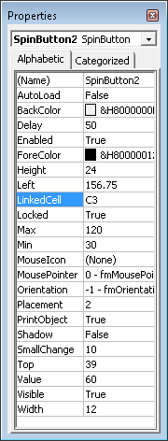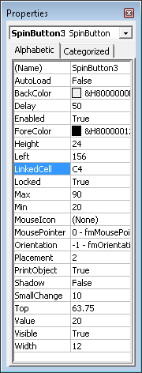

**SUGGESTED ANSWERS TO THE CASES**

**16.1** Student reports will vary depending on what they find and focus on in the website. The website contains pages such as Latest News, Project News, Technical News, etc.

However, the useful page for students will likely be the XBRL IN ACTION page. This page contains case studies that describe how XBRL is being used in specific organizations, details of XBRL projects that are being implemented or are currently being developed. It also contains interactive demonstrations of XBRL projects and descriptions of XBRL related products and services.

**16.2** Answers will vary depending upon the package selected and depth of research undertaken. You may want to assign the package to be researched in order to reduce the number of students studying the same package.

Grade on writing quality, soundness of reasoning, and completeness of answer.