Controlling the Problem 2.7

Applications of the right-hand-side (RHS) range value (and coefficients of the objective function sensitivity range): Computer implementation together with managerial interpretations of the computer solution.

Using WinQSB, we arrive at the following solution of this Linear Problem:

Using this information, we quickly see the ranges of the cost coefficients that will not change to optimal solution. Wilson’s profit on baseballs can vary between $5 and $8.33, and its profit on softballs can vary between $8.40 and 14, while still the current optimal strategy remains optimal. Notice that the optimal value may change for any change in the coefficients of objective function.

We can also conclude from this information that as long as the amount of cowhide remains between 2880 sq. ft. and 3880 sq. ft., a one unit increase or decrease in the amount of cowhide available will only increase or decrease the profit by $1. Similarly, as long as the amount of production time ranges between 866.67 and 1120 minutes, any increase or decrease of production time of 1 minute will increase or decrease the optimal profit by $2.

Construct the dual problem, solve it and then provide economical interpretations for the dual and its solution.

The dual of this problem is as follows:

MINIMIZE: 3600U₁ + 960U₂ + 500U₃ + 500U₄
SUCH THAT:
5U₁ + U₂ + U₃ ≥ 7
6U₁ + 2U₂ + U₄ ≥ 10
U₁, U2, U3, U4 ≥ 0

Using WinQSB, we arrive at the following dual solution of this Linear Problem:

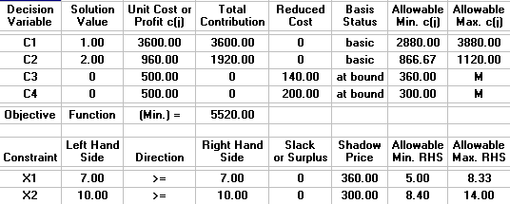

The dual problem tells us that Wilson will lose 5 sq. ft. worth of cowhide, 1 minute of production time for each dozen baseballs not produced, and 6 sq. ft. of cowhide, along with 2 minutes of production time for each dozen of softballs not produced.

Notice that the optimal solution to one problem is the shadow price for the other problem and vice versa. The sensitivity ranges for the RHS of one problem is the same as sensitivity ranges for the coefficient of objective function for the other problem, and vise versa. Therefore, when the manager solves one problem he/she gets enough information for the other problem. This is why the report in WinQSB is called “A combined Report”.

Perform some "what-if" scenarios on your problem. That is, use your computer software package to do some numerical experimentation on variations of your problem. Again, this computer-assisted learning assignment provides a "hands-on" experience, which will enhance your understanding of the technical concepts, involved in various topics of controlling the problems, which we have covered. Your experimentation must include adding a New Constraint; Deleting a Constraint; Replacing a Constraint; introducing a new product; and terminating a product.

- Adding a new product.

I decided to add the constraint that the plant wants to produce “fungo” balls, a leather covered ball similar to a baseball but with a bouncy core. These fungo balls use the same amount of cowhide as a baseball per dozen, but require 4 minutes of production time per dozen balls. Even though I jacked the price up on this specialty ball, I found it was not feasible for Wilson to produce this type of ball, given the same constraints as before. The data table from WinQSB is below.

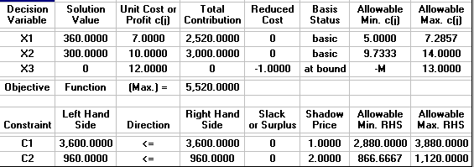

- Adding a new constraint.

Let’s say Wilson also needs to consider activity-based costs such as machine cleaning into their planning. For a run of baseballs it will figure out to cost $3 to clean the production machine, and $4 to clean the softball production machine. They can only afford to spend $800 per day on these cleanings. This changes the feasible region entirely, where in order to optimize profit, they should only produce 200 softballs per day. The data and graphs are below.

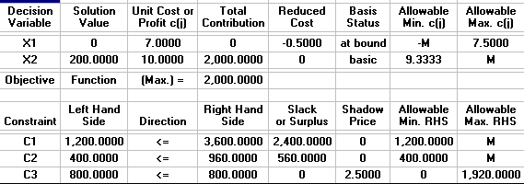

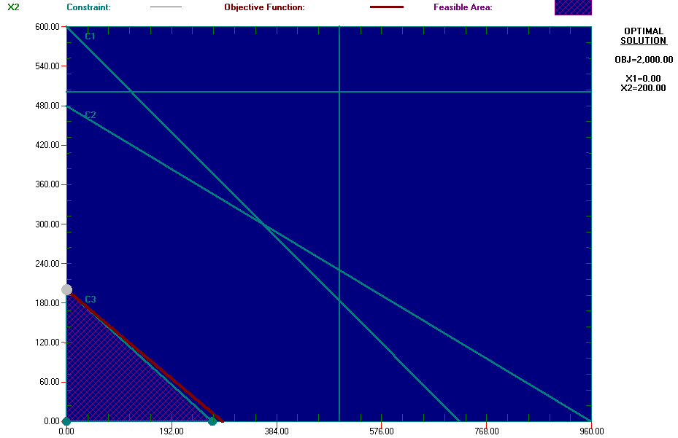

- Deletion of a constraint.
Wilson just inherited free cowhide from Europe, due to Mad Cow sickness. Rather than entirely waste a cow, the Europeans decided to give their hides away. Removing any constraint on how much cowhide they use per production run. This really didn’t change the amount of profit Wilson stands to gain because of the constraints that they can only produce 500 dozen baseballs and 500 dozen softballs per day. It might be a good time to beef up that limitation by adding new machinery. They will be producing more baseballs and less softball. The data and graphs are below.

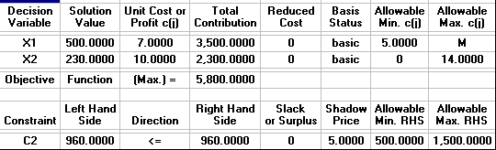

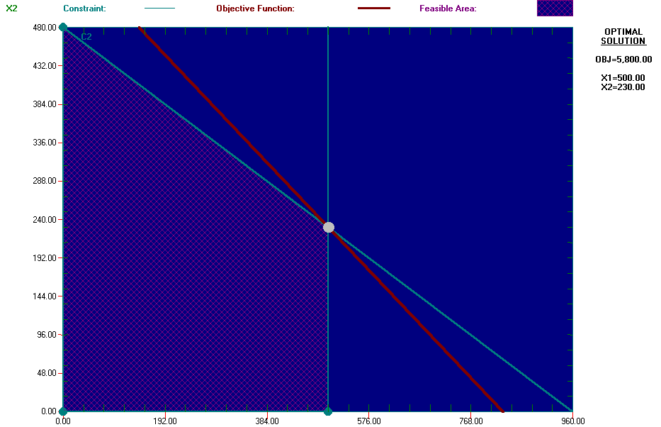

- Removal of a product.

Wilson finds that softball has been outlawed in the United States. What a bummer! Anyhow, as suspected, this allows them to produce as many baseballs as they can, 500 dozen per day. The data is below. There is no graph because the feasible region is basically a straight line at 500 dozen baseballs, with no Y coordinate.

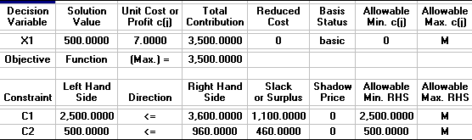

- Replace a constraint.

Wilson finds that it can produce baseballs in half the time after investing in a new “baseball maker machine.” Though this sounds like they should produce more baseballs, don’t forget the baseball generates less profit than the softball. Wilson would actually optimize its profit if they made more softballs than baseballs. The data and graphs are below.

