6.3) a) What is the optimal solution if the manager is optimistic?
This would be a maximax problem in which the optimal solution would be to select the highest of the max for each decision alternative. The max for each option is 1 commercial: 13, 2 commercials: 18, and 3 commercials: 22. The manager would choose 3 commercials because they anticipate the game will be exciting.
b) What is the optimal solution if the manager is pessimistic?
This would be a maximin problem in which the optimal solution would be to select the highest of the min for each decision alternative. The min for each option is 1 commercial: -2, 2 commercials: -5, and 3 commercials: -9. The manager would choose 1 commercial because they would anticipate the game being dull. They could also decide not to purchase a commercial slot at all, resulting in a profit of 0, but this would not be the worst case scenario.
c) What is the optimal solution if the manager wants to minimize the firm’s maximum regret?
In this problem the manager wants to pick the smallest of the max regrets. The optimal solution would be two commercials with a max regret of $4.
6.4) a) Expected Value of Return
EV (one commercial): .2(-2) + .4(3) + .3(7) + .1(13) = 4.2
EV (two commercials): .2(-5) + .4(6) + .3(12) + .1(18) = 6.8 or $680,000
EV (three commercials): .2(-9) + .4(5) + .3(13) + .1(22) = 6.3
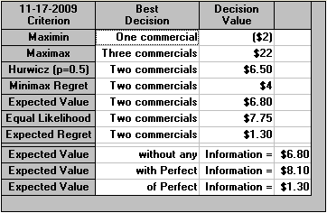
b) EVPI = ERPI – EREV
EREV = 6.8
ERPI = .2(-2) + .4(6) + .3(13) + .1(22) = 8.1
EVPI = 8.1 – 6.8 = 1.3 or $130,000

The WinQSB results for the National Foods problem are the same as my hand computations.

6.5)
Interesting
 | Prior Probabilities | Conditional Probabilities | Joint Probabilities | Posterior Probabilities
States of nature | P(A_{i}) | P(B| A_{i}) | P(A_{i}) x P(B| A_{i}) | P(A_{i}) x P(B| A_{i})/P(B)
Dull | .20 | .15 | .03 | .083
Average | .40 | .25 | .10 | .278
Above average | .30 | .50 | .15 | .417
Exciting | .10 | .80 | .08 | .222
 |  |  | P(B) = .36

Not Interesting
 | Prior Probabilities | Conditional Probabilities | Joint Probabilities | Posterior Probabilities
States of nature | P(A_{i}) | P(B| A_{i}) | P(A_{i}) x P(B| A_{i}) | P(A_{i}) x P(B| A_{i})/P(B)
Dull | .20 | .85 | .17 | .266
Average | .40 | .75 | .30 | .469
Above average | .30 | .50 | .15 | .234
Exciting | .10 | .20 | .02 | .031
 |  |  | P(B) = .64

a) Probability that the game will be dull if Jim predicts it will be interesting is 8.3%.

b) Optimal strategy for interesting: 3 commercials
EV (one commercial): .083(-200,000) + 0.278(300,000) + 0.417(700,000) + 0.222(1,300,000) = 6.47
EV (two commercials): .083(-500,000) + 0.278(600,000) + 0.417(1,200,000) + 0.222(1,800,000) = 10.25
EV (three commercials): .083(-900,000) + 0.278(500,000) + 0.417(1,300,000) + 0.222(2,200,000) = 10.94
Optimal Strategy for not interesting: 2 commercials
EV (one commercial): 0.266(-200,000) + 0.469(300,000) + 0.234(700,000) + 0.031(1,300,000) = 2.92
EV (two commercials): .266(-500,000) + 0.469(600,000) + 0.234(1,200,000) + 0.031(1,800,000) = 4.85
EV (three commercials): .266(-900,000) + 0.469(500,000) + 0.234(1,300,000) + 0.031(2,200,000) = 3.68
c) EVSI – ERSI – EREV
EREV = 6.8
ERSI = .36($1,094,800) + 0.64($485,300) = $704,720
EVSI = $704,720 - $680,000 = $24,720

WinQSB Output for Problem 6.5
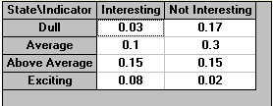
Joint probabilities
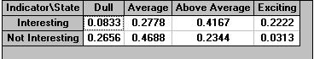
Posterior Probabilities
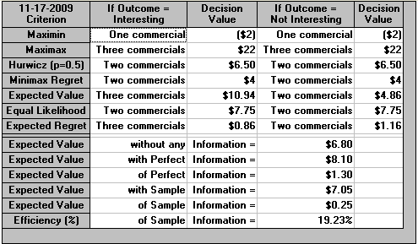
WinQSB outcome
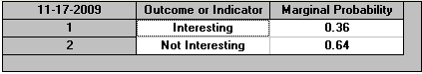
Marginal Probabilities
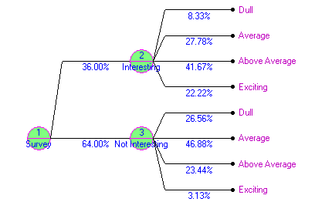
Decision Tree illustrating choices

6.34)
a) Risk neutral, expected payoff values. Steve should be willing to pay $580 for insurance.
0(.975) = 0
10,000(.010) = 100
20,000(.008) = 160
30,000(.004) = 120
50,000(.002) = 100
100,000(.001) = 100
580
b) What is the expected utility corresponding to fire damage? .9952
.975(1) = .975
.010(.95) = .0095
.008(.8) = .0064
.004(.75) = .003
.002(.65) = .0013
.001(0) = 0
.9952
c) Because the expected utility is equal to 1 Steve should be willing to spend about
$1,000.

