6.3
a. What is the optimal decision if the National Foods advertising manager is optimistic?
The optimal decision is to buy 3 commercials because if the manager is optimistic, he will expect the game to be exciting. 3 commercials brings the most profit if the game is exciting.
b. What is the optimal decision if the National Foods advertising manager is pessimistic?
The optimal decision is to buy 1 commercial if the manager is pessimistic. If he is pessimistic, he will expect the worst case scenario: that the game is dull. If the game is dull, the best option is to buy 1 commercial.
c. What is the optimal decision if the National Foods advertising manager wishes to minimize the firm’s maximum regret?
Max Regret Table:
Dull Average Above Average Exciting Max Regret
One 0 3 6 9 9
Two 3 0 1 4 4
Three 7 1 0 0 7
The manager should choose the option with the smallest of the max regrets. This would be to buy 2 commercials with a max regret of 4.
WinQSB Solution:
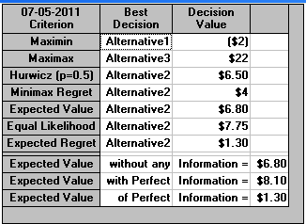
As shown, the WinQSB gives the same results as those calculated by hand.
6.4
P(dull game)=.2
P(Average Game)=.4
P(Above Average Game)=.3
P(Exciting Game)=.1
- EV(1 Commercial)=.2(-2)+.4(3)+.3(7)+.1(13)=4.2
EV(2 Commercials)=.2(-5)+.4(6)+.3(12)+.1(18)=6.8
EV(3 Commercials)=.2(-9)+.4(5)+.3(13)+.1(22)=6.3
Based on the expected value criterion, National Foods should purchase 2 commercials.
- EVPI=ERPI-EREV
ERPI=.2(-2)+.4(6)+.3(13)+.1(22)=8.1
EREV=6.8
EVPI=1.3
6.5
a. If Jim predicts the game will be interesting, the probability the game is dull is .08.

State of Nature Prior Prob. Conditional Prob. Joint Prob. Posterior Prob.
Dull .2 .15 .03 .08
Average .4 .25 .1 .28
Above Average .3 .5 .15 .42
Exciting .1 .8 .08 .22
P(interesting)=.36
State of Nature Prior Prob. Conditional Prob. Joint Prob. Posterior Prob.
Dull .2 .85 .17 .27
Average .4 .75 .3 .47
Above Average .3 .5 .15 .23
Exciting .1 .2 .02 .03
P(Not interesting)=.64
b.
EV(1 commercial)=.083(-2)+.278(3)+.417(7)+.222(13)=6.473
EV(2 commercials)=.083(-5)+.278(6)+.417(12)+.222(18)=7.4315
EV(3 commercials)=.083(-9)+.278(5)+.417(13)+.222(22)=10.948 or $1,094,800
If Jim predicts the game to be interesting, the optimal strategy would be to buy 3 commercials.
EV(1 commercial)=.266(-2)+.469(3)+.234(7)+.031(13)=2.916
EV(2 commercials)=.266(-5)+.469(6)+.234(12)+.031(18)=4.853 or $485,300
EV(3 commercials)=.266(-9)+.469(5)+.234(13)+.031(22)=3.675
If Jim predicts the game to not be interesting, the optimal strategy would be to buy 2 commercials.

c. EVSI – ERSI – EREV
EREV = $680,000
ERSI = .36($1,094,800) + 0.64($485,300) = $704,720
EVSI = $704,720 - $680,000 = $24,720
Marginal Probability:
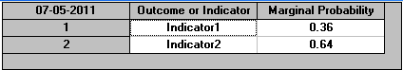
Posterior Probability:
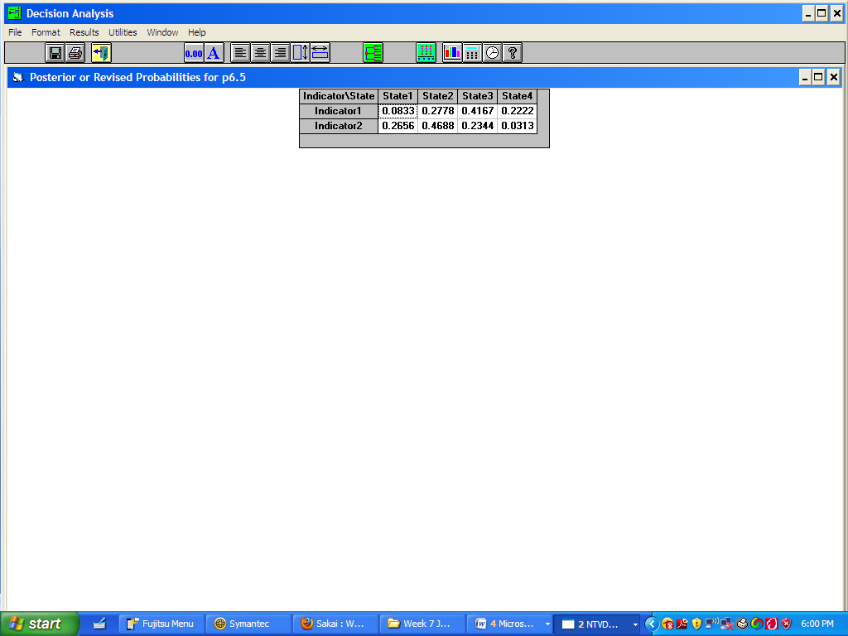
Joint Probability:
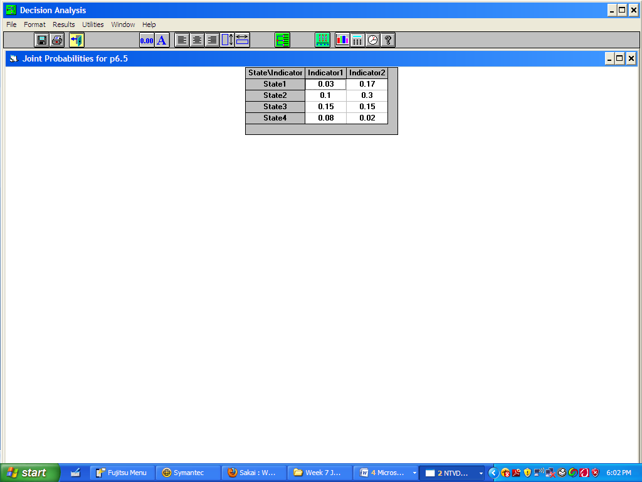
The payoff decision table from WinQSB confirms the results from my hand calculations.
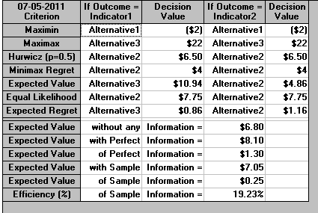
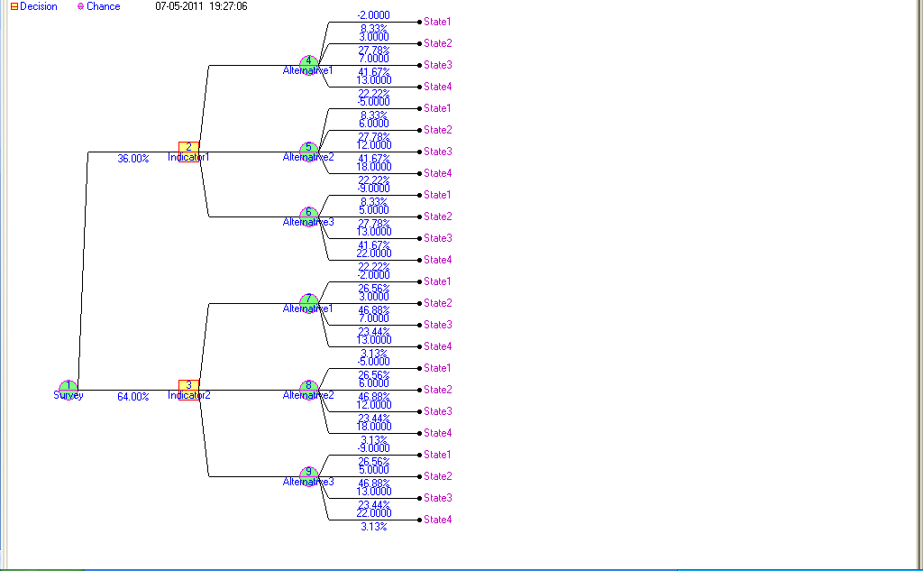
6.34
Steve Greene is considering purchasing fire insurance for his home. According to statistics for Steve’s county, Steve estimates the damage from fire to his home in a given year is as follows:

Amount of Damage Probability
0 .975
$10,000 .010
$20,000 .008
$30,000 .004
$50,000 .002
$100,000 .001

a. If Steve is risk neutral, how much should he be willing to pay for the fire insurance?
EV=. 975(0) + 0.010(10000)+ 0.008(20000)+ 0.004(30000)+ 0.002(50000)+ 0.001(100000)=580
He should be willing to pay $580.
b. Suppose Steve’s utility values are as follows:

Amount of Loss ($1000s)
100 50 30 20 10 1 0
Utility 0 .65 .75 .8 .95 .995 1
What is the expected utility corresponding to fire damage?

EV=.975(1)+.01(.95)+.008(.8) +.004(.75)+.002(.65)+.001(0)=.9952
The expected utility is .9952.
- Since the expected utility of .9952 is approximately 1, he should be willing to pay about $1000 for fire insurance.

