Assignment: Do problems 6.1, and 6.2 by hand and WinQSB applications

Problem 6.1
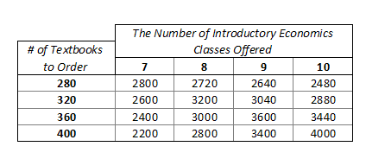
The Campus Bookstore at East Tennessee State University must decide how many economics textbooks to order for the next semester’s class. The bookstore believes that seven, eight, nine or ten sections of the course will be offered next semester; each section contains 40 students. The publisher is offering bookstores a discount if they place their orders early. If the bookstore orders too few texts and runs out, the publisher will air express additional books at the bookstore’s expense. If it orders too many texts, the store can return unsold texts to the publisher for a partial credit. The bookstore is considering ordering either, 280, 320, 360 or 400 texts in order to get the discount. Taking into account the discounts, air express expenses, and credits for returned texts, the bookstore manager estimates the following resulting profits.
States
Of
Nature

Decision Alternatives
(In bold)

- What is the optimal decision if the bookstore manager uses the maximax criterion?

An optimistic, and/or aggressive decision maker feels that any decision they make will bring the best outcome. So, they would most likely go for the maximax criterion that brings the maximum profit for each decision alternative. They would select the one that has the highest (max) “maximum payoff” (this could stand for the max profits, or the min cost). If you take a look at the chart, ordering the last decision alternative of 400 textbooks would bring the maximum payoff of 4000 within each possible state of nature.

- What is the optimal decision if the bookstore manager uses the maximin criterion?

If an individual uses maximin criterion, they are typically basing their decisions on where they would reach maximum profits give the occurrence of the “worst-case scenario.” First, you would find the minimum payoff for each decision alternative (# of textbooks to order). Then, the optimal decision is the one that maximizes the minimum payoff. So,

280 has a minimum of 2480
320 has a minimum of 2600 Out of these, 2600 is the highest, or maximum, minimum payoff.
360 has a minimum of 2400
400 has a minimum of 2200

Therefore, the optimal decision based on maximum criterion would be ordering 320 textbooks, which would gain them the highest (max) minimum payoff of 2600.
- What is the optimal decision if the bookstore manager uses the minimax regret criterion?

This decision is usually based on “lost opportunity” or “regret” rather than costs. It involves calculating the regret or lost opportunity corresponding to each criterion on calculated regret values. One incurs regret by “failing” to choose the “best” decision (the one with the highest profit or lowest cost). Depending on the state of nature, you can find the max payoff for each state of nature. Then, you would recalculate the regret corresponding to the decision alternative as the difference between its payoffs. So, the maximum payoffs per state of nature are highlighted in the chart below.

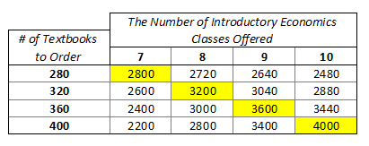

The following chart displays the differences between the max payoffs per state of nature (highlighted above) and the other decisions alternatives for each state of nature.
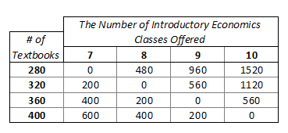
For 280, the maximum regret is 1520
For 320, the maximum regret is 1120
For 360, the maximum regret is 560
For 400, the maximum regret is 600

Therefore, the optimal decision based on minimax regret criterion would be ordering 360 textbooks because it has the lowest (minimum) maximum regret of 560 out of all the decision alternatives.

My Decision:
I would most likely chose the maximax criterion to make my decisions. I am an extremely optimistic person and would anticipate good results based on my decision. Plus, if I have more left over, I could just as easily sell the books to someone else (ex. Amazon.com). There are multitudes of students who purchase school books on sites like Amazon or EBay. I could potential gain more by doing so rather than selling the books back to the publisher. You can’t expect any decision to be completely stable; however, I believe my decision would have greatest stability because if you consider the course for which I am order books, it is likely the classes will fill up and books will sell. Economics classes are typically general education classes for business majors; therefore, chances are, students will be eager to take the course so they can move on with their program of study.

Problem 6.2

Consider the data given in problem 1 for the Campus Bookstore at ETSU. Based on conversations with the chair of the economics department, suppose the bookstore manager believes that the following probabilities hold:

P (7 classes offered) = .10
P (8 classes offered) = .30
P (9 classes offered) = .40
P (10 classes offered) = .20

- Using the expected value criterion, determine how many economics books the bookstore manager should purchase in order to maximize the store’s expected profit. Do you think the expected value criterion is appropriate for this problem?
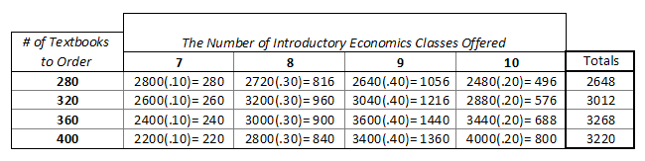

EV (280) = $2648
EV (320) = $3012
EV (360) = $3268
EV (400) = $3220

The optimal decision would be ordering 360 textbooks because this decision has the highest expected value (EV) of $3268 considering the probabilities per state of nature.

Considering that the expected value criterion only declares that the decision will be optimal in the long run, it does not seem to be appropriate criterion in this specific situation. The manager is facing the problem only in the short run, one time; so, supporting an optimal decision exclusively on expected value may not be optimal.

- Based on the probabilities given in part (a), determine the expected value of perfect information and interpret its meaning.

The expected value of perfect information (EVPI) can be found by subtracting the expected return using the expected value criterion (EREV) from the expected return with perfect information (ERPI).

(EVPI = ERPI – EREV)

ERPI:
2800(.10) + 3200(.30) + 3600(.40) + 4000(.20) = 3480
EREV = 3268 (calculations can be found in part a. of this problem)

So, ERPI (3480) – EREV (3268) = EVPI (212)

EVPI = 212

The EVPI represents the gain in the expected return resulting from knowledge of ERPI and EREV. Though it is impossible to have perfect information regarding any future situation, it is helpful, given these two pieces of information (ERPI and EREV) in finding the upper value of and sample information.

Below are the WinQSB results:

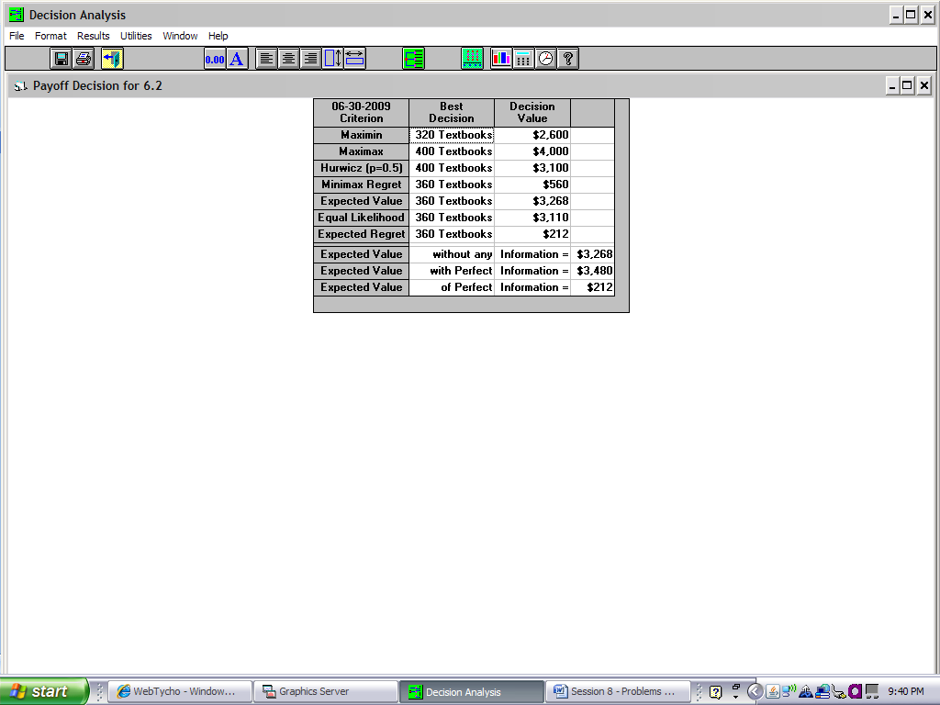

Analysis of My Decision:
As shown by the WinQSB results, ordering 360 textbooks seems to be the best decision considering all criterions. Perhaps, my previous decision ordering 400 textbook is less stable than expected. The smart choice would probably be ordering 360 books because many of the results state it as the optimal decision. In decision making under pure uncertainty, the decision-maker has no knowledge regarding which state of nature is "most likely" to happen. He or she is probabilistically ignorant concerning the state of nature therefore he or she cannot be optimistic or pessimistic. In such a case, the decision-maker invokes consideration of security. I would feel secure choosing to order 360 books based on the WinQSB results; however, there is no guarantee this will be the best choice.

**Computer Assignments section of HW is below; this will explain the WinQSB results shown above**

WinQSB Computational Tool:
Select Da.exe "Decision Analysis" module then perform some numerical experiment for deeper understanding of the concepts. For example, you may like checking your hand-computations for the homework problem(s), or checking the numerical examples from your textbook. Submit along with the rest of your homework, a short report entitle "Computer Assignments" describing your findings. As a starting point (worth 20%).

“COMPUTER ASSIGNMENTS”

I began by checking my hand-computations for homework problems 6.1 and 6.2.

Results:

As you can see, the WinQSB results show that my hand-computation for 6.1 and 6.2 are correct. As indicated in the preceding pages of this assignment, I found the highest (max) maximum payoff is 4000 by purchasing 400 textbooks, which is shown in the “Maximax” column. I also found the highest (max) minimum payoff is 2600, by purchasing 320 textbooks; this is shown in the “Maximin” column above. I also found that the minimum maximum regret if the manager chose the wrong option would be 560; this is indicated in the “minimax regret” column.

Here are my hand-computations for the Expected Value criterion (EV): (below)

The red box indicated the maximum Expected Return using EV criterion (EREV) of 3268 (shown in WinQSB results). Then I determined ERPI, Expected Value w/ Perfect Information (2800(.10) + 3200(.30) + 3600(.40) + 4000(.20) = 3480). Finally, I found the EV of Perfect Information (EVPI) by using the formula: EVPI = ERPI – EREV; therefore, 3480 – 3268 = 212. The EVPI represents the gain in the expected return resulting from knowledge of ERPI and EREV. Though it is impossible to have perfect information regarding any future situation, it is finding the upper value of and sample information if one were trying to ensure a certain possible range of potentially EVPI. Therefore, EVPI cannot go higher than 212 in this situation.

The best decision in this situation would most likely be purchasing 360 textbooks. While there is no guarantee this will be the best choice, it seems to be the optimal decision because it is recognized as the best or most frequent criterion chosen by the WinQSB results and my calculation.

