HW: Graph the following feasible region, find the coordinated of the corner points.
x1+2x2 <= 40
4x1+3x2 <=120
All variables are non-negative

Blue line = x1+2x2=40
Red line = 4x1+3x2=120

Corner points | X1 | X2
a | 0 | 0
b | 30 | 0
c | 24 | 8
d | 0 | 20

What about this problem?
x1>=4
4x1+2x2<=8
x2 >=6
All variables are non-negative

Blue line = x1=4
Red line = 4x1+2x2=8
Green line = x2=6

What about this problem?
x1>=4
x2 >=2
All variables are non-negative

Blue line = x1=4
Green line = x2=2

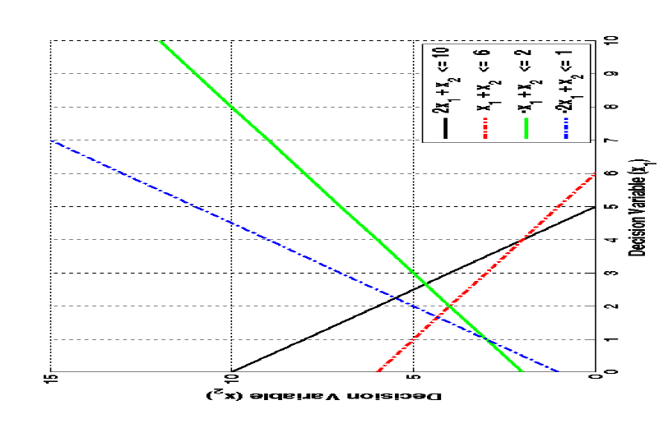
Max X1 + 2X2

Subject to: 2X1 + X2 ≤10
X1 + X ≤ 6
-X1 + X2 ≤ 2
-2X1 + X2 ≤ 1
X1 ≥ 0, X2 ≥ 0
By trying all feasible vertices we will find that, the optimal solution occurs at vertex X1 = 2, X2 = 4, with optima value of X1 + 2X2 = 10,

