“What-If” Analysis on Problem 2.7
- For my first “What-If,” I am going to make a change with the amount of profit made on each baseball. I would assume that the production of baseballs would definitely increase, which would also cause the production of softballs to decrease. This would also increase the total profits by a decent amount because the change in price is $2.50. The surplus of baseballs will also decrease and the exact opposite will happen with the softballs. I’m not too sure what would happen with the sensitivity or right hand side analysis. When I ran the test, everything that I thought would change did and in the direction that I had anticipated. Please refer to following setup, calculations, and graphs for a visual interpretation.
Variable | Baseball | Softball | Direction | RHS
Maximize | 9.5 | 10
Cowhide | 5 | 6 | <= | 3600
Time | 1 | 2 | <= | 960
Baseballs | 1 |  | <= | 500
Softballs |  | 1 | <= | 500
Lower-bound | 0 | 0
Upper-bound | M | M
Variable Type | Continuous | Continuous

 | Decision Variable | Solution Value | Profit c(j) | Tot. Contribution | Reduced Cost | Basis | Allowable Min. c(j) | Allowable Max. c(j)
1 | X1 | 500 | 9.5 | 4,750.00 | 0 | basic | 8.3333 | M
2 | X2 | 183.3333 | 10 | 1,833.33 | 0 | basic | 0 | 11.4
 | Objective | Function | (Max.) = | 6,583.33
 |  | LHS | Direction | RHS | Surplus | Shadow Price | Allowable Min. RHS | Allowable Max. RHS
 | Constraint
1 | C1 | 3,600.00 | <= | 3,600.00 | 0 | 1.6667 | 2,500.00 | 3,880.00
2 | C2 | 866.6666 | <= | 960 | 93.3333 | 0 | 866.6667 | M
3 | C3 | 500 | <= | 500 | 0 | 1.1667 | 360 | 720
4 | C4 | 183.3333 | <= | 500 | 316.6667 | 0 | 183.3333 | M

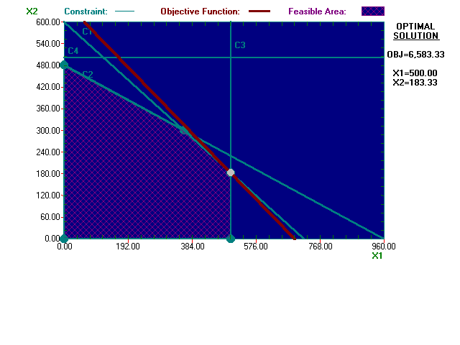
- In the second one, I added another variable, but I didn’t change any of the constraints. Along with the baseball and softball, I decided that producing a semi-hardball would be a good idea because kids that play T-Ball do not use hard balls, but ones that have some cushion to them so the kids don’t get hurt. In reviewing the current information the way it is, I would have to say that nothing is going to change because there is no cowhide or production hours left and the price of the T-Ball is less than the baseball and softball. There would be no reason to change the current production to add a third product that is not going to increase the profits. After I ran the program, what I had anticipated did happen. There were actually two solutions. The first solution showed no change, but there was also an alternate solution. I am not including the first chart because there wasn’t any change. The second solution did not change the amount of profits made, but it did change the amount of baseballs produced. The softballs stayed the same and the total amount of T-balls would be produced.
Variable |  | Baseball |  | Softball |  |  | T-Ball |  | Direction |  | RHS
Maximize |  | 7 |  | 10 |  |  | 3.5
Cowhide |  | 5 |  | 6 |  |  | 2.5 |  | <= |  | 3600
Time |  | 1 |  | 2 |  |  | 0.5 |  | <= |  | 960
Baseballs |  | 1 |  |  |  |  |  |  | <= |  | 500
Softballs |  |  |  | 1 |  |  |  |  | <= |  | 500
T-Balls |  |  |  |  |  |  | 1 |  | <= |  | 250
Lower-Bound |  | 0 |  | 0 |  |  | 0
Upper-Bound |  | M |  | M |  |  | M
Variable Type |  | Continuous |  | Continuous |  |  | Continuous
 | Decision Variable |  | Solution Value |  | Profit c(j) | Total Contribution |  | Reduced Cost |  | Basis Status |  | Allowable Min. c(j) | Allowable Max. c(j)
1 | Baseballs |  | 235 |  | 7 | 1,645.00 |  | 0 |  | basic |  | 5 | 7
2 | Softballs |  | 300 |  | 10 | 3,000.00 |  | 0 |  | basic |  | 8.4 | 14
3 | T-Balls |  | 250 |  | 3.5 | 875 |  | 0 |  | basic |  | 3.5 | M
 | Objective |  | Function |  | (Max.) = | 5,520.00
 | Constraint |  | LHS |  | Direction | RHS |  | Surplus |  | Shadow Price |  | Allowable Min. RHS | Allowable Max. RHS
1 | Cowhide |  | 3,600.00 |  | <= | 3,600.00 |  | 0 |  | 1 |  | 3,130.00 | 4,130.00
2 | Time |  | 960 |  | <= | 960 |  | 0 |  | 2 |  | 783.3333 | 1,116.67
3 | Baseballs |  | 235 |  | <= | 500 |  | 265 |  | 0 |  | 235 | M
4 | Softballs |  | 300 |  | <= | 500 |  | 200 |  | 0 |  | 300 | M
5 | T-Balls |  | 250 |  | <= | 250 |  | 0 |  | 0 |  | 0 | 720

Clearly asking for graphical method is meaningless because the problem is not a 2-dimensional one. But if you ask you get the following which has wrong solution (does not agree with the tabular one)

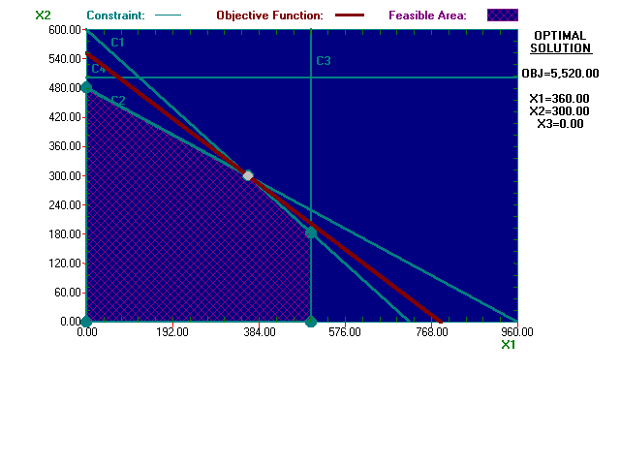
- This time I tried changing one of the constraints. I increased the amount of available cowhide by 400 units to 4000. I would expect the production of both products to increase especially the softballs because Wilson makes more money off of them. There is going to be some cowhide left over because there is no increase in production hours, which means that there will not be enough time to use up all of the cowhide. There will also be an increase in profits as a result of increased production. When I ran the calculations, I was correct about the increase in profits, increase in overall production, and left over cowhide. However, I was incorrect about the how the production would change between the baseballs and softballs. I did not expect the softballs to decrease and the baseballs to increase. Please refer to the following tables and graph for a visual representation.
Variable | Baseball | Softball | Direction | RHS
Maximize | 7 | 10
Cowhide | 5 | 6 | <= | 4000
Time | 1 | 2 | <= | 960
Baseballs | 1 |  | <= | 500
Softballs |  | 1 | <= | 500
Lower-Bound | 0 | 0
Upper-Bound | M | M
Variable Type | Continuous | Continuous

 | Decision Variable | Solution Value | Profit c(j) | Total Contribution | Reduced Cost | Basis Status | Allowable Min. c(j) | Allowable Max. c(j)
1 | Baseball | 500 | 7 | 3,500.00 | 0 | basic | 5 | M
2 | Softball | 230 | 10 | 2,300.00 | 0 | basic | 0 | 14
 | Objective | Function | (Max.) = | 5,800.00
 | Constraint | LHS | Direction | RHS | Surplus | Shadow Price | Allowable Min. RHS | Allowable Max. RHS
1 | Cowhide | 3,880.00 | <= | 4,000.00 | 120 | 0 | 3,880.00 | M
2 | Time | 960 | <= | 960 | 0 | 5 | 500 | 1,000.00
3 | Baseballs | 500 | <= | 500 | 0 | 2 | 0 | 560
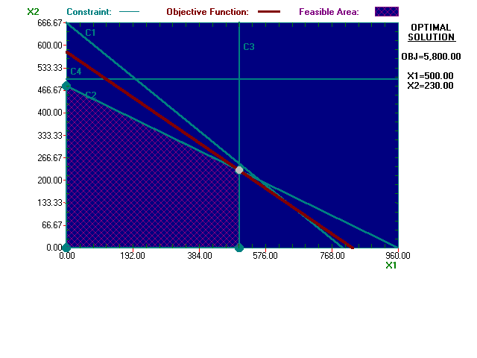  4 | Softballs | 230 | <= | 500 | 270 | 0 | 230 | M

- For this one, I am increasing both constraints and I expect to see an increase in all of the calculations. Unlike the previous example, I don’t expect a lot of cowhide and time left over after production. The profits are obviously going to increase with more cowhide and time available. After I ran the calculations, I was a little surprised with the results that I received after increasing both amounts. Production and profits increased like I had expected it to, but everything else pretty much stayed the same. The shadow price, maximum and minimum range for the objective coefficient and range for the RHS analysis did not change. The surplus went down, which means that more of the materials are being used right away instead of stored away.

Variable | Baseball | Softball | Direction | RHS
Maximize | 7 | 10
Cowhide | 5 | 6 | <= | 4000
Time | 1 | 2 | <= | 1000
Baseballs | 1 |  | <= | 500
Softballs |  | 1 | <= | 500
Lower-Bound | 0 | 0
Upper-Bound | M | M
Variable Type | Continuous | Continuous

 | Decision Variable | Solution Value | Profit c(j) | Total Contribution | Reduced Cost | Basis Status | Allowable Min. c(j) | Allowable Max. c(j)
1 | X1 | 500 | 7 | 3,500.00 | 0 | basic | 5 | 8.3333
2 | X2 | 250 | 10 | 2,500.00 | 0 | basic | 8.4 | 14
 | Objective | Function | (Max.) = | 6,000.00
 | Constraint | LHS | Direction | RHS | Surplus | Shadow Price | Allowable Min. RHS | Allowable Max. RHS
1 | C1 | 4,000.00 | <= | 4,000.00 | 0 | 1 | 3,000.00 | 4,000.00
2 | C2 | 1,000.00 | <= | 1,000.00 | 0 | 2 | 1,000.00 | 1,200.00
3 | C3 | 500 | <= | 500 | 0 | 0 | 500 | M
4 | C4 | 250 | <= | 500 | 250 | 0 | 250 | M

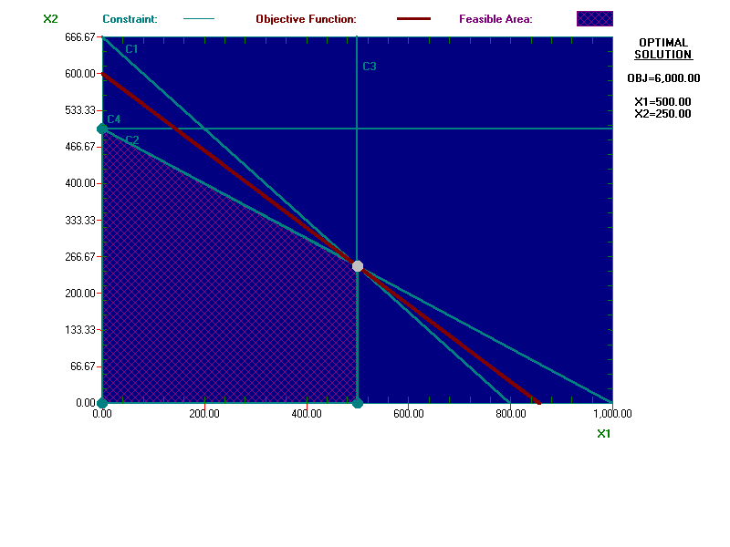
- This next “What-If” calculation involved changing the amount of cowhide required for each baseball and softball without increasing the available amount. I increased each one by 1unit. I would expect that the overall profits would decrease. I would also say that the production of softballs would increase and decrease for the baseballs. I am saying this because the amount of resources available has decreased now, which means that Wilson Manufacturing is going to want to maximize their profits with what they have. Because they make more money off of the softballs, they would definitely make a push to produce more of them instead of the baseballs. I don’t think that there will be that much of a difference in production amounts, but enough to offset the increase in production requirements so they can stay near the original optimal level. After I ran the program, I was really surprised by these results. The program said to make pretty much all softballs and hardly any baseballs. I expect the baseballs to decrease, but not by a couple of hundred. The surplus of baseballs explodes to an enormously high number. The shadow prices also went down as well as the profit, which is what I had expected. The following tables and graphs give more of a visual explanation.
Variable |  |  | Baseball |  | Softball |  |  | Direction |  | RHS
Maximize |  |  | 7 |  | 10
Cowhide |  |  | 6 |  | 7 |  |  | <= |  | 3600
Time |  |  | 1 |  | 2 |  |  | <= |  | 960
Baseballs |  |  | 1 |  |  |  |  | <= |  | 500
Softballs |  |  |  |  | 1 |  |  | <= |  | 500
Lower-Bound |  |  | 0 |  | 0
Upper-Bound |  |  | M |  | M
 |  |  | Continuous |  | Continuous
 | Decision Variable | Solution Value |  | Profit c(j) |  | Total Contribution | Reduced Cost |  | Basis Status |  | Allowable Min. c(j) | Allowable Max. c(j)
1 | Baseball | 96 |  | 7 |  | 672 | 0 |  | basic |  | 5 | 8.5714
2 | Softball | 432 |  | 10 |  | 4,320.00 | 0 |  | basic |  | 8.1667 | 14
 | Objective | Function |  | (Max.) = |  | 4,992.00
 | Constraint | LHS |  | Direction |  | RHS | Surplus |  | Shadow Price |  | Allowable Min. RHS | Allowable Max. RHS
1 | Cowhide | 3,600.00 |  | <= |  | 3,600.00 | 0 |  | 0.8 |  | 3,360.00 | 4,610.00
2 | Time | 960 |  | <= |  | 960 | 0 |  | 2.2 |  | 671.4286 | 1,016.67
3 | Baseballs | 96 |  | <= |  | 500 | 404 |  | 0 |  | 96 | M
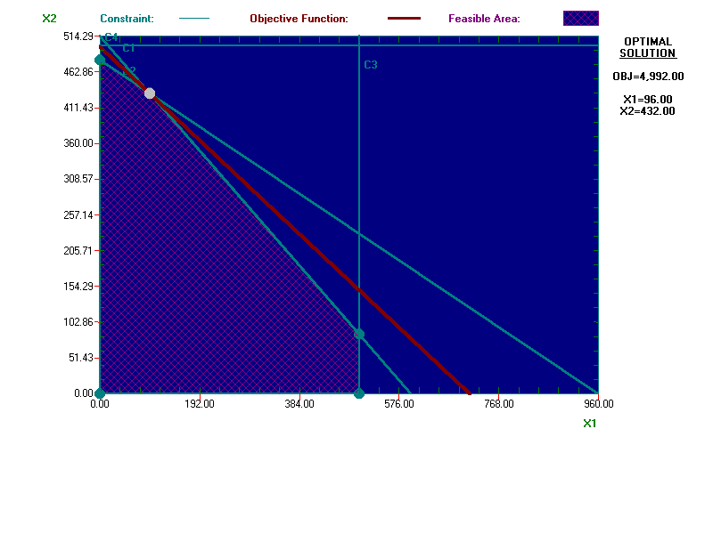  4 | Softballs | 432 |  | <= |  | 500 | 68 |  | 0 |  | 432 | M
- For this analysis, I added the production of 2 more products, baseball and softball gloves, and increased the available amounts of cowhide and production time. This “What-If” is rather hard to predict because there are many more options as a result of adding two more products and increasing all of the resources. Prices, amount of cowhide, and time it takes to make each glove will be twice as much as their respective ball. I am going to increase the amounts of each resource by 2000 units. The profits are definitely going to increase as well as production of each product. I would say that the amount of softballs produced is going to increase more than the baseballs. There will probably be a surplus both kinds of gloves because a total of 1000 can be produced of each one. After I ran the program, I was definitely surprised by the results. I did not even imagine that the numbers would turn out the way they did. There was an alternate solution to the problem, but it really didn’t change the production plan at all. The first solution said to produce nothing but softball gloves. There is no feasible region because nothing else is going to be produced. The profits were a little over $9000, but I didn’t think that only producing one product would be a possibility. It also stated that Wilson would lose money if they decided to produce baseballs and or baseball gloves. The aforementioned results obviously meant that there would be an extremely large amount of surplus left over of each product and resource. Now the second solution was not that much different or better. The profits did not change at all, but production schedule did a little bit. Instead of only producing softball gloves, softballs would also be produced. Actually, they were advised to produce more softballs than gloves made to maximize profits. This may not be that bad because the products do go hand-in-hand with each other. Maybe they could specialize in making these two products. It probably wouldn’t be a good idea, but it is a possibility. Everything else pretty much stayed the same as it was in the first solution. Please refer to the following charts and graphs for more details.
Variable | Baseball | Softball | BB Glove | SB Glove | Direction | RHS
Maximize | 7 | 10 | 14 | 20
Cowhide | 5 | 6 | 10 | 12 | <= | 5600
Time | 1 | 2 | 2 | 4 | <= | 2960
Baseballs | 1 |  |  |  | <= | 500
Softballs |  | 1 |  |  | <= | 500
BB Gloves |  |  | 1 |  | <= | 1000
SF Gloves |  |  |  | 1 | <= | 1000
Lower-Bound | 0 | 0 | 0 | 0
Upper-Bound | M | M | M | M
Variable Type | Continuous | Continuous | Continuous | Continuous

A | Decision Variable |  | Solution Value |  | Profit c(j) |  | Total Contribution |  | Reduced Cost |  | Basis Status |  | Allowable Min. c(j) |  | Allowable Max. c(j)
1 | Baseball |  | 0 |  | 7 |  | 0 |  | -1.3333 |  | at bound |  | - M |  | 8.3333
2 | Softball |  | 0 |  | 10 |  | 0 |  | 0 |  | at bound |  | - M |  | 10
3 | BB Glove |  | 0 |  | 14 |  | 0 |  | -2.6667 |  | at bound |  | - M |  | 16.6667
4 | SB Glove |  | 466.6667 |  | 20 |  | 9,333.33 |  | 0 |  | basic |  | 20 |  | M
 | Objective |  | Function |  | (Max.) = |  | 9,333.33
 | Constraint |  | LHS |  | Direction |  | RHS |  | Surplus |  | Shadow Price |  | Allowable Min. RHS |  | Allowable Max. RHS
1 | Cowhide |  | 5,600.00 |  | <= |  | 5,600.00 |  | 0 |  | 1.6667 |  | 0 |  | 8,880.00
2 | Time |  | 1,866.67 |  | <= |  | 2,960.00 |  | 1,093.33 |  | 0 |  | 1,866.67 |  | M
3 | Baseball |  | 0 |  | <= |  | 500 |  | 500 |  | 0 |  | 0 |  | M
4 | Softball |  | 0 |  | <= |  | 500 |  | 500 |  | 0 |  | 0 |  | M
5 | BB Glove |  | 0 |  | <= |  | 1,000.00 |  | 1,000.00 |  | 0 |  | 0 |  | M
6 | SB Glove |  | 466.6667 |  | <= |  | 1,000.00 |  | 533.3333 |  | 0 |  | 466.6667 |  | M
B |  | Decision Variable |  | Solution Value |  | Profit c(j) |  | Total Contribution |  | Reduced Cost |  | Basis Status |  | Allowable Min. c(j) |  | Allowable Max. c(j)
1 |  | Baseball |  | 0 |  | 7 |  | 0 |  | -1.3333 |  | at bound |  | - M |  | 8.3333
2 |  | Softball |  | 500 |  | 10 |  | 5,000.00 |  | 0 |  | basic |  | 10 |  | M
3 |  | BB Glove |  | 0 |  | 14 |  | 0 |  | -2.6667 |  | at bound |  | -16.6667 |  | 16.6667
4 |  | SB Glove |  | 216.6667 |  | 20 |  | 4,333.33 |  | 0 |  | basic |  | 16.8 |  | 20
 |  | Objective |  | Function |  | (Max.) = |  | 9,333.33
 |  | Constraint |  | LHS |  | Direction |  | RHS |  | Surplus |  | Shadow Price |  | Allowable Min. RHS |  | Allowable Max. RHS
1 |  | Cowhide |  | 5,600.00 |  | <= |  | 5,600.00 |  | 0 |  | 1.6667 |  | 3,000.00 |  | 8,880.00
2 |  | Time |  | 1,866.67 |  | <= |  | 2,960.00 |  | 1,093.33 |  | 0 |  | 1,866.67 |  | M
3 |  | Baseball |  | 0 |  | <= |  | 500 |  | 500 |  | 0 |  | 0 |  | M
4 |  | Softball |  | 500 |  | <= |  | 500 |  | 0 |  | 0 |  | 0 |  | 933.3334
5 |  | BB Glove |  | 0 |  | <= |  | 1,000.00 |  | 1,000.00 |  | 0 |  | 0 |  | M
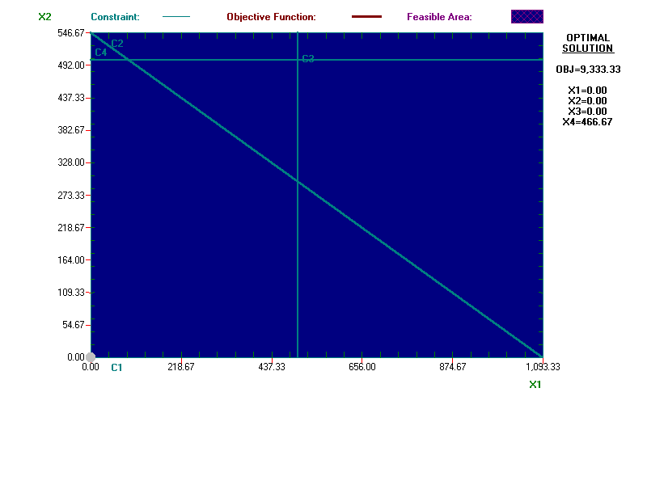  6 |  | SB Glove |  | 216.6667 |  | <= |  | 1,000.00 |  | 783.3333 |  | 0 |  | 216.6667 |  | M

7) For my last “What-If,” I am going to take out one of the constraints. The constraint that I have decided to get rid of is the amount of it takes to make each product. By doing this, the only constraint that should come into play is the amount of cowhide available. I would expect to see production of softballs increase substantially and the production of baseballs is going to decrease. The reason for this is the simple fact that Wilson makes more money selling the softballs. Therefore they are going to make as many as possible and then use the rest of the cowhide to make baseballs. This means that profits will also increase. There will be very little surplus of cowhide with a decent amount for baseballs. There will be no softballs remaining. When I ran the calculations, everything that I predicted happened. Please refer to the charts and graphs for visuals.
Variable | Baseball | Softball | Direction | RHS
Maximize | 7 | 10
Cowhide | 5 | 6 | <= | 3600
Baseballs | 1 |  | <= | 500
Softballs |  | 1 | <= | 500
Lower-Bound | 0 | 0
Upper-Bound | M | M
Variable Type | Continuous | Continuous

 | Decision Variable | Solution Value | Profit c(j) | Total Contribution | Reduced Cost | Basis Status | Allowable Min. c(j) | Allowable Max. c(j)
1 | Baseball | 120 | 7 | 840 | 0 | basic | 0 | 8.3333
2 | Softball | 500 | 10 | 5,000.00 | 0 | basic | 8.4 | M
 | Objective | Function | (Max.) = | 5,840.00
 | Constraint | LHS | Direction | RHS | Surplus | Shadow Price | Allowable Min. RHS | Allowable Max. RHS
1 | Cowhide | 3,600.00 | <= | 3,600.00 | 0 | 1.4 | 3,000.00 | 5,500.00
2 | Baseball | 120 | <= | 500 | 380 | 0 | 120 | M
3 | Softball | 500 | <= | 500 | 0 | 1.6 | 183.3333 | 600
