Sensitivity Analysis: Review the Sensitivity Analysis section of the course lecture notes. Apply the right-hand-side (RHS) value and coefficients of the objective function (known as the cost coefficients, because historically during World War II, the first LP problem was a cost minimization problem) sensitivity range to problem 2.7 in Ch. 2, computer implementation together with managerial interpretations of the computer solution. Construct the dual problem, solve it and then provide economical interpretations for the dual and its solution. To construct the dual of a given problem by using WinQSB, click on Format, then select "Switch to the Dual Form".
- Sensitivity analysis (or post-optimality analysis) is used to determine how the optimal solution is affected by changes, within specified ranges, in:
  - the objective function coefficients
  - the right-hand side (RHS) values
- Sensitivity analysis is important to the manager who must operate in a dynamic environment with imprecise estimates of the coefficients.

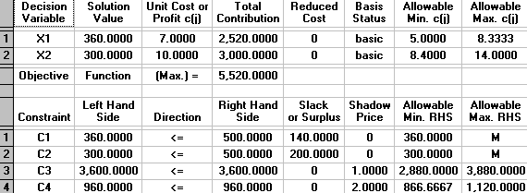

Wilson estimates that its profit is $7 per dozen baseballs and $10 per dozen for softballs.

Max 7X1+10X2 (Objective Function)

360 | 300 | 7(360)+10(300)= | 5520
Optimal Solution

The optimal solution for Wilson Manufacturing was determined to be 360 baseballs @ $7.00 and 300 softballs @10.00 which will give them the maximized profit of $5,520.00. As a manager there may be various questions as to how sensitive the stated optimal solution is due to some of the below situations:

- Input parameters may not have been known with certainty but are approximations or best estimates.
- The prototype for the balls may have been formulated in a dynamic environment in which some of the parameters are subject to change the size of the balls.
- The manager may want to simply wish to perform a “what-if” analysis resulting from changes to some of the inputs not known at the time when the optimal solution is configured.
In the above chart you can see that there are columns shown as Allowable Min. & Allowable Max. In these columns the numbers listed will give you the range in which each input can be changed without the optimal solution changing. As you can see X1 has a range of 5 to 8.3333 and the soft balls has a range of 8.4 to 14. This information will allow the manager to be informed on how much a change in production to expect if those variables change.

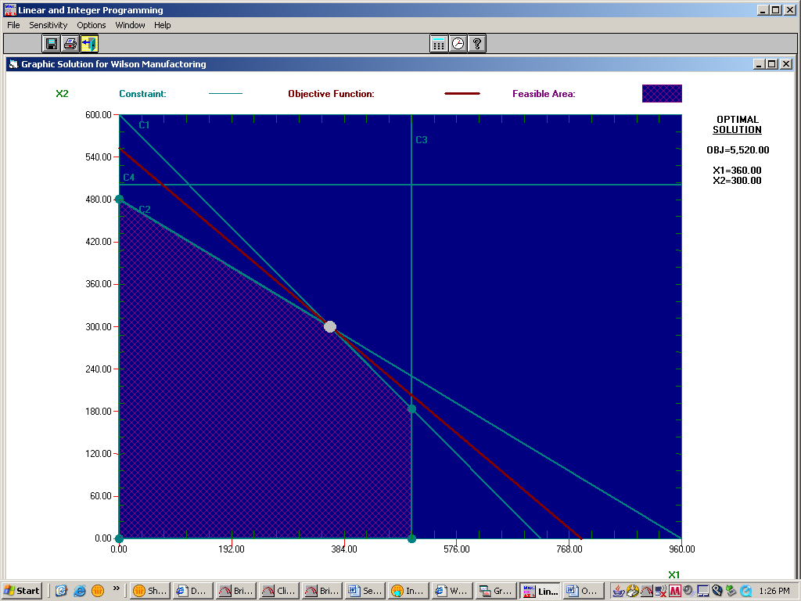

RHS Sensitivity Analysis for Problem 2.7
Calculations shown on graph below

The right hand side (RHS) analysis deals with the effect of a single unit change to the total number of binding constraints on the optimal value, or profits. The single unit change is otherwise known as the shadow price. The shadow price is the amount the company will gain for every 1 unit increase of resources. For Wilson Manufacturing, the first binding constraint (C1) is the limitations on use of cowhide, which is represented in my calculations by 5X₁ + 6X₂ ≤ 3600. C1 has a shadow price of 1, which means if units of cowhide increase by 1 unit, then W.M. will gain a profit of $1. Similarly, the second constraint (C2) is the allowable production time of Wilson’s Manufacturing, represented by 1X₁+ 2X₂ ≤ 960. C2 has a shadow price of 2, meaning if production time increase by 1 unit, then W.M. will gain $2 profit. The RHS come into play when referring to the shadow price. As long as the RHS of each constraint remains between the allowable ranges, then the shadow price will remain the same. So, for C1, the shadow price, or profit per 1 unit increase, will remain at 1 as long as the RHS stays between 2880 and 3880. Similarly, the shadow price for C2 will remain at 2 as long as its RHS stays between 866.67 and 1120.

The following calculations for RHS Sensitivity Analysis determined using WinQSB:

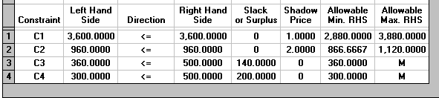

Cost Coefficient Sensitivity Analysis
Calculations shown on graph below

The sensitivity analysis formulates a range of values that the coefficients of the objective function can take that will NOT have any effect on the optimal solution. Make note that even though the optimal solution is not affected; however, the optimal objective function value will change as the coefficients increase/decrease.

If you take a look at the printout below, you will notice the current cost coefficients for each variable of the objective function are X₁ = 7, X₂ = 10. The allowable maximum and minimum for each variable shows the amount to which the cost coefficients may change without compromising the optimal solution. However, remember the objective function value is subject to change if the coefficients change. As shown on the WinQSB printout, the allowable ranges for X₁ are between 5 and 8.333. The allowable range for X₂ is between 8.4 and 14.

For example:
The CURRENT equation represents the information on the WinQSB printout below; the yellow highlighted numbers are the current cost coefficients.
The POSSIBILITY equation represents a potential range for the cost coefficients; the green highlight numbers are adequate coefficient values because X₁ is between 5 and 8.333; X₂ is between 8.4 and 14.
The NON-POSSIBILITY equation is not adequate because its cost coefficients (highlighted in blue) are not within the ranges (allowable max and min).
**The objective function values (highlighted in purple) are calculated only to show the potential changes in the objective function value if cost coefficients are modified.

CURRENT: 7(360) + 10(300) = 5520

POSSIBLITY: 5.2(360) + 10(300) = 4872

NON-POSSIBLITY: 9(360) + 7(300) = 5340

ONE-Change-at a-time is permissible. Otherwise the problem should be solve as a new problem

The above calculations for Cost Coefficient Sensitivity Analysis determined using the first part of following WinQSB table:

Similarly On the top of this table This information shows the ranges of the cost coefficients that will not change the optimal solution. For example, Wilson’s can set a price on baseballs that can vary between $5 and $8.33, and for softballs, the price can fluctuate between $8.40 and $14. Any price between these values will still yield the current optimal strategy.

Assignment:
Construct the dual problem, solve it and then provide economical interpretations for the dual and its solution. To construct the dual of a given problem by using WinQSB, click on Format, then select "Switch to the Dual Form".
With the Wilson Manufacturing’s problem, we were challenged to maximize their profits (7X1+10X2) and not going beyond their given constraints. The optimal value was calculated to be (360,300) resulting in a profit of $5,520.

The Mathematical Model

X1= number of dozen baseballs produced daily
X2= number of dozen softballs produced daily

Subject to:

Max 7X1+10X2 (Objective Function)
ST 5X1 + 6X2 ≤ 3600 (Cowhide)
X1 + 2X2 ≤ 960 (Production time)
X1 ≤ 500 (Production limit of baseballs)
X2 ≤ 500 (Production limit of softballs)
X1, X2 ≥ 0 (Non-negativity)

Dual problem analysis is a method that is used to look at a problem in the opposite perspective. For example, if the problem is maximization, then in dual analysis it would become the minimization and vice versa. In other word, dual analysis is the opposite of primal (original) equation or problem. In problem 2.7 of Chapter 2, the Wilson Manufacturing, the primal equation is 7X1 + 10X2, which means the company wants to maximize their profit. In dual problem analysis, the variable names are the constraint names of the primal (original) problem. Since we have 4 constraints in the primal problem, we will also have 4 variables in dual problem. The coefficient of the objective function of the dual problem comes from the right hand side of the constraint of the primal (original) problem, thus it is MIN 500C1 + 500C2 + 3600C3 + 960C4. In addition, dual problem also has a constraint. The constraint number of dual problem is the number of variables of primal (original) problem. Baseball and softball are the variables of primal problem, therefore these 2 variables are the constraints in dual problem. Thus, it is C1 + 5C3 + C4 ≥ 7 and C2 + 6C3 + 2C4 ≥ 10. Also, in this particular problem, since the dual is a minimization problem, the direction of the constraint is ≥ (greater than or equal to).

In order to calculate the dual problem, the number of variables is calculated by looking at the number of constraints of the original maximization problem (also known as the primal). Since there are 4 constraints, the dual will have 4 variables. The coefficients of the dual problem will come from the right hand side (RHS) of the constraints of the primal. The number of constraints for the dual problem is determined by the number of variables of the primal. Because the original problem has 2 variables, the dual will have 2 constraints. The coefficients of the dual problem come from the coefficients of the constraints from the primal. The right hand side of the constraints comes from the coefficients of the maximization equation of the primal. The following equations represent the transformation of the original problem (maximization) to the dual problem (minimization):

Per given text:

The Primal and Dual Linear Programming Problems: Linear programming problems come in pairs — a primal linear program (P) and an associated dual linear program (D). The linear objective function and the linear constraints of primal and dual programs of the linear programming problem are related in a specific way. I illustrate the mathematical statement of a linear programming problem with the following example.
** Therefore the Dual of a linear programming problem is the opposite of your original solution.

Primal Linear Program  Maximize the Objective Function (P)  7 x₁ + 10 x₂  subject to  C1: 5 x₁ + 6 x₂ <= 3600  C2: 1 x₁ + 2 x₂ <= 960  C3: x₁<= 500  C4: x₂ <= 500  X1, X2 ≥ 0 | Dual Linear Program  Minimize the Objective Function (D)  3600U₁ + 960U₂ +500U₃ + 500U₄  subject to  C1: 5 U₁ + 1U₂ + U₃ ≥ 7  C2: 6U₁ ₊ 2U₂ ₊ U₄ ≥ 10  Uj ≥ 0 j=1,2,3,4

Max.

Min.

