Graphing Straight Lines: Linear Functions
Homework I: Consider the graph at the right containing three lines. Which of the following equations matches the lines A, B, and C?
- y = 4 + (1/3) x  - y = 6  - y = -1/3 + 4 x  - y = x + 6  - y = 4 - (1/3) x  - y = (3/2)x + 2 | 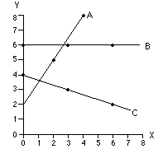

Solution: By plugging at least coordinates of two points in each equation, we recognize which ones are satisfied for what points. The finding is:
Line A belongs to the linear equation y = (3/2)x + 2
Line B belongs to the linear equation y = 6
Line C belongs to linear equation y = 4 - (1/3)x

Homework II: Consider the graph containing two lines, which of the following equations matches the lines A and B.
- y = 4 - 2 x  - y = (2/3)x + 14  - y = 1/2 x + 4  - y = 4 + 2 x  - y = 14 - (3/2) x  - y = 14 - (2/3) x | 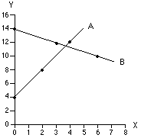

Solution: By plugging at least coordinates of two points in each equation, we recognize which ones are satisfied for what points. The finding is:
Line A belongs to the linear equation y = 4 + 2x
Line B belongs to the linear equation y = 14 – (2/3)x

