HW1: Graph the following feasible region, find the coordinated of the corner
points.
x1+2x2 <= 40
4x1+3x2 <=120
All variables are non-negative

D

C
Feasible Region

A B

Blue line = x1+2x2=40
Red line = 4x1+3x2=120

Solution: It is a bounded feasible region. There are four feasible vertices (corner points) denoted by letter A, B, C, D. The coordinates (X1, X2) for these vertices are tabulated below.

Corner points | X1 | X2
A | 0 | 0
B | 30 | 0
C | 24 | 8
D | 0 | 20

Q2: What about this problem?
x1>=4
4x1+2x2<=8
x2 >=6
All variables are non-negative

Blue line = x1=4
Red line = 4x1+2x2=8
Green line = x2=6

Solution: It is an Infeasible region. As you see there are conflicts anong constraints. There is no feasible regiion. It is empty. Therefore no corner points.
Q3: What about this problem?
x1>=4
x2 >=2
All variables are non-negative

Feasible Region

A

Blue line = x1=4
Green line = x2=2
Solution: It is an unboubed feasible region. The feasible region is above the line X2 = 2 and to the right side of X1 = 2.
As you see it is an unbounded feasible region having one vertex at point A with coordinates (X1= 4, X2 = 2).

Corner points | X1 | X2
C | 4 | 2

Q4: Graph the feasible region, find the coordinates of feasible corner points. Then evaluate objective function at those point to find the optimal vertex.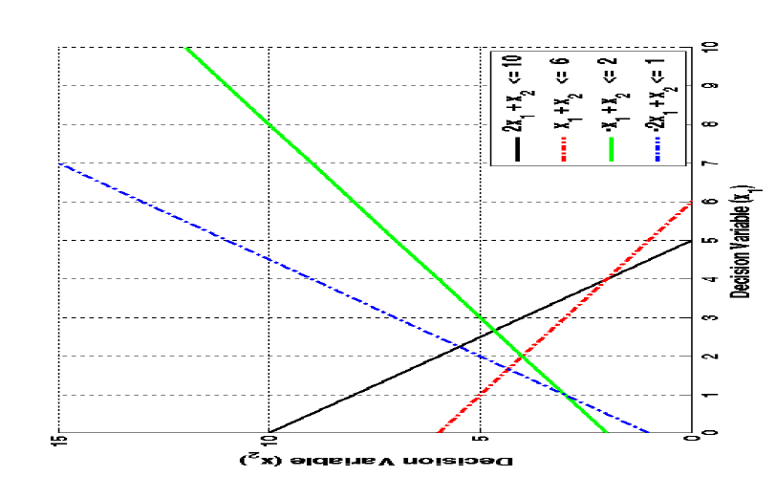
Max X1 + 2X2

Subject to: 2X1 + X2 ≤10
X1 + X ≤ 6
-X1 + X2 ≤ 2
-2X1 + X2 ≤ 1
X1 ≥ 0, X2 ≥ 0
Solution: Sine the feasible region is bounded one can find the coordinated of all feasible corner points. By finding all feasible vertices (there are 6 of them), the evaluating the objective function at each point by plugging its coordinate X1 and X2 into objective function X1 + 2X2 we will find that, the optimal solution occurs at vertex X1 = 2, X2 = 4, with optima value of X1 + 2X2 = 10,

