Graphical Solution to LP

Detailed step-by-step description of the graphical method for problem 2.7

Wilson manufacturing produces both baseballs and softballs, which it wholesales to vendors around the country. Its facilities permit the manufacture of a maximum of 500 dozen baseballs and a maximum of 500 dozen softballs each day. The cowhide covers for each ball are cut from the same processed cowhide sheets. Each dozen baseballs require 5 square feet of cowhide, including waste, whereas each dozen softballs require 6 square feet. Wilson has 3600 square feet of cowhide sheets available every day.

Production of baseballs and softballs includes making the inside core, cutting and sewing the cover, and packaging. It takes about 1 minute to manufacture a dozen baseballs and 2 minutes to manufacture a dozen softballs. A total of 960 minutes is available for production daily.

a) Formulate a set of linear constraints that characterize the production process at Wilson Manufacturing and draw a graph of the feasible region.

Decision Variables
Wilson manufacturing produces baseballs and softballs, which it wholesales to vendors around the country, by the dozens on a daily basis. Therefore,

X1= number of dozen baseballs produced daily
X2= number of dozen softballs produced daily

Constraints

Cowhide
Each dozen baseballs require 5 square feet of cowhide, including waste, whereas each dozen softballs require 6 square feet. Wilson has 3600 square feet of cowhide sheets available every day. Therefore,

(The total amount of cowhide used daily) cannot exceed (The amount of cowhide available daily)
5X1 + 6X2 ≤ 3600

Production Time
It takes about 1 minute to manufacture a dozen baseballs and 2 minutes to manufacture a dozen softballs. A total of 960 minutes is available for production daily. Therefore,

(The amount of production minutes used daily) cannot exceed (The total number of production minutes available daily)
X1 + 2X2 ≤ 960

Production Limit
Its facilities permit the manufacture of a maximum of 500 dozen baseballs and a maximum of 500 dozen softballs each day. Therefore,

(The total number of dozen units produced daily) cannot exceed (The marketing limit)
X1 ≤ 500
X2 ≤ 500

Non-negativity of Decision Variables
Negative production of baseballs and softballs is impossible. Therefore,
X1 ≥ 0
X2 ≥ 0

With that said, the next step is to form the mathematical model.

The Mathematical Model

Max 7X1 + 10X2 (Objective Function- From part 7 d)

ST 5X1 + 6X2 ≤ 3600 (Cowhide)
X1 + 2X2 ≤ 960 (Production time)
X1 ≤ 500 (Production limit of baseballs)
X2 ≤ 500 (Production limit of softballs)
X1, X2 ≥ 0 (Non-negativity)

In order to make a graph that shows the feasible region, we must first label the axis. The horizontal axis represents baseballs and the vertical axis represents softballs. First, a vertical line should be drawn on the x-axis at 500, as well as a horizontal line on the y-axis (also at 500). These lines represent the maximum number of baseballs (on the horizontal axis) and the maximum number of softballs (on the vertical axis) that can be produced. Next, you graph the time constraint. Total time available is 960 and since it takes only 1 minute to make a dozen baseballs, you make a point at 960 on the x-axis. The y-axis, which represents the time to make softballs, a point should be made at 480 (960 total minutes/ 2 minutes per dozen softballs). A line is then drawn between the two points. Finally, you graph the cowhide restraint. For the x-axis, you determine the point finding the number that corresponds to if all the cowhide were used on baseballs. The number is 720. Now we do the same thing but for the use of softballs. This number is 600. You then draw a line between the two points. The feasible region is shown in the graph below. It is bounded by five corner points.
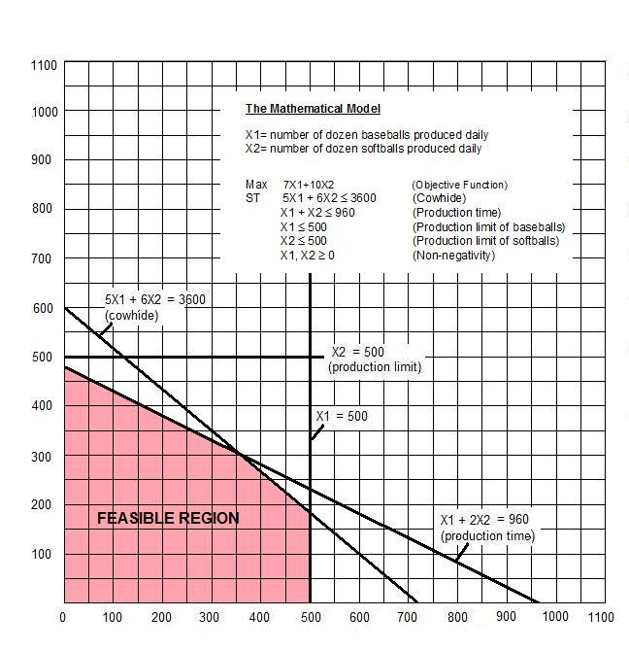

b) Wilson is considering manufacturing either 300 dozen baseballs and 300 dozen softballs or 350 dozen baseballs and 350 dozen softballs. Characterize each of these solutions as an interior point, extreme point, or infeasible point and explain why, regardless of Wilson Manufacturing’s objective, neither could be an optimal solution.

When producing 300 baseballs and 300 softballs, all of the constraints are satisfied:
Constraint 1: X1 < 500 = 300 < 500 Constraint is satisfied.
Constraint 2: X2 < 500 = 300 < 500 Constraint is satisfied.
Constraint 3: 5X1 + 6X2 < 3600 = 5(300) + 6(300) = 3300 < 3600
Constraint is satisfied.
Constraint 4: X1 + 2X2 < 960 = 300 +2(300) = 900 < 960 Constraint is satisfied.

It is therefore an interior point. As for 350 baseballs and 350 softballs, only 2 of the constraints are satisfied: (X1 ≤ 500 and X2 ≤ 500). It is therefore an infeasible point.

Constraint 1: X1 ≤ 500 = 350 < 500 Constraint is satisfied.
Constraint 2: X2 ≤ 500 = 350 < 500 Constraint is satisfied.
Constraint 3: 5X1 + 6X2 ≤ 3600 = 5(350) +6(350) = 3850 > 3600
Constraint is not satisfied.
Constraint 4: X1 + 2X2 ≤ 960 = 350 + 2(350) = 1050 > 960
Constraint is not satisfied.
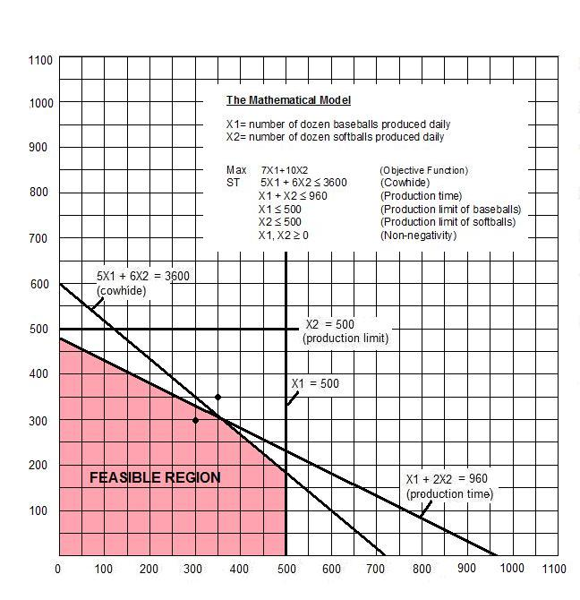
Neither of these options are optimal solutions. This is because point (300 softballs; 300 baseballs) is an interior point. An interior point prohibits the optimal solution from being attained. The second solution lies outside the feasible region and is therefore, not possible under the constraints discussed.

c) If Wilson estimates that its profit is $7 per dozen baseballs and $10 per dozen softballs, determine a production schedule that maximizes Wilson’s daily profit.

As you notice the depicted feasible region is bounded having five corner points (i.e., vertices). Since the feasible region is bounded therefore optimal solution must be one of the vertices. However, it could be any one of the five vertices. To find out which one is optimal one has to find the coordinates (X1, X2) of each vertex.

Let’s denote the feasible corner points by letter A, B, C, D, E, clockwise starting at the origin (0, 0). The following table provides the coordinate of the corner (i.e. extreme) points:

Corner points | X1 | X2
A | 0 | 0
B | 0 | 480
C | 360 | 300
D | 500 | 183 + 1/3
E | 500 | 0

For example extreme point C is the intersection of the two boundary lines:

5X1 + 6X2 = 3600
X1 + 2X2 = 960

Multiply bottom equation by 3 to cancel out the number of softballs.

5X1 + 6X2 = 3600
3X1 + 6X2 = 2880

Subtract the bottom equation from the top equation and solve.

2X1 = 720 X1= 360

Substitute X1 into the first equation.

5 (360) + 6X2 = 3600
1800 + 6X2 = 3600
6X2 = 1800
X2 = 300

After finding the coordinates (X1, X2) of all feasible vertices we must evaluate the objective function 7X1 + 7X2, by insert the values found for X1 and X2 into the objective function.

7(360) + 10(300) = 2520 + 3000 = $5520

Evaluating the objective function for the other four vertices we will notice that the production schedule that maximizes Wilson Manufacturing’s daily profit is found at the extreme point (360, 300). In other words, they should produce 360 dozen baseballs and 300 dozen softballs to give them a maximized profit of $5,520.
Conclusion
The optimal solution (strategy) is: (360, 300)
The Optimal Value is: $5,520

