**Integer, Networks, and Special Cases of Linear Programs**

**LP in Non-standard Form**

The standard form of LP requires that All variables to be Non-negative.

Consider the following LP in non-standard form:

Maximize X1

Subject To:

X1 + X2 $≥0$

2X1+X2 $≥2$

X1 $≥0$

X2 $≤0$

One can solve this problem by declaring that the

**Lindo Inputs:**

Max X1

S. T.

X1+X2>0

2X1+X2<2

X1>0

X2<0

end

free X1

free X2

**Lindo Report:**

OBJECTIVE FUNCTION VALUE

1) 2.000000

VARIABLE VALUE

X1 2.000000

X2 -2.000000

**Findings:**

According to the Lindo repot 2 is the optimal value.in this solution with optimal solution given X1=2 and X2=-2.

**Solving System of Linear Equations**

Suppose we wish to solve the following system of equation with 3 equations and 3 unknowns. To solve it by LP optimizer, we need to introduce **a dummy objective function**, and then set all variables as **free variables**:

**LP formulation:**

Maximize X1+X2+X3

Subject To:

2X1+3X2+X3=4

X1+X2-X3=3

2X1-2X2-X3=1

**Lindo Inputs:**

Max X1+X2+X3

S. T. 2X1+3X2+X3=4

X1+X2-X3=3

2X1-2X2-X3=1

End

Free X1

Free X2

Free X3

**Lindo Report:**

OBJECTIVE FUNCTION VALUE (**one should ignore it, since it is a dummy**)

1) 1.000000

VARIABLE VALUE

X1 1.000000

X2 1.000000

X3 -1.000000

**Findings:**

When we run any type of LP we need to have an objective function in order to have the optimum results. For this reason in this example we used dummy Objective function to get the results.

Base on Lindo report, the solution to the system of equations is: X1=1, X2=1, X3=-1.

**Integer LP Problem**

Consider the Carpenter Problem:

Maximize 5X1+3X2

Subject to:

2X1+X2 $≤40$

*X1 + 2X2  50*

*X1  0*

*X2  0*

Now the market requires 4 Table for Every Chair. The LP revised problem is:

**LP formulation:**

Maximize 5X1+3X2

Subject to:

2X1+X2 $≤40$

*X1 + 2X2  50*

***4X1 - X2 = 0***

*X1  0*

*X2  0*

***X1, X2 Integer***

**Lindo Inputs:**

Max 5X1+3X2

st

2X1+X2<40

X1+2X2<50

4X1-X2=0

X1>0

X2>0

end

GINX1

GINX2

**Lindo Report:**

OBJECTIVE FUNCTION VALUE

1) 85.00000

VARIABLE VALUE

X1 5.000000

X2 20.000000

**Findings:**

According to the Lindo report, the optimal value for this solution is 85 with given variables X1=5 and X2=20, with net profit of $85.

**Goal-Seeking Problem**

In most business applications, the manager wishes to achieve a specific goal, while satisfying the constraints of the model. The user does not particularly want to optimize anything so there is no reason to define an objective function. This type of problem is usually called a feasibility problem.

Consider the Carpenter Weekly LP Problem:

Maximize 5X1+3X2

Subject to:

2X1+X2 $≤40$

*X1 + 2X2  50*

*X1  0*

*X2  0*

Suppose for this week he wishes to make $100 profit, how should he programs his activities? That is finding a solution to satisfy **5X1+3X2 =100**, beside his usual constraint. One my introduce a Dummy objective function, (say, X1+X2) the we have

Max X1+X2

5X1+3X2 =100

2X1 + X2 * *

X1 + 2X2 * *

All variables non-negative and integer

**Lindo Input:**

Max X1 + X2

S.T.5X1 + 3X2 = 100

2X1 + X2 <40

X1 + 2X2 <50

End

GIN X1

GIN X2

**Lindo Output:**

OBJECTIVE FUNCTION VALUE

1) 28.00000

VARIABLE VALUE

X1 8.000000

X2 20.000000

Ignoring the objective value a feasible solution is X1 = 8, X2 = 20, bringing net profit of

5X1+3X2 =100

**The Knapsack (0, 1) Problem:**

**LP formulation:**

Maximize 11X*1* + 9X*2* + 8X*3* + 15X*4*

Subject To:

4X*1* + 3X*2* + 2X*3* + 5X*4*  ≤ 8

X*i* = 0 ,or X*i* = 1.

**Lindo Inputs:**

Max 11X1+9X2+8X3+15X4

S. T. 4X1+3X2+2X3+5X4<8

END

INT X1

INT X2

INT X3

INT X4

**Lindo Report:**

OBJECTIVE FUNCTION VALUE

1) 24.00000

VARIABLE VALUE

X1 0.000000

X2 1.000000

X3 0.000000

X4 1.000000

**Findings:**

We used ILP in Lindo to find the solution since we have a large possibilities to find optimal solution with given 4 variables ( 2 4 = 16 possibilities).

Based on Lindo report, the optimal value for the objective function is 24 with given 4 variables X1=0, X2=1, X3=0 and X4=1.

**Transportation Problem: p.234**

LP Formulation:

Minimize ***Z=6X11+8X12+10X13+7X21+11X22+11X23+4X31+5X32+12X33***

Subject to:

X11+X12+X13=150

X21+X22+X23=175

X31+X32+X33=275

X11+X21+X31=200

X12+X22+X32=100

X13+X23+X33=300

Xij * *

**Lindo Report:**

OBJECTIVE FUNCTION VALUE

1) 4525.000

VARIABLE VALUE

X11 25.000000

X12 0.000000

X13 125.000000

X21 0.000000

X22 0.000000

X23 175.000000

X31 175.000000

X32 100.000000

X33 0.0000000

**Findings:**

Objective function is $4,252 to minimize the total cost of transportation. the shipping cost for each destination should be as follow :

|  |  |  |  |
| --- | --- | --- | --- |
|  | Mills | | |
| Grain elevators | Chicago | St. Louise | Cinn. |
| Kansas city | 25 | 0 | 125 |
| Omaha | 0 | 0 | 175 |
| Des | 175 | 100 | 0 |

200 100 300

Right hand side range reflect number of shipment for each location.

**Assignment Problem: p.247**

LP Formulation:

*Minimize 210X11+90X12+180X13+160X14+100X21+70X22+130X23+200X24+175X31+105X32+140X33+170X34+80X41+65X42+105X43+120X44*

Subject to:

X11+X12+X13+X14=1

X21+X22+X23+X24=1

X31+X32+X33+X34=1

X41+X42+X43+X44=1

X11+X21+X31+X41=1

X12+X22+X32+X42=1

X13+X23+X33+X43=1

X13+X23+X33+X43=1

Xij * *

**Lindo Report:**

OBJECTIVE FUNCTION VALUE

1) 450.0000

VARIABLE VALUE

X11 0.000000

X12 0.000000

X13 0.000000

X14 1.000000

X21 0.000000

X22 1.000000

X23 0.000000

X24 0.000000

X31 0.000000

X32 0.000000

X33 1.000000

X34 0.000000

X41 1.000000

X42 0.000000

X43 0.000000

X44 0.000000

**Findings:**

Assign 1 to 4

Assign 2 to 2

Assign 3 to 3

Assign 4 to 1

This best assignment has total of 450 Miles.

**Critical Path (PERT) Problem:**

**Suppose we wish to find the critical path (the longest path) of the following project:**

To find the CP, define the binary variables Xij, where Xij = 1, if the activity i j is on the CP, and Xij = 0 otherwise. The length of the path is the sum of the durations of the activities on the path. Formally, the CP problem is to find the longest path from node 1 to node m, i.e.

The LP formulation of this project network is:

Max 9X12 + 6X13 + 0X23 + 7X34 + 8X35 + 10X45 + 12X56

Subject to:

X12 +X13 = 1,

X12 - X23 = 0,

X13 + X23 - X34 - X35 = 0,

X34 - X45 = 0,

X35 + X45 - X56 = 0,

X56  = 1,

and all Xij ≥ 0.

The first and the last constraints are imposed to start (node 1) and complete the project (node m) by critical activities, respectively; while the other constraints provide that if any node is arrived at by a critical activity, then it must be left by a critical activity. Note that the integrality conditions (i.e. Xij=0 or 1) are changed to

Xij ≥ 0 since it is known that the optimal solution to these types of LP problems satisfy these conditions.

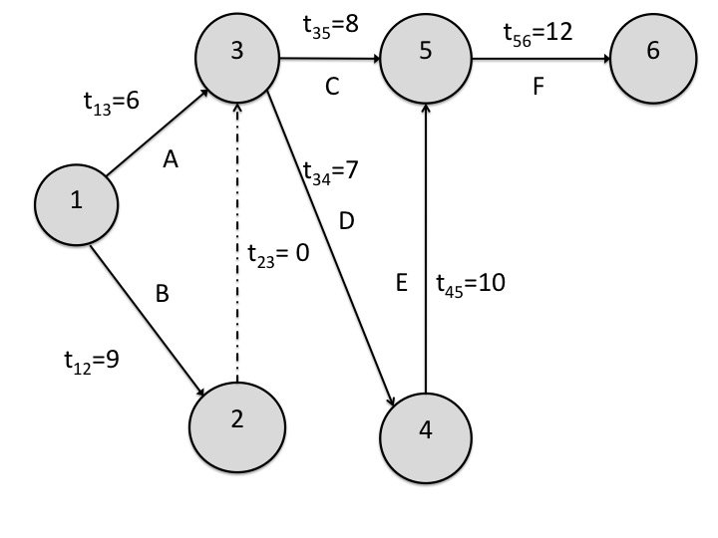

The Lindo result are: X12 = 1, X23 = 1, X34 = 1, X45 = 1, X56 = 1 and all other Xij = 0. That is, the Critical Path is 1 → 2 → 3 → 4 → 5 → 6 with a project completion time of 38 time units.