1. Formulate a set of linear constraints that characterize the production process at Wilson Manufacturing.

Wilson manufactures baseballs and softballs per dozen on a daily basis.

X1 = Baseballs

X2 = Softballs

**FUNCTIONAL CONSTRAINTS**

*PRODUCTION MATERIALS*

Baseballs require 5 square feet of cowhide during production

Softballs require 6 square feet of cowhide during production

The production requirements for both products combined cannot exceed the use of 3600 square feet of cowhide on a daily basis.

5X1 + 6X2 ≤ 3600

*PRODUCTION TIME*

Baseballs require 1 minute of production time

Softballs require 2 minutes of production

The production requirements for both products combined cannot exceed the use of 960 minutes of time on a daily basis.

1X1 + 2X2 ≤ 960

*PRODUCTION LIMIT*

There can only be a maximum of 500 dozen baseballs produced daily

There can only be a maximum of 500 dozen softballs produced daily

X1 ≤ 500

X2 ≤ 500

**NONNEGATIVITY RESTRAINTS**

There has to be a positive production of baseballs and softballs. It is impossible to produce a negative amount of products.

X1 ≥ 0

X2 ≥ 0

**LINEAR CONSTRAINTS FOR THE PRODUCTION OF BASEBALLS AND SOFTBALLS AT WILSON MANUFACTURING**

Max 7X1+10X2

Subject to:

5X1 + 6X2 ≤ 3600 square feet of cowhide

1X1 + 2X2 ≤ 960 minutes of production time

X1 ≤ 500 baseballs produced daily

X2 ≤ 500 softballs produced daily

X1, X2 ≥ 0 non-negativity conditions (implied constraints)

Refer to the accompanying **hand computation and using graph paper worksheet**, and following the step-by-step instruction in our lecture notes, the feasible region is shown in the above graph. It is bounded having five corner points. Therefore, one of these points must be provide the optimal solution optimal. Solving a few paper of systems of equation, we obtain the coordinates of these feasible vertices. The coordinates of the corner points are

A=(0, 0), B=(500, 0), C=(500, 184.3), (D=360, 300), and E=(0, 430).

By plugging in the coordinates of these vertices into objective function we get 0, 3500, 5333, 5520, and 4800, respectively. By examining the objective function values at these corner points, we conclude that the optimal solution is (X1= 360, X2= 300), with optimal value of 5520.

This preliminary work was completed before checking the answer with the LP Solver.

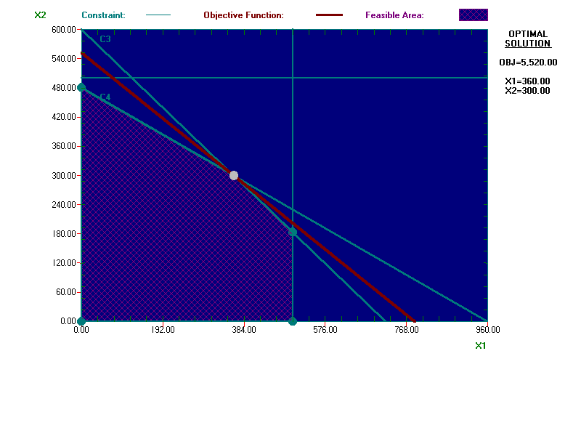

1. Wilson is considering manufacturing either 300 dozen baseballs and 300 dozen softballs or 350 dozen baseballs and 350 dozen softballs. Characterize each of these solutions as an interior point, extreme point, or infeasible point and explain why, regardless of Wilson Manufacturing’s objective, neither could be an optimal solution.

***PRODUCTION of 300***

1. **X1** ≥ **0**

**X2** ≥ **0**

300 dozen baseballs and 300 dozen softballs produced daily exceed the non- negativity constraint. Reveals a surplus of 300.

1. **X1** ≤ **500 baseballs produced daily**

**X2** ≤ **500 baseballs produced daily**

300 dozen baseballs is less than the production constraint ≤ 500 dozen baseballs produced daily. 300 dozen softballs is less than the production constraint ≤ 500 dozen softballs produced daily.

1. **1X1 + 2X2** ≤ **960 minutes of production time**

300 production minutes for baseballs plus 600 production minutes for softballs equals 900 minutes of total production time, which meets the production constraint.

1. **5X1 + 6X2** ≤ **3600 square feet of cowhide**

1500 square feet of cowhide for baseballs plus 1800 square feet of cowhide equals 3300 square feet of total cowhide used daily to produce the products, which meets the materials constraint.

Therefore the manufacturing of 300 dozen baseballs and 300 dozen softballs daily would fall in the graph as an interior point because all constraints are satisfied. However, this is not an optimal solution because all three-constraint models reveal a slack of 200 dozen baseballs/200 dozen softballs that could potentially be made, 60 minutes of total production time that could be utilized and 300 square feet of total cowhide that could be used as well. None of the constraints are met with equality or zero slack and therefore the company is not maximizing the facilities, materials or staff time if they were to manufacture 300/300.

***PRODUCTION OF 350***

1. **X1** ≥ **0**

**X2** ≥ **0**

350 dozen baseballs and 350 dozen softballs produced daily exceed the non- negativity constraint. Reveals a surplus of 350.

1. **X1** ≤ **500 baseballs produced daily**

**X2** ≤ **500 baseballs produced daily**

350 dozen baseballs is less than the production constraint ≤500 dozen baseballs produced daily. 350 dozen softballs is less than the production constraint ≤500 dozen softballs produced daily.

1. **1X1 + 2X2** ≤ **960 minutes of production time**

350 production minutes for baseballs plus 700 production minutes for softballs equals 1050 minutes of total production time, which exceeds the production constraint.

1. **5X1 + 6X2** ≤ **3600 square feet of cowhide**

1750 square feet of cowhide for baseballs plus 2100 square feet of cowhide equals 3850 square feet of total cowhide used daily to produce the products, which exceeds the materials constraint.

Therefore the manufacturing of 350 dozen baseballs and 350 dozen softballs daily would fall in the graph as an infeasible point because only 1 out of 3 constraints are satisfied. This would never be an optimal solution because two constraints are violated. For example total production time needed is 1050 which is 90 minutes over the total production time allotted and the materials needed exceeds the allotted cowhide usage by 250 square feet. Since several of the constraints exceed the company’s conditions, the division would not be manufacturing efficiently and would exceed budgeted expenses.

1. If Wilson estimates that its profit is $7 per dozen baseballs and $10 per dozen for softballs, determine a production schedule that maximizes Wilson’s daily profit.

Based on the LP problem Wilson would have to produce 360 dozen baseballs and 300 softballs daily.

1. Characterize each of the constraint as binding, non-binding, or redundant.

5X1 + 6X2 ≤ 3600 square feet of cowhide = Binding

1X1 + 2X2 ≤ 960 minutes of production time = Binding

X1 ≤ 500 baseballs produced daily = Non-binding constraint because it is not satisfied with equality at the optimal point.

X2 ≤ 500 softballs produced daily = Redundant Constraint because it does not eliminate any other points from consideration.

X1, X2 ≥ 0 = Non-binding constraints because it is not satisfied with equality at the optimal point.