Some Network Applications Solved by Specialized Software

1.Transportation Problem

NW Lumber owns three processing plants located at Eureka, Crescent City and Coos Bay. The plants can process the following number of tons in the coming month:
Eureka 2000
Crescent City 1400
Coos Bay 1500
NW Lumber has three logging locations at Garberville, Grant's Pass and Willard. Each of the logging locations can supply 1600 tons in the coming month.
The shipping costs per ton are as follows:
From / To | Eureka | Crescent City | Coos Bay
Garberville | 175 | 225 | 250
Grant's Pass | 150 | 100 | 100
Willard | 300 | 275 | 200
NW Lumber wishes to determine a shipping schedule that will minimize its transportation costs. The problem was solved as a transportation problem using WinQSB's "Network Modeling" module, and produced the following solution:
 | From | To | Shipment | Unit Cost | Total Cost
1 | Garberville | Eureka | 1600 | 175 | 280000
2 | Grant's Pass | Eureka | 200 | 150 | 30000
3 | Grant's Pass | Crescent City | 1400 | 100 | 140000
4 | Willard | Eureka | 100 | 300 | 30000
5 | Willard | Coos Bay | 1500 | 200 | 300000
6 | Unfilled_Demand | Eureka | 100 | 0 | 0
 | Total | Objective | Function | Value = | 780000
Page 1
The entire logging yield from Garberville should be shipped to Eureka. Fourteen hundred tons from Grant's Pass should be shipped to Crescent City and the remaining 200 tons should be shipped to Eureka. Fifteen hundred tons from Willard should be shipped to Coos Bay and the remaining 100 tons should be shipped to Eureka. All processing plants except Eureka have their production capacity met. Eureka falls 100 tons short of its production capacity. The total shipping costs for Garberville are $280,000; for Grant's Pass $170,000; and for Willard $330,000. The total cost of shipping the lumber to the various plants is $780,000.
The cost per ton of the routes from Garberville to Crescent City and Coos Bay will need to drop by $100 and $175 respectively before these routes will become cost effective. The cost per ton of the route from Grant's Pass to Coos Bay will need to drop by $50 for the route to become cost effective. The cost per ton of the route from Willard to Crescent City will need to drop by $25 for the route to become cost effective. The cost per ton of the selected shipping routes may be increased by $25 without affecting the optimal solution. The cost per ton of some of the selected shipping routes may be increased by up to $100 per ton without affecting the optimal solution.

2. Assignment Problem

Beckley City wishes to undertake 5 projects during the fiscal year. It has solicited bids from interested companies. The bids are shown below. All values are in $1,000 units.
Company / Project | Refurbish Courthouse | Build New Library | Modernize Playground | Build Parking Structure | Improve City Park
Millard Associates | 800 | 750 | 300 | 450 | 200
QM Construction | 950 | 725 |  | 500 | 275
Latham Brothers |  |  | 200 |  | 225
Beckley Engineering | 650 | 700 | 250 | 400 | 225
WRT, Inc. | 700 | 800 | 175 | 300 | 300
B&P Enterprises | 850 | 900 | 270 | 475
Page 2
Beckley wishes to assign the projects to contractors in a manner that will minimize the total cost. The problem was solved as an assignment problem using WinQSB's "Network Modeling" module. The following output was produced:
 | From | To | Assignment | Unit Cost | Total Cost
1 | Millard | City Park | 1 | 200 | 200
2 | QM | Library | 1 | 725 | 725
3 | Latham | Playground | 1 | 200 | 200
4 | Beckley | Courthouse | 1 | 650 | 650
5 | WRT | Parking | 1 | 300 | 300
6 | B&P | Unused_Supply | 1 | 0 | 0
 | Total | Objective | Function | Value = | 2075

The courthouse project is assigned to Beckley Engineering. The new library project is assigned to QM Construction. The playground project is assigned to Latham Brothers. The parking structure project is assigned to WRT Inc. The city park project is assigned to Millard Associates. B&P Enterprises is not assigned to any project. The total cost of the projects will be $2,075,000.

Beckley has budgeted $2 million for the projects. The project assignments violate the budget. One project will have to be sacrificed. Beckley may choose to sacrifice a project based on economic, political or public demand consideration. If the primary consideration is cost savings, then sacrificing the new library will yield the greatest cost savings while completing four projects and remaining in budget. Other choices are possible if political or public demands are the criterion.
Page 3

3. Shortest Path Problem
a)
Jo Yu, president of BroadTech Inc. needs to travel from San Bernardino to San Pedro to pick up a shipment. He would like to minimize the distance traveled. The distances are shown in the following map:
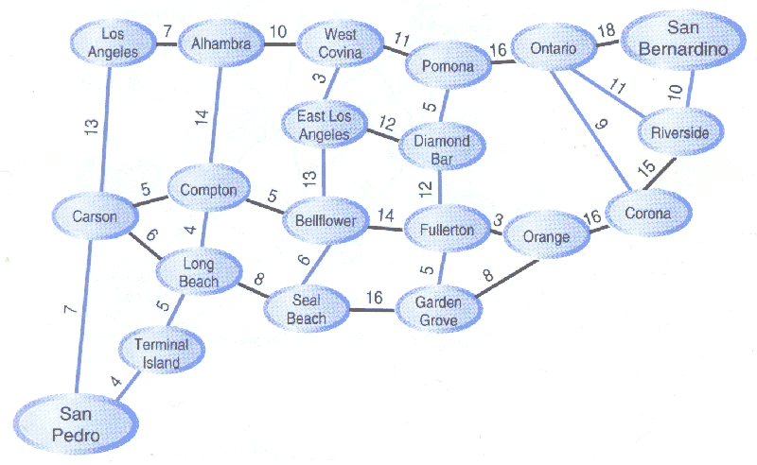
The problem was solved as a shortest-path problem using WinQSB's "Network Modeling" module. The following solution was provided:
 | From | To | Distance | Cumulative Distance
1 | San Bernardino | Riverside | 10 | 10
2 | Riverside | Corona | 15 | 25
3 | Corona | Orange | 16 | 41
4 | Orange | Fullerton | 3 | 44
5 | Fullerton | BellFlower | 14 | 58
6 | BellFlower | Compton | 5 | 63
7 | Compton | Carson | 5 | 68
8 | Carson | San Pedro | 7 | 75

Page 4

b)
If Jo travels during the morning rush, he can achieve 25mph on east-west routes and 40mph on north-south routes. The map was edited to provide the time in minutes (accurate to 1 decimal place, or 6 seconds) along the various routes:
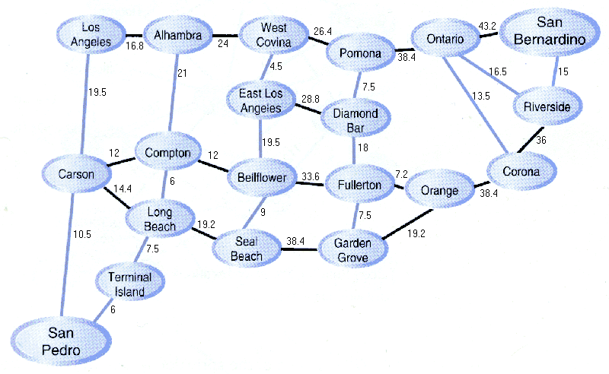
The problem was solved as a shortest-path problem using WinQSB's "Network Modeling" module. The following solution was provided:
 | From | To | Time | Cumulative Time
1 | San Bernardino | Riverside | 15 | 15
2 | Riverside | Ontario | 16.5 | 31.5
3 | Ontario | Pomona | 38.4 | 69.9
4 | Pomona | West Covina | 26.4 | 96.3
5 | West Covina | East LA | 4.5 | 100.8
6 | East LA | BellFlower | 19.5 | 120.3
7 | BellFlower | Compton | 12 | 132.3
8 | Compton | Long Beach | 6 | 138.3
9 | Long Beach | Terminal Island | 7.5 | 145.8
10 | Terminal Island | San Pedro | 6 | 151.8
Page 5

4. Maximum Flow Problem
The planning council of Silverton City would like to know the maximum hourly flow of vehicles from interstate 4 North to interstate 4 South through Silverton. The flow capacities of the roads are show below. The flow capacities are in 100's of vehicles per hour.
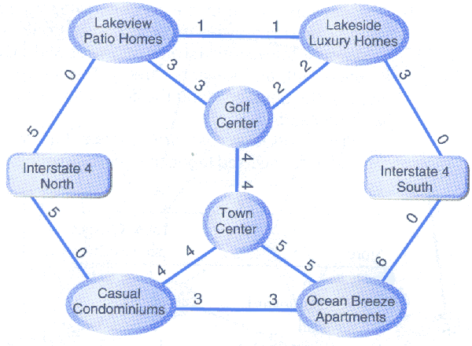
The problem was solved as a maximal flow problem in WinQSB's "Network Modeling" module. The following output was produced:
 | From | To | Net Flow |  | From | To | Net Flow
1 | Interstate North | Lakeview Patio | 4 | 7 | Golf Center | Town Center | 1
2 | Interstate North | Casual Condos | 5 | 8 | Golf Center | Lakeside Luxury | 2
3 | Lakeview Patio | Golf Center | 3 | 9 | Town Center | Ocean Breeze | 3
4 | Lakeview Patio | Lakeside Luxury | 1 | 10 | Lakeside Luxury | Interstate South | 3
5 | Casual Condos | Town Center | 2 | 11 | Ocean Breeze | Interstate South | 6
6 | Casual Condos | Ocean Breeze | 3
Total | Net Flow | From | Interstate North | To | Interstate South | = | 9
Page 6

The maximal hourly flow of vehicles is 900 vehicles per hour.

5. Assignment Problem

a) Fox Television would like to appoint department heads to each of its departments based on the number of years of experience. The applicant's experience is listed below:
 | News | Sports | Features | Marketing | Development
Tony Hernandez | 8 | 7 | 0 | 0 | 2
Jim Lampsy | 2 | 12 | 4 | 1 | 3
Monica Fish | 7 | 2 | 7 | 2 | 4
Connie Chu | 2 | 0 | 7 | 8 | 6
Scott Young | 0 | 10 | 0 | 0 | 5
Linda Harlan | 10 | 0 | 10 | 5 | 2
Ann Chambers | 5 | 0 | 5 | 11 | 9

The problem was solved as an assignment problem using WinQSB's "Network Modeling" module. The following solution was provided:
 | From | To | Assignment | Unit Profit | Total Profit
1 | Tony Hernandez | News | 1 | 8 | 8
2 | Jim Lampsy | Sports | 1 | 12 | 12
3 | Monica Fish | Unused_Supply | 1 | 0 | 0
4 | Connie Chu | Development | 1 | 6 | 6
5 | Scott Young | Unused_Supply | 1 | 0 | 0
6 | Linda Harlan | Features | 1 | 10 | 10
7 | Ann Chambers | Marketing | 1 | 11 | 11
 | Total | Objective | Function | Value = | 47

Tony Hernandez is assigned to the News department. Jim Lampsy is assigned to the Sports department. Connie Chu is assigned to the Development department. Linda Harlan is assigned to the Features department. Ann Chambers is assigned to the Marketing department. All other applicants are not assigned a position. The total number of years experience in the
Page 7

respective departments for those appointed is 47 years.
b)
Fox is considering making one department of the Features and Development departments. Fox would like to make new assignments based on the changes in department.
 | News | Sports | Features & Development | Marketing
Tony Hernandez | 8 | 7 | 2 | 0
Jim Lampsy | 2 | 12 | 7 | 1
Monica Fish | 7 | 2 | 11 | 2
Connie Chu | 2 | 0 | 13 | 8
Scott Young | 0 | 10 | 5 | 0
Linda Harlan | 10 | 0 | 12 | 5
Ann Chambers | 5 | 0 | 14 | 11

The problem was solved as an assignment problem using WinQSB's "Network Modeling" module. The following solution was provided:

1 | Tony Hernandez | Unused_Supply | 1 | 0 | 0
2 | Jim Lampsy | Sports | 1 | 12 | 12
3 | Monica Fish | Unused_Supply | 1 | 0 | 0
4 | Connie Chu | Features & Development | 1 | 13 | 13
5 | Scott Young | Unused_Supply | 1 | 0 | 0
6 | Linda Harlan | News | 1 | 10 | 10
7 | Ann Chambers | Marketing | 1 | 11 | 11
 | Total | Objective | Function | Value = | 46

Jim Lampsy is assigned to the Sports department. Connie Chu is assigned to the Features & Development department. Linda Harlan is assigned to the News department. Ann Chambers is assigned to the Marketing department. All other candidates are not assigned to a department. The total number of years of experience in their fields between those selected is 46 years.
Page 8

