Review of Our Algebra and Geometry

Analytical-Geometry

Numbers (and operations on them)
Point

Pair of number
Point

Equation (linear)
Lines

Slope of a line

Use of a Scientific Calculator:

Factorial (!), π, e

Conventions in algebra

Normal distribution

Discrete and continuous random variables

Never divide by zero

Odd, chance, percentage
Analytic Geometry Tools
Why Mathematics: Mathematics is a human endeavor which has spanned over four thousand years; it is part of our cultural heritage; it is a very useful, beautiful and prosperous subject. Mathematics is one of the oldest of sciences; it is also one of the most active; for its strength is the vigor of perpetual youth. Mathematics is also our native language. Numbers are cultural phenomena; humans invented them to quantify the external world around them. The external world is qualitative in its nature. However, human can understand, compare and manipulate numbers only. Therefore, we use some measurable and numerical scales to quantify the world. This enables us to understand the world by, for example finding any relationship, manipulating, comparing, calculating, etc. That is, to make an Analytical Structured Model for the external world. Then we use the same scale to qualify it back to the world. If you cannot measure it, you cannot manage it. This is the essence of human's understanding and decision-making process. 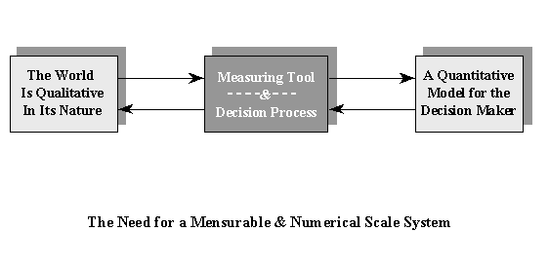
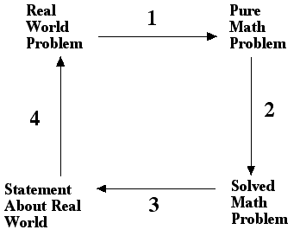
During the past 500 years there has been a steady increasing body of knowledge in mathematics, science, and engineering. The industrial age and our more recent information age have lead to a steady increase in the use of "higher" math in many different disciplines and on the job. Our Education System has moved steadily toward the idea that the basic computational aspects described above are insufficient. Students also need to know basic algebra, geometry, statistics, probability, and other higher math topics.
Operations Research as a Science of Making Decision Describing, Prescribing, and Controlling a real world problem by Modeling.

Numbers: The introduction of zero into the decimal system in the 13th century was the most significant achievement in the development of a number system, in which calculation with large numbers became feasible. Without the notion of zero, the descriptive and prescriptive modeling processes in commerce, astronomy, physics, chemistry, and industry would have been unthinkable. The lack of such a symbol is one of the serious drawbacks in the Roman numeral system. In addition, the Roman numeral system is difficult to use in any arithmetic operations, such as multiplication. The purpose of this site is to raise students and teachers awareness of issues in working with zero and other numbers. Imprecise mathematical thinking is by no means unknown; however, we need to think more clearly if we are to keep out of confusions.

Dividing by Zero Can Get You into Trouble!
If we persist in retaining such errata in our educational texts, an unwitting or unscrupulous person could utilize the result to show that 1 = 2 as follows:
(a).(a) - a.a = a² - a²
for any finite a. Now, factoring by a, and using the identity
(a² - b²) = (a - b)(a + b) for the other side, this can be written as:
a(a-a) = (a-a)(a+a)
dividing both sides by (a-a) gives
a = 2a
now, dividing by a gives
1 = 2, Voila!
This result follows directly from the assumption that it is a legal operation to divide by zero because a - a = 0. If one divides 2 by zero even on a simple, inexpensive calculator, the display will indicate an error condition.
Again, I do emphasis, the question in this Section goes beyond the fallacy that 2/0 is infinity or not. It demonstrates that one should never divide by zero [here (a-a)]. If one does allow oneself dividing by zero, then one ends up in a hell. That is all.

Equation: Its Structure, Roots, and Solutions
Equations are any symbolic expression with equality sign, such as X² = 4. It is good to know that, the word "root" is derived from Sanskrit word "Bija" for "seed" or "root", is the usual term for algebra, where the "root" is the unknown quantity (often called X) that then produces a definite result via the structure of equation.
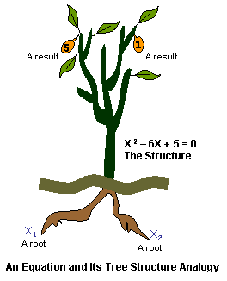
The definite result (i.e., a fruit) of an equation is called its solution because it satisfies the equation. The above figure depicts the historical analogy developed during the second century between equations' elements and a tree structure. Since by plugging in the numerical value for the root (X), the equation resolves, i.e., it disappears. Hence the numerical value is called a solution, as for example when sugar is mixed with water in making lemonade sugar disappears, making a solution.

= +2, and - 2 right?

Misplacement of the Sign
Another common error is found in some textbooks which, announcing that the square root of 4 has two answers namely +2, and -2. When this writer confronted an author guilty of this practice observing that one number cannot be equal to two different numbers, the reply received was "check it for yourself by squaring both sides". He followed with self-satisfaction, "you see!" This writer advised that following his argument one could also demonstrate that one is equal to minus one. An observer witnessing this exchange jumped in volunteering the results of the computation performed with a calculator as producing a single result of plus 2 declaring "he is right."
Solving the equation X² = 4 has two solutions: X = , -. The number, square root (Sqrt) of 4, is two, therefore, the solution is both X = 2, and X = -2. The symbol ± is plus OR minus (could be both, but not at the same time). This correct result is distorted when one goes on to write X = and concludes that this later result is +2, and -2. This is the genealogy of this error. There is a clear distinction here and an important difference that a careful reader will note.
is a positive number that, when you square it, you get 4. While - must first, be written as - () and then interpreting the quantity inside the bracket. Do you see the difference?
Unfortunately, this distinction is not still recognized by many instructors. Many authors when taking, e.g., the square root of 9, commit this error. The authors profess to the students that "there are two possible numbers that square to 9, 3 and -3. So, when we take the square root of 9, we put a + and - in front of it." While the first part of this statement is correct, however the conclusion is wrong. When we take the square root of 9, we always get 3, NOT 3 and -3.
What Is Infinity: While zero is a concept and a number, Infinity is not a number; it is the name for a concept.
To facilitate a visual understanding of the infinity concept, you may wish to use the following demonstration for your students: Draw to straight line segments parallel to each other on the board. Make one line segments clearly longer (say, twice) length than the other line segment, as shown in the following graph:
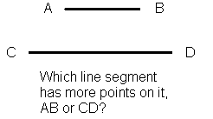

Now, pose the following question: Which line segments have the most points?
From Analytical-Geometry concepts introduced by Descartes in the 17th century, a real numbers is a point while an interval is the length between two points which is the difference between two numbers.
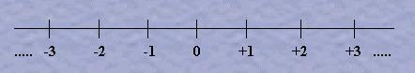

Any number represents a point on this real number axis, called O-X axis.

Higher Dimensional Analytical-Geometry:
One may extend the one dimensional analytical-geometry concepts in visualization of other algebraic elements,
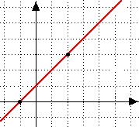
such as equations. For example, the above figure is a graph (i.e., a picture) of equation Y = X + 1, which is a straight line. The slope of the line is the Tan (a), where the angle (a) is that of the horizontal axis making with the line, counterclockwise. For example, the slope of the above line is m = Tan (45) = 1. As another example, if a line has slope of m = -1, then the angle (a) is obtained by the inverse function aTan(-1) = 135 degrees.

The Two Numbers Nature Cares Most: Inventions or Discoveries
The two numbers that Nature loves most are denoted by π and e. The first is relevant to planets movements around the sun while the second is related to the growth of population of different species.
What is π? Planets move around the Sun in ellipsoid shaped-path with major diameter and minor diameter denoted by 2a, and 2b respectively, then the areas they travel are π.a.b. For a circle a = b = r the radius of a circle, therefore the area is π.r², and its circumference length is 2 π.r . Therefore, π is the ratio of the circumference length of ANY circle divided by the length of its diameter. That is, to have a notion for the numerical value of π, take a robe of any size and make a circle, then circumference/diameter is the π.
It is nice to notice that, the derivative of the area of a circle: A = π r², is the circumference C = 2 π r. Similarly, for sphere the surface is S = 4 π r², which is the derivative of volume V = 4/3 π r³.
Beside the fact that π is a number it is also a measurement for an angle in terms of radians. A radian is an angle subtended at the center of a circle by an arc whose length is equal to the radius. Therefore:
180 degrees = π radians
In both cases, π is dimensionless; it is just a number, with two related applications.
What is e? The growth of population for every species follows an Exponential law. The size of a population is, after length of time t years is P.e ^{rt} , where P is the initial population size and r is the rate of growth of a particular species. The growth rate of human population is about r = 0.019 since World War II.
What is the difference between the accumulations of $1000 invested at a given rate (r) if the interest is compounded daily versus annually?
Suppose you invest $1000, over a period if t-years, with an annual (fixed) interest rate of r, if the interest is added n times per year at the end of each period, then your compounded investment is $1000(1 + r/n)^{nt}.
Now suppose the banker adds the interest at the end of each day then your investment growth faster 1000(1 + r/365) ^{365t} which is very close to 1000e ^{rt} which is the compounded investment continuously.
In fact, increasing number of time intervals, e.g. days into half-days, this approximation gets much better, as shown by the following limiting result when the length of each period gets smaller and smaller:
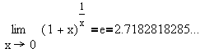
The number e is discovered by John Napier , and it is the base for the so called natural-logarithm, because this number appears frequently in nature. Notice that, the explicit function y = Ln (x), x > 0, is equivalent to the implicit function x = e^{y}, by definition. Moreover, the first and the second function are generally called the logarithmic (Ln) and the exponential (Exp) functions, respectively.
Therefore, finally the algebra and geometry are unified by the means of analytical-geometry concepts in last couple of hundred years. This helps overcoming our human visual limitation to see with the eyes-mind and work within space of higher dimensions than the 3-dimensional space we live in.

Arithmetic and geometric progressions: Many financial mathematics such as compound interest, discounting, annuities, etc are based on two kinds of series, the Arithmetic and Geometric Series

A "progression" is a series of numbers created by some rule. Two common kinds of progressions are "arithmetic" and "geometric".

Arithmetic Progression: An arithmetic progression is a sequence of the form ak + b where a and b are fixed and k runs through integer values. The goal of this section is to discover whatever we can about primes in arithmetic progression.
An arithmetic progression is built using addition. For example, we could use the rule "add 2" and create the following progression starting with the number 1:
1, 2, 4, 6, 8, 10... etc.
An arithmetic progression creates a straight line.
The sum of the numbers in (an initial segment of) an arithmetic progression is sometimes called an arithmetic series. A convenient formula for arithmetic series is available. The
sum S of the first n values of a finite sequence is given by the formula:

S = n(a₁ + a_{n})/2
where a₁ is the first term and a_{n} the last.
A geometric progression is built using multiplication. For example, we could use the rule "multiply by 2" and create the following progression starting with the number 1:
1, 2, 4, 8, 16... etc.
Notice that a geometric progression will get big very quickly compared to an arithmetic progression. In fact, it keeps getting bigger faster.
A geometric progression creates a curved line. The sum of the numbers in a geometric progression is called a geometric series. A convenient formula for geometric series is:
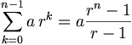
Compare this with a arithmetic progression showing linear growth (or decline) such as 4, 15, 26, 37, 48, .... Note that the two kinds of progression are related: taking the logarithm of each term in a geometric progression yields arithmetic one.
Optimization: Decision-makers (e.g. consumers, firms, governments) in standard economic theory are assumed to be "rational". That is, each decision-maker is assumed to have a preference ordering over the outcomes to which her actions lead and to choose an action, among those feasible, that is most preferred according to this ordering. We usually make assumptions that guarantee that a decision-maker's preference ordering is represented by a payoff function (sometimes called utility function), so that we can present the decision-maker's problem as one of choosing an action, among those feasible, that maximizes the value of this function.

