2.19
Category | Frequency | Percentage
A | 13 | 26%
B | 28 | 56%
C | 9 | 18%
A)

B) Category B is the highest percentage.

2.36
A)
Bulb Life | Frequency Manufacturer A |  | Bulb Life | Frequency Manufacturer B
650-749 | 3 |  | 750-849 | 2
750-849 | 5 |  | 850-949 | 8
850-949 | 20 |  | 950-1049 | 16
950-1049 | 9 |  | 1050-1149 | 9
1050-1149 | 3 |  | 1150-1249 | 5

B)
Bulb Life | Manufacturer A |  | Manufacturer B
 | Percentage | Cumulative % | Percentage | Cumulative %
650-749 | 7.5% | 7.5% | 0.0% | 0.0%
750-849 | 12.5% | 20.0% | 0.0% | 5.0%
850-949 | 50.0% | 70.0% | 0.0% | 25.0%
950-1049 | 22.5% | 92.5% | 0.0% | 65.0%
1050-1149 | 7.5% | 100.0% | 2.5% | 87.5%
1150-1249 | 0.0% | 100.0% | 2.5% | 100.0%

C) Manufacturer B produces bulbs with longer lives than Manufacturer A. 70% of the bulbs from Manufacturer A have a life of 950 or below, whereas only 25% of the bulbs from Manufacturer B have a life of 950 or below, which supports Manufacturer B having longer bulb life averages.

2.51
A) Ordered Array:
.55, .57, .57, .68, .72, .77, .86, .90, .92, .94, 1.14, 1.41, 1.42, 1.51

B) Stem-Leaf display:

.5 | 577
.6 | 8
.7 | 27
.8 | 8
.9 | 024
1.1| 4
1.4| 12
1.5| 1

C) The stem-and-leaf display gets across more information than the ordered array. Through the stem-and-leaf display you can better determine the arrangement of the data and see the price fluctuations.
D) The cost is not concentrated around any particular value in the stem-and-leaf display.

2.52
A)
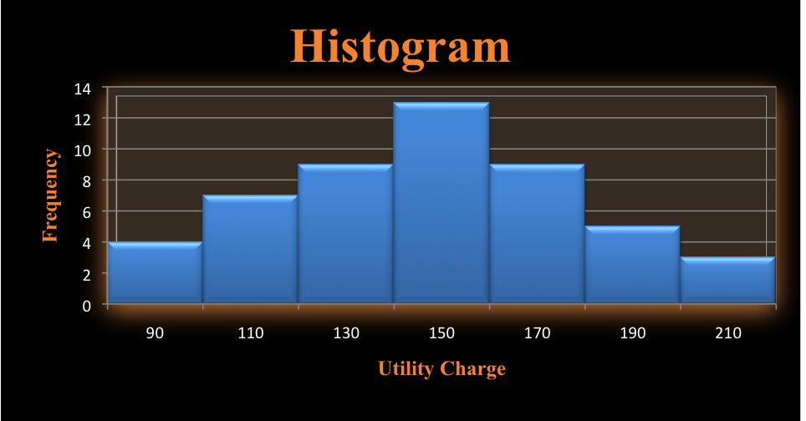

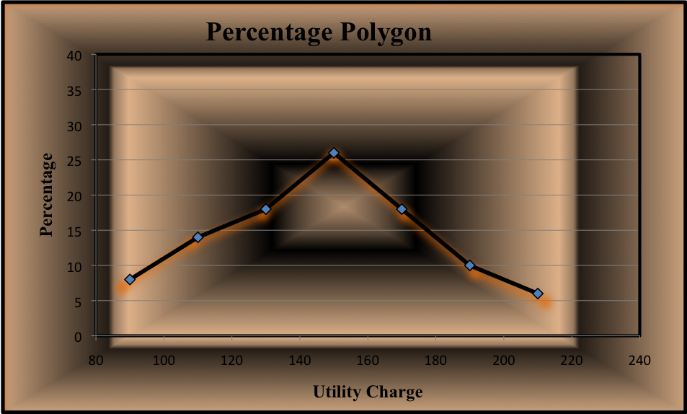

B)
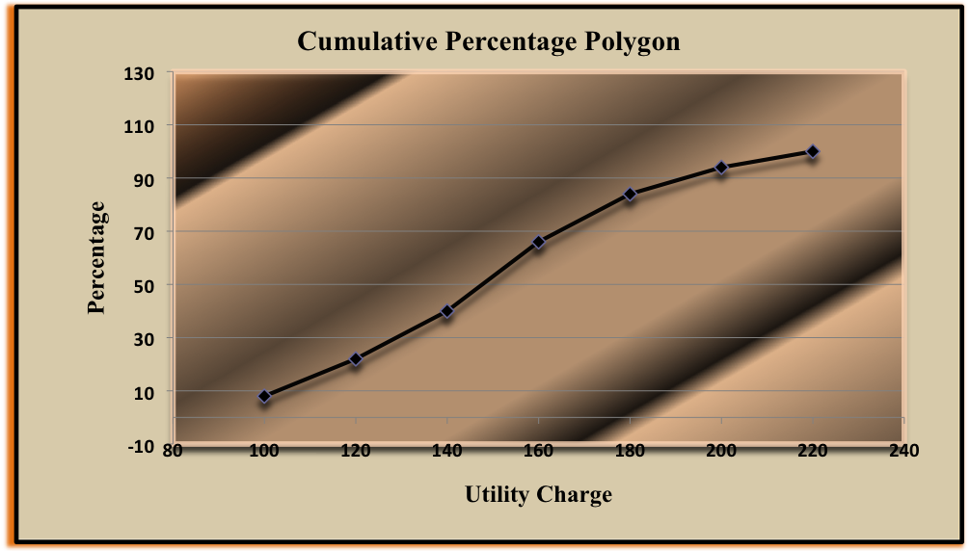

C) The majority of utility charges are between 120 and 180.

3.3
A)
X
Mean | 6
Median | 7
Mode | 7
Standard Deviation | 4
Sample Variance | 16
Kurtosis | -0.34688
Minimum | 0
Maximum | 12
Sum | 42
Count | 7
First Quartile | 3
Third Quartile | 9
Inter-quartile Range | 6
Coefficient of Variation | 66.67%

Mean = 6 ‘
Median = 7
Mode = 7

B) Range = 12 Variance = 16 Standard déviation = 4
Coefficient of variation = (4/6) x 100% = 66.67%

C) Z Scores: 1.5, 0.25, -0.5, 0.75, -1.5, 0.25, - 0.75. No outlier.

D) The distribution is left-skewed.

3.27

A)

Five Number
Minimum | 7
First Quartile | 23.5
Median | 36
Third Quartile | 44.5
Maximum | 54
Inter-quartile Range | 21

C) Right Scewerd Distribution:

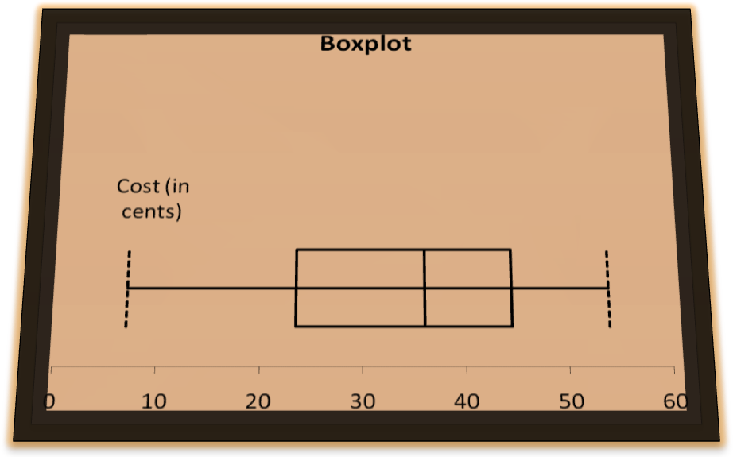

3.37
A) Population Mean = 6
B) σ$s^{2}$ = 9.4

