Using SPSS for Windows

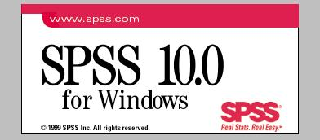

Instructions on creating charts may be found in SPSS by clicking:
Help, Tutorial, Contents, Tutorials, Creating and Editing Charts.

This Guide focuses on using common statistical procedures, creating new variables, and on selecting a subset of cases for analysis.

by Robert Jones
Associate Professor of Economics
Statistics Mentor for Faculty
Skidmore College

Summer 2000

Table of Contents

Selecting Cases 1
Recoding Variables 2
Computing New Variables 4
Descriptive Statistics 5
Frequencies 6
Descriptives 7
Crosstabs 8
Compare Means 9
Correlations 10
Regression Analysis 11
Logistic Regression 13
Using Commands 15

Selecting Cases

Selecting Cases enables you to focus only on certain observations, e.g., females in EC237.

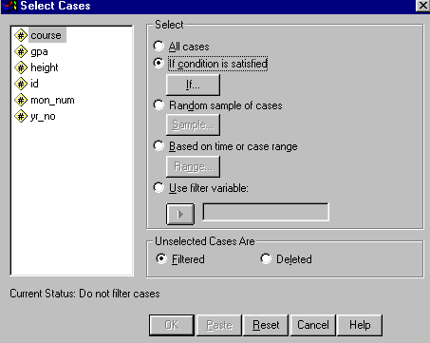
Click Data, Select Cases, then click the circle labeled “If condition is satisfied”, then click the “If…” button.

Now specify the condition for selecting (including) those observations in future analyses:
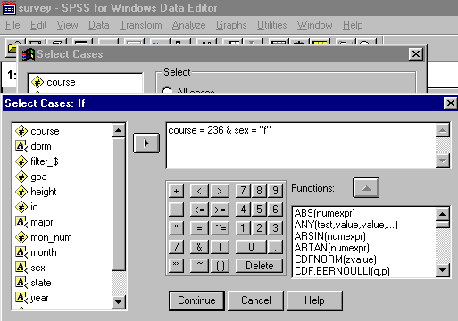

Type the conditions in the window, then click “Continue”, then click OK.

If you later want to change the condition or revert to all cases, choose Data, Select Cases, and make the appropriate changes.

Recoding Variables

Recoding variables enables you to create new variables based on values of existing variables.

For example, to recode “yr_no” 3 and 4 into a code of 1 in a new variable called “jrsr” with “yr_no” 1 and 2 coded as 0 in “jrsr”, do the following:

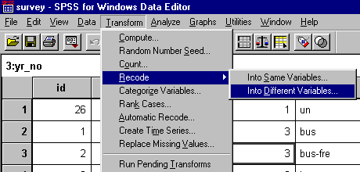
Choose Transform, Recode, Into Different Variable

Type the name of the existing variable to be recoded in the Numeric Variable box, then give a name to the new variable to be created in the Output Variable Name box, then click the “Change” box. Then Click “Old and New Values”. Valid SPSS names may be up to 8 characters (numbers, letters, or “_” only), beginning with a letter.
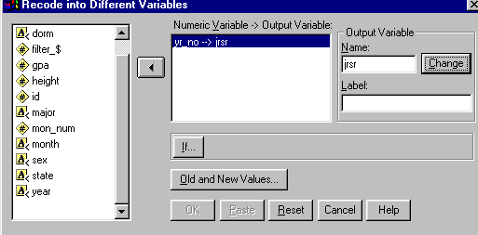

Indicate the range of values in the “Old” variable on the left hand side and the New Value of the new variable for those values on the right hand side. Then click “Add”.
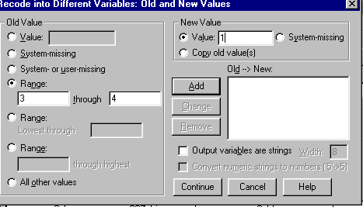
Then do the same for each other individual or range of values for the old variable until the “Add” window shows how all possible values of the old variable will be recoded into the new variable. In this example, the result would look like this:
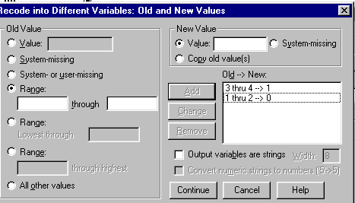
When finished with this recoding, click Continue, then OK.
Then click Transform, Run Pending Transformations.

In the data editor window, your newly created variable will appear on the rightmost column.

Computing New Variables

Computing (calculating) a new variable.

If you want to create a new variable from arithmetic operations on an existing variable, click Transform, Compute.

In the Target Variable box, provide a name for the new variable. Valid SPSS names may be up to 8 characters (numbers, letters, or “_” only), beginning with a letter.
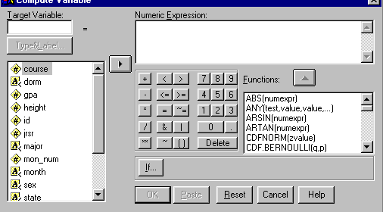

In the “Numeric Expression” window, enter a formula. For example if you wanted to convert height (in inches) into feet, you might name the target variable “Ht_feet”, with the “Numeric Expression” being “height/12”. These equations can be quite complex and may use any of the “Functions” shown. For example for the natural log of height in feet, the equation would read “LN(height/12)”.

When you have finished the equation, click OK.

In the data editor window, your newly created variable will appear on the rightmost column.

Descriptive Statistics

Statistical applications are reached via the Analyze menu item.
Shown below are the Descriptive Statistics options.

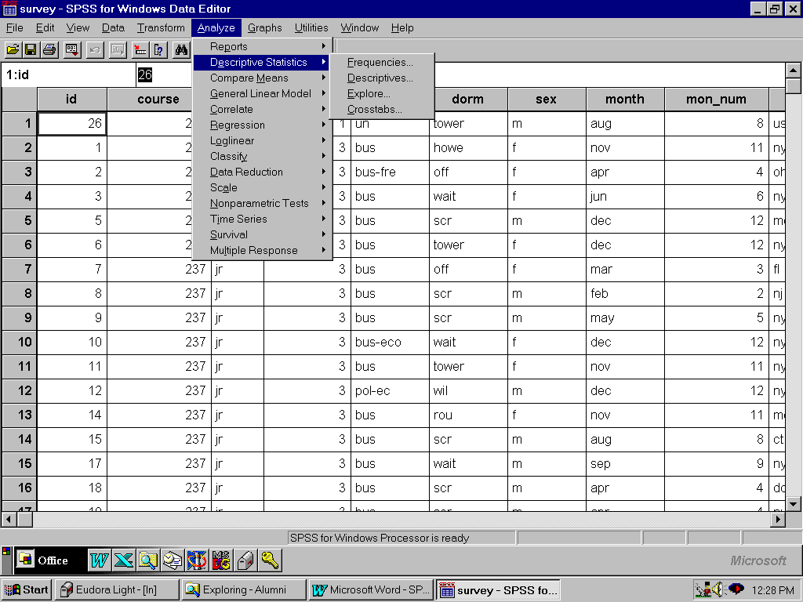

The pages that follow explain some of these commonly used options.

Frequencies

Using Frequencies (Analyze, Descriptive Statistics, Frequencies)

Frequencies is used to count the number of occurrences for each possible value of a variable. Frequencies is usually used for categorical or nominal variables, e.g., sex, marital status. Frequencies may be used for integer data if there are not many numerical possibilities, e.g., number of children.
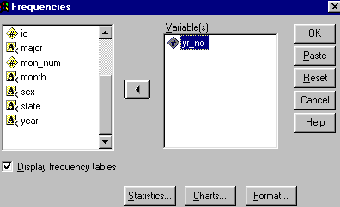

Typical Frequencies output is shown below:

YR_NO
 |  | Frequency | Percent | Valid Percent | Cumulative Percent
Valid | 1 | 1 | 2.3 | 2.3 | 2.3
 | 2 | 12 | 27.9 | 27.9 | 30.2
 | 3 | 25 | 58.1 | 58.1 | 88.4
 | 4 | 5 | 11.6 | 11.6 | 100.0
 | Total | 43 | 100.0 | 100.0

Descriptives

Using Descriptives (Analyze, Descriptive Statistics, Descriptives)

Descriptives are used with numerical data in order to obtain measures of central tendency and dispersion.

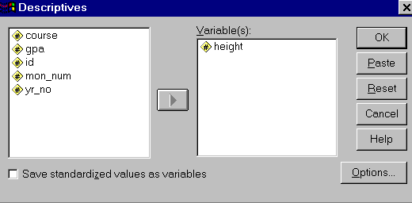

The default Descriptives output is as follows:

Descriptive Statistics
 | N | Minimum | Maximum | Mean | Std. Deviation
HEIGHT | 43 | 57.0 | 81.0 | 67.919 | 4.487
Valid N (listwise) | 43

Crosstabs

Using Crosstabs (Analyze, Descriptive Statistics, Crosstabs)

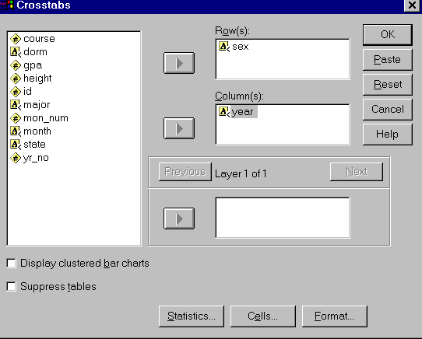
Crosstabulations are used to compare two categories, e.g., sex and year, to each other. Usually the causal variable is placed in the columns and the effect in the rows. This rule may be overridden if the table would fit on a page better if the column and row variables are reversed. It is usually useful to select Cells and select the Percent of whichever is the causal variable, e.g., Columns. (If the cause is placed in the rows, select Percent of Rows instead.)

Typical Crosstabs output:

SEX * YEAR Crosstabulation
Count
 |  | YEAR |  |  |  | Total
 |  | fr | jr | so | sr
SEX | f |  | 12 | 2 | 3 | 17
 | m | 1 | 13 | 10 | 2 | 26
Total |  | 1 | 25 | 12 | 5 | 43

Each cell (i.e., combination) shows the count of each combination and the percentage of the row that the total represents.

If you are interested in a hypothesis test of independence between the categories, select Statistics, Chi-Square:
Chi-Square Tests
 | Value | df | Asymp. Sig. (2-sided)
Pearson Chi-Square | 4.904 | 3 | .179
Likelihood Ratio | 5.552 | 3 | .136
N of Valid Cases | 43
5 cells (62.5%) have expected count less than 5. The minimum expected count is .40.

Compare Means
(Analyze, Compare Means, Means)

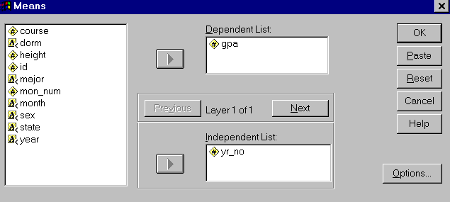
To compare two or more means, select Analyze, Compare Means, Means. The Dependent List should compare the variables whose means you want to compare, e.g., income. The Independent List should contain the variable containing the criteria by which you want to separate out the means, e.g., sex, race, etc. This will give you the mean income by sex or by race. Under Options you may want to select Anova Table if you want to perform a hypothesis test of equality of the means.

Sample Compare Means output is shown below:

Report
GPA
YR_NO | Mean | N | Std. Deviation
1 | 3.5000 | 1 | .
2 | 3.1592 | 12 | .3675
3 | 2.9808 | 25 | .3519
4 | 3.4220 | 5 | .1540
Total | 3.0940 | 43 | .3660

If the ANOVA table is selected, you also see the following table:

ANOVA Table
 |  |  | Sum of Squares | df | Mean Square | F | Sig.
GPA * YR_NO | Between Groups | (Combined) | 1.074 | 3 | .358 | 3.067 | .039
 | Within Groups |  | 4.553 | 39 | .117
 | Total |  | 5.627 | 42

Correlations
(Analyze, Correlate)

Correlation Analysis may be performed by selecting Analyze, Correlate, Bivariate.
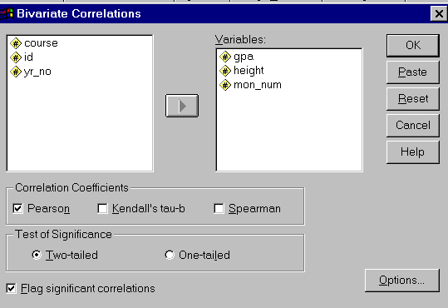

Output from Correlate is shown below:

Correlations
 |  | GPA | HEIGHT | MON_NUM
GPA | Pearson Correlation | 1.000 | -.112 | .022
 | Sig. (2-tailed) | . | .475 | .891
 | N | 43 | 43 | 43
HEIGHT | Pearson Correlation | -.112 | 1.000 | .108
 | Sig. (2-tailed) | .475 | . | .492
 | N | 43 | 43 | 43
MON_NUM | Pearson Correlation | .022 | .108 | 1.000
 | Sig. (2-tailed) | .891 | .492 | .
 | N | 43 | 43 | 43

Regression Analysis

Regression analysis may be performed by selecting Analyze, Regression, Linear.
Under the Statistics option, you may want to select Descriptives and Collinearity Diagnostics.
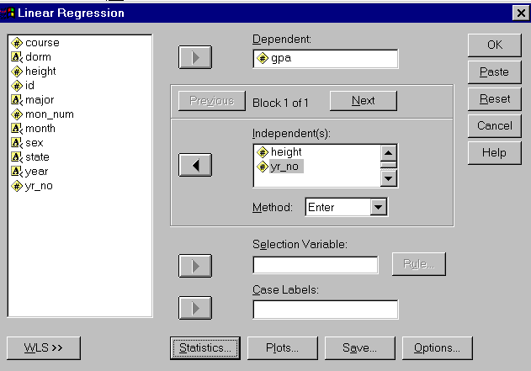

Sample Regression Output

Descriptive Statistics
 | Mean | Std. Deviation | N
GPA | 3.0940 | .3660 | 43
HEIGHT | 67.919 | 4.487 | 43
YR_NO | 2.79 | .67 | 43

Correlations
 |  | GPA | HEIGHT | YR_NO
Pearson Correlation | GPA | 1.000 | -.112 | .004
 | HEIGHT | -.112 | 1.000 | -.025
 | YR_NO | .004 | -.025 | 1.000
Sig. (1-tailed) | GPA | . | .237 | .489
 | HEIGHT | .237 | . | .436
 | YR_NO | .489 | .436 | .
N | GPA | 43 | 43 | 43
 | HEIGHT | 43 | 43 | 43
 | YR_NO | 43 | 43 | 43

Model Summary
Model | R | R Square | Adjusted R Square | Std. Error of the Estimate
1 | .112 | .013 | -.037 | .3727
Predictors: (Constant), YR_NO, HEIGHT

ANOVA
Model |  | Sum of Squares | df | Mean Square | F | Sig.
1 | Regression | 7.062E-02 | 2 | 3.531E-02 | .254 | .777
 | Residual | 5.556 | 40 | .139
 | Total | 5.627 | 42
a Predictors: (Constant), YR_NO, HEIGHT
b Dependent Variable: GPA

Coefficients
 |  | Unstandard-ized Coefficients |  | Standardized Coefficients | t | Sig. | Collinearity Statistics
Model |  | B | Std. Error | Beta |  |  | Tolerance | VIF
1 | (Constant) | 3.712 | .910 |  | 4.078 | .000
 | HEIGHT | -9.135E-03 | .013 | -.112 | -.712 | .480 | .999 | 1.001
 | YR_NO | 8.397E-04 | .085 | .002 | .010 | .992 | .999 | 1.001
Dependent Variable: GPA

Logistic Regression
(Analyze, Regression, Binary Logistic)

Logistic (Logit) Regression may be performed by selecting Analyze, Regression, Binary Logistic. The dependent variable is normally a bivariate (i.e., "0", "1") variable. The independent variables are selected as "Covariates".

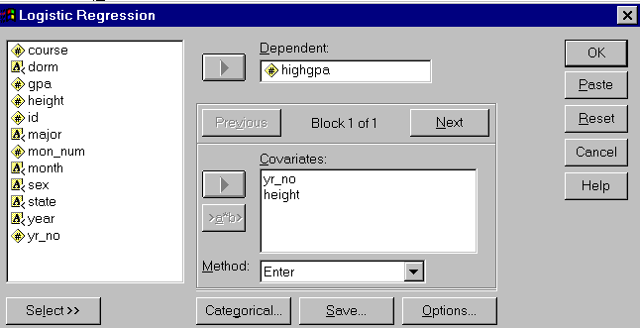

Sample Logistic Results are shown on the next page . . .
Output from Binary Logistic Regression
[Excerpts]
_

Total number of cases: 43 (Unweighted)

Estimation terminated at iteration number 3 because
Log Likelihood decreased by less than .01 percent.

-2 Log Likelihood 55.161
Goodness of Fit 42.498
Cox & Snell - R^2 .058
Nagelkerke - R^2 .078

Chi-Square df Significance

Model 2.552 2 .2791
Block 2.552 2 .2791
Step 2.552 2 .2791

Classification Table for HIGHGPA
The Cut Value is .50
Predicted
.00 1.00 Percent Correct
0 1
Observed -----------------
.00 0 21 5 80.77%
-----------------
1.00 1 13 4 23.53%
-----------------
Overall 58.14%

---------------------- Variables in the Equation -----------------------

Variable B S.E. Wald df Sig R Exp(B)

YR_NO .0987 .4741 .0434 1 .8350 .0000 1.1038
HEIGHT -.1168 .0778 2.2541 1 .1333 -.0664 .8897
Constant 7.2076 5.4732 1.7342 1 .1879

Using Commands
(Syntax) Files

If you prefer (or need) to enter SPSS commands or have a file containing such commands, you may instruct SPSS Windows run those commands in so called Production mode.

To open an existing command file, select File, Open, SPSS Syntax.
Then select the Drive, Directory, and File name contaning the commands.

To enter commands directly into SPSS Windows, select File, New, SPSS Syntax.

For help with command syntax, while entering commands, click Syntax.

Use the mouse to select the commands which you want to run.
To select a few commands to be run,
Move the mouse to the beginning of the desired commands, then,
holding down the left mouse button,
drag the mouse over the desired command lines, then
release the mouse button.
To select all of the commands from the cursor to the end of the syntax box,
Move the mouse to the beginning of the desired commands, then
press shift-control-end.

Select Run after the commands have been selected.

The progress of SPSS will be reported at the bottom of the SPSS Window.
The results will appear in the Output window as the commands are processed.
The output window may be enlaraged (i.e., maximized) by clicking on the “^” button in the upper right-hand corner of that window.

To edit or add to your commands, make the syntax window become the active window by clicking anywhere on the syntax window (or select Window from the menu at the top of the screen, then click on the name of the window containing your commands), and edit or add the commands.

After you have modified or added your commands, use the mouse to select the commands to be run (as described above), then select Run.

You may save the contents of your command (i.e., Syntax) or Output window by selecting File, Save As, then enter a file name. Click OK.

You may print out the results contained in the Output or the Syntax window by making that window the active window (by clicking anywhere on it) and then selecting File, Print, OK.

