**CHAPTER 15**

**THE HUMAN RESOURCES MANAGEMENT/PAYROLL CYCLE**

**SUGGESTED ANSWERS TO DISCUSSION QUESTIONS**

**15.1** **This chapter noted many of the benefits that can arise by integrating the HRM and payroll databases. Nevertheless, many companies maintain separate payroll and HRM information systems. Why do you think this is so? (*Hint:* Think about the differences in employee background and the functions performed by the HRM and payroll departments.)**

Payroll and HRM systems are separate in many companies because integration was generally not feasible using early data processing technology. Also, different events generate data and two different professions were interested in using the data. As a result, many companies (and their employees) became accustomed to having payroll data processed by the accounting function and personnel data processed by the human relations function. Now that modern information technology makes integration more feasible, employees in some companies are still likely to resist suggestions for change because they are comfortable with the old way of doing things. In addition, employees within the accounting and personnel functions probably feel some degree of "ownership" of "their" data, and this is taken away when control of these data is transferred to a centralized data base function.

Reasons for integrating the personnel and HRM systems include the following:

* Integration will improve decision-making by providing access to more of the relevant data needed for monitoring employee development.
* It is logical, since both systems are organized around the same entity: the employee.
* It should facilitate the retrieval and utilization of employee data when the data required would otherwise have to be obtained from both data bases.
* It should facilitate the process of updating employee data, since a single update process would replace two separate updating processes.
* It should simplify the development and implementation of more complex compensation schemes, such as flexible benefits or incentive pay.
* Centralizing the administration of employee data under the control of database management software should enhance data security.
* It should minimize or eliminate the cost of storing identical data in two different databases.
* It should minimize or eliminate the confusion that might otherwise arise when two different databases use different data definitions, or report different values, for the same data item.

**15.2** **Some accountants have advocated that a company’s human assets be measured and included directly in the financial statements. For example, the costs of hiring and training an employee would be recorded as an asset that is amortized over the employee’s expected term of service. Do you agree or disagree? Why?**

This question should generate some debate. The issue is the trade-off between “subjectivity” in measuring the value of a company’s investment in the knowledge and skills of its employees versus the usefulness of at least attempting to explicitly measure those assets.

In the “information era” the value of a company’s employee knowledge base is increasingly important. Attempting to measure it should facilitate more effective management of this resource by focusing more attention on it.

Some companies, such as Dow Chemical and Skandia, have attempted to formally provide stockholders with information about the company’s intellectual capital, but such efforts have not become mainstream because of the inherent subjectivity.

**15.3** **You are responsible for implementing a new employee performance measurement system that will provide factory supervisors with detailed information about each of their employees on a weekly basis. In conversation with some of these supervisors, you are surprised to learn they do not believe these reports will be useful. They explain that they can already obtain all the information they need to manage their employees simply by observing the shop floor. Comment on that opinion.**

Formal reports on employee performance are not intended to replace direct observation, but to supplement it. Direct observation is important, but a manager cannot observe all employees all the time. It is also difficult to accurately summarize detailed observations across time.

**How could formal reports supplement and enhance what the supervisors learn by direct observation?**

Well-designed reports provide quantitative summary measures of aspects of employee performance that are believed to be important to the achievement of the organization’s goals. Quantitative measures facilitate tracking performance trends over time. These benefits, however, will be difficult for many managers to understand until they have had experience in using such reports.

There are also legal issues at stake. If an employee or former employee brings suit against the employer, supporting documentation may justify the employer’s position.

**15.4 One of the threats associated with having employees telecommute is that they may use company-provided resources (e.g., laptop, printer, etc.) for a side business. What are some other threats?**

Other threats are:

1. Not working or working less productively than if the employees were working onsite.
2. Security risks, such as the employee not proactively maintaining proper antivirus and patch management practices or not protecting and/or backing up their data adequately.
3. Inappropriate use of company hardware (e.g., gambling, visiting pornographic websites, etc.).
4. An increased risk of loss of confidentiality and privacy if sensitive data is stored on the remote computer. Such remote storage may also violate privacy regulations, such as HIPAA.

**What controls can mitigate the risk of these threats?**

The solutions to these potential threats primarily involve monitoring and the use of security controls discussed in chapter 8. For example, software exists to enable companies to monitor employees, including what they do on the Internet.

In addition, a company could require that telecommuting employees login their company’s network and store all work related files on the company’s network and not on their home machines. The VPN connection could be configured to restrict what employees can do, such as preventing local storage of sensitive data and mandatory updates of anti-virus and security software. The VPN software should also be designed to prevent employees from simultaneously opening a VPN connection to the corporate network and a second connection to their ISP (i.e., disable split-tunneling).

**15.5 How would you respond to the treasurer of a small charity who tells you that the organization does not use a separate checking account for payroll because the benefits are not worth the extra monthly service fee?**

A separate payroll account limits the organization’s exposure to only the amount of cash deposited into the payroll account.

A separate account is also easier to reconcile and to detect any errors or irregularities.

**15.6 This chapter discussed how the HR department should have responsibility for updating the HRM/payroll database for hiring, firing, and promotions. What other kinds of changes may need to be made?**

Other types of changes include name changes (usually due to change in marital status), number of dependents, voluntary extra withholdings, and address changes.

**What controls should be implemented to ensure the accuracy and validity of such changes?**

Allow employees to make these changes through a web-based application available on the organization’s intranet. The application should include processing integrity checks to prevent invalid entries.

Closed loop verification (displaying all changes to the employee) should also be used.

To ensure validity, multi-factor authentication should be required to enter such changes

Strict access controls should be implemented to protect the master database.

A detective control is to separately notify the employee of changes that were made and ask for confirmation that they are valid.

**SUGGESTED ANSWERS TO THE PROBLEMS**

**15.1** **Match the terms in the left column with the appropriate definition from the right column.**

|  |  |
| --- | --- |
| 1. _e__ Payroll service bureau | a. A list of each employee’s gross pay, payroll deductions, and net pay in a multicolumn format. |
| 2. _h__ Payroll clearing account | b. Used to record the activities performed by a salaried professional for various clients. |
| 3. _g__ Earnings statement | c. Used to record time worked by an hourly-wage employee. |
| 4. _a__ Payroll register | d. An organization that processes payroll and provides other HRM services. |
| 5. _c__ Time card | e. An organization that processes payroll. |
| 6. _b__ Time sheet | f. A list of all the deductions for each employee. |
|  | g. A document given to each employee that shows gross pay, net pay, and itemizes all deductions both for the current pay period and for the year-to-date. |
|  | h. Special general ledger account used for payroll processing. |

**15.2** **What internal control procedure(s) would be most effective in preventing the following errors or fraudulent acts?**

**a. An inadvertent data entry error caused an employee’s wage rate to be overstated in the payroll master file.**

* Have the personnel department maintain a hash total of employee wage rates
* Check hash total against payroll master file total after each update.
* Test the reasonableness of wage rate changes during data entry to detect large errors.
* Have supervisors review departmental payroll expenses as a way of detecting these kinds of problems.

**b. A fictitious employee payroll record was added to the payroll master file.**

* Use strong multifactor authentication techniques to restrict access to the payroll master data to authorized personnel in the HR department..
* Have the personnel department maintain a record count of the number of employees and check it against a record count generated during each payroll-processing run.

Require positive identification of recipients as each paycheck is distributed. This would likely result in the paycheck not being claimed, which would then trigger an investigation.

* Periodically print and verify all changes to the payroll master file

**c. During data entry, the hours worked on an employee’s time card for one day were accidentally entered as 80 hours, instead of 8 hours.**

* Use a limit check during data entry to check the hours-worked field for each employee transaction record. Management would set a limit that makes sense in their organization. If overtime was never allowed, they could use 8 hours for the limit. If overtime was permitted, they might decide instead to use 9 or 10 hours.

**d. A computer operator used an online terminal to increase her own salary.**

* Use passwords and an access control matrix to restrict access to authorized personnel.
* Use a compatibility test on all transactions entered to verify that the operator's password allows access and modification authority.
* Have the the personnel department maintain a batch total of all salaries and check it against the corresponding total generated during each payroll run as a backup control,

**e. A factory supervisor failed to notify the HRM department that an employee had been fired. Consequently, paychecks continued to be issued for that employee. The supervisor pocketed and cashed those paychecks.**

* Implement a policy prohibiting supervisors from picking up or distributing paychecks. Instead, have the payroll department distribute all paychecks.
* Investigate all unclaimed paychecks.

**f. A factory employee punched a friend’s time card in at 1:00 p.m. and out at 5:00 p.m. while the friend played golf that afternoon.**

* Use biometric controls to record time in and time out
* Observe (in person or by video surveillance) time clock activity to uncover punching other people’s cards
* Collect detailed job time data and *prior to payroll processing* reconcile it with data
  + Prepared or approved by factory supervisors, or
  + Captured with automated data collection equipment

**g. A programmer obtained the payroll master file and increased his salary.**

* Implement physical access controls such as a file library function to prevent programmers from having unsupervised access to production databases
* Implement authentication and authorization controls such as user ID’s, passwords, and access control matrix to limit access to all master files to authorized personnel
* Have supervisors review reports of all changes to payroll master data to detect this type of fraud
* Have the the personnel department maintain a batch total of all salaries and check it against the corresponding total generated during each payroll run as a backup control,
* Batch total of all salaries maintained by the personnel department that is checked against a corresponding total generated during each payroll run.

**h. Some time cards were lost during payroll preparation; consequently, when paychecks were distributed, several employees complained about not being paid.**

A record count of job time records should be prepared before the records are submitted for processing, and checked subsequent to data entry. In addition, reconciliation of job time records to employee clock cards should detect this.

* Prepare a record count of job time records before they are submitted for processing and compare record count subsequent to data entry against the number of paychecks prepared.
* Reconcile job time records to employee clock cards
* Print a payroll register report with the paychecks. The total number of employees should match the number in the payroll master file
  + Promptly investigate any discrepancies.

**i. A large portion of the payroll master file was destroyed when the disk pack containing the file was used as a scratch file for another application.**

* Use internal and external file labels to identify the contents and expiration date of all active files
* Train computer operators to carefully examine external file labels before file processing begins.
* Have all programs check internal file labels prior to processing.
* Maintain backup copies of all current files.

**j.** **The organization was fined $5000 for making a late quarterly payroll tax payment to the IRS.**

* Use IRS Publication Circular E, which provides instructions for making required remittances of payroll taxes, to configure the system to make payroll tax payments.
* Set up a quarterly “tickler” or reminder message to the cashier about making the required payroll tax remittance.

**15.3 You have been hired to evaluate the payroll system for the Skip-Rope Manufacturing Company. The company processes its payroll in-house. Use Table 15-1 as a reference to prepare a list of questions to evaluate Skip-Rope’s internal control structure as it pertains to payroll processing for its factory employees. Each question should be phrased so that it can be answered with either a yes or a no; all no answers should indicate potential internal control weaknesses. Include a third column listing the potential problem that could arise if that particular control were not in place.** (CPA Exam, adapted)

|  |  |  |
| --- | --- | --- |
| **Question** | **Y/N** | **Threat if control missing** |
| 1. Are payroll changes (hires, separations, salary changes, overtime, bonuses, promotions, etc.) properly authorized and approved? |  | 1. Unauthorized pay raises and fictitious employees. |
| 2. Are discretionary payroll deductions and withholdings authorized in writing by employees? |  | 2. Errors; employee lawsuits; penalties if tax code violated. |
| 3. Are the employees who perform each of the following payroll functions independent of the other five functions?   * personnel and approval of payroll changes * preparation of payroll data * approval of payroll * signing of paychecks * distribution of paychecks * reconciliation of payroll account |  | 3. Fraud; theft of paychecks. |
| 4. Are changes in standard data on which payroll is based (hires, separations, salary changes, promotions, deduction and withholding changes, etc.) promptly input to the system to process payroll? |  | 4. Errors in future payroll; possible fines and penalties. |
| 5. Is gross pay determined by using authorized salary rates and time and attendance records? |  | 5. Over/under payment of employees. |
| 6. Are clerical operations in payroll preparation verified? |  | 6. Errors not detected. |
| 7. Is payroll preparation and recording reviewed by supervisors or internal audit personnel? |  | 7. Errors not detected and corrected. |
| 8. Is access to payroll master data restricted to authorized employees? |  | 8. Unauthorized changes in pay rates or creation of fictitious employees. |
| 9. Are paychecks approved by reviewing the payroll register before payroll checks are issued? |  | 9. Fraudulent paychecks. |
| 10. Is a separate checking account used for payroll? |  | 10. Greater risk of paycheck forgery; harder to reconcile payroll. |
| 11. Is the payroll bank account reconciled to the general ledger by someone not involved in payroll or paycheck distribution? |  | 11. Failure to detect errors |
| 12. Are payroll bank reconciliations properly approved and differences promptly followed up? |  | 12. Failure to detect and correct problems. |
| 13. Is the custody and follow-up of unclaimed salary checks assigned to a responsible official? |  | 13. Theft of paychecks. Failure to detect fake employees. |
| 14. Are differences reported by employees followed up on a timely basis by persons not involved in payroll preparation? |  | 14. Cover-up of fraud. |
| 15. Are there procedures (e.g., tickler files) to assure proper and timely payment of withholdings to appropriate bodies and to file required information returns? |  | 15. Fines and/or penalties. |
| 16. Are employee compensation records reconciled to control accounts? |  | 16. Inaccurate records; failure to detect and correct errors. |
| 17. Is access to personnel and payroll records, checks, forms, signature plates, etc. limited? |  | 17. Fraudulent payroll. |
| 18. Is payroll master data encrypted both in storage and during transmission over the Internet? |  | 18. Unauthorized disclosure of sensitive information. |
| 19. Is payroll master data regularly backed up? |  | 19. Loss of data. |
| 20. Are credentials of job applicants verified? |  | 20. Hiring larcenous or unqualified employees. |
| 21. Are hiring, firing, and performance evaluation processes performed in accordance with applicable laws and such practices documented? |  | 21. Possible violations of employment laws. |

**15.4 Although most medium and large companies have implemented sophisticated payroll and HRM systems like the one described in this chapter, many smaller companies still maintain separate payroll and HRM systems that employ many manual procedures. Typical of such small companies is the Kowal Manufacturing Company, which employs about 50 production workers and has the following payroll procedures:**

**• The factory supervisor interviews and hires all job applicants. The new employee prepares a W-4 form (Employee’s Withholding Exemption Certificate) and gives it to the supervisor. The supervisor writes the hourly rate of pay for the new employee in the corner of the W-4 form and then gives the form to the payroll clerk as notice that a new worker has been hired. The supervisor verbally advises the payroll department of any subsequent pay raises.**

**• A supply of blank time cards is kept in a box near the entrance to the factory. All workers take a time card on Monday morning and fill in their names. During the week they record the time they arrive and leave work by punching their time cards in the time clock located near the main entrance to the factory. At the end of the week the workers drop the time cards in a box near the exit. A payroll clerk retrieves the completed time cards from the box on Monday morning. Employees are automatically removed from the payroll master file when they fail to turn in a time card.**

**• The payroll checks are manually signed by the chief accountant and then given to the factory supervisor, who distributes them to the employees. The factory supervisor arranges for delivery of the paychecks to any employee who is absent on payday.**

**• The payroll bank account is reconciled by the chief accountant, who also prepares the various quarterly and annual tax reports.**

**a. Identify weaknesses in current procedures, and explain the threats that they may allow to occur.**

|  |  |
| --- | --- |
| **Weakness** | **Threat** |
| 1. Factory supervisor hires all job applicants and forwards their W-4 form to the payroll clerk. | The factory supervisor could hire fictitious employees and submit their W-4 form. |
| 2. Factory supervisor verbally informs payroll of all employee pay raises. | No documentation on pay raises could lead to employee disputes and litigation.  The factory supervisor could give the fictitious employees raises. |
| 3. Factory supervisors determine pay rates | Factory supervisors can overpay or underpay new hires |
| 4. Blank time cards are readily available. | An employee could have another employee fill out a time card when they were late or not even at work. |
| 5. Weekly time cards are not collected until the next Monday. | Time cards could be altered over the weekend with fictitious or false information in the case of a vendetta against another employee.  Someone could “fire” an employee by removing his timecard over the weekend |
| 1. Employees are automatically removed from the payroll master if they do not turn in a timecard | A sick employee or one on vacation could be “fired” because they did not turn in a timecard. |
| 7. The factory supervisor distributes pay checks. | The supervisor can conveniently keep the pay checks of fictitious or fired employees. |

**b. Suggest ways to improve the Kowal Manufacturing Company’s internal controls over hiring and payroll processing.** *(CPA Examination, adapted)*

1. A system of advice forms should be installed so that new hires, terminations, rate changes, etc., are reported to the payroll department in writing. Such forms should be submitted by the employee and verified by the appropriate supervisor.
2. Before applicants are hired, their backgrounds should be investigated by contacting references to determine that they are honest and have no undesirable personal characteristics.
3. The supply of blank time cards should be removed. At the beginning of each week the payroll department should provide each worker with a time card with his name typed or printed on it.
4. The foreman should collect the time cards at the end of the week, approve them, and turn them over to the payroll clerk. All time cards should be accounted for and any missing cards investigated.
5. The payroll checks should be distributed to the workers by a responsible person other than the foreman. Unclaimed checks should be sent to internal audit until claimed by the worker.

In addition, the following changes should be made because the problem does not state that these procedures are being followed:

* If the Company has a cost system that requires the workers to prepare production reports or to account for their time by work tickets, the time cards and the production reports or work tickets should be compared.
* The payroll checks should be prenumbered to control their issuance.
* A responsible person other than the chief accountant and the payroll clerks should reconcile the payroll bank account.
* From time to time, an officer of the Company should witness a payroll distribution on a surprise basis.

**15.5 Arlington Industries manufactures and sells engine parts for large industrial equipment. The company employs over 1,000 workers for three shifts, and most employees work overtime when necessary. Figure 15-10 depicts the procedures followed to process payroll. Additional information about payroll procedures follows:**

**• The HRM department determines the wage rates of all employees. The process begins when a form authorizing the addition of a new employee to the payroll master file is sent to the payroll coordinator for review and approval. Once the information about the new employee is entered in the system, the computer automatically calculates the overtime and shift differential rates for that employee.**

**• A local accounting firm provides Arlington with monthly payroll tax updates, which are used to modify the tax rates.**

**• Employees record time worked on time cards. Every Monday morning the previous week’s time cards are collected from a bin next to the time clock, and new time cards are left for employees to use. The payroll department manager reviews the time cards to ensure that hours are correctly totaled; the system automatically determines if overtime has been worked or a shift differential is required.**

**• The payroll department manager performs all the other activities depicted in Figure 15-10.**

**• The system automatically assigns a sequential number to each payroll check. The checks are stored in a box next to the printer for easy access. After the checks are printed, the payroll department manager uses an automatic check-signing machine to sign the checks. The signature plate is kept locked in a safe. After the checks have been signed, the payroll manager distributes the paychecks to all first-shift employees. Paychecks for the other two shifts are given to the shift supervisor for distribution.**

**• The payroll master file is backed up weekly, after payroll processing is finished.**

*(CMA Examination, adapted)*

**a. Identify and describe at least three weaknesses in Arlington Industries’ payroll process.**

* The payroll processing system at Arlington Industries violates the principle of segregation of duties. The same individual verifies time cards, inputs payroll information into the master file, prints the checks, machine-signs the checks, distributes the checks, and prepares the payroll journal entry.
* There is no authorization of employees' time cards by a supervisor or other objective party such as a timekeeper.
* Time cards are not stored securely when completed on Fridays.
* There is no authorization of overtime.
* The payroll checks are not prenumbered nor are they properly stored. As a result, there is no audit trail to verify check usage.
* Supervisors for the second and third shifts distribute paychecks.

**b. Identify and describe at least two different areas in Arlington’s payroll processing system where controls are satisfactory.**

* The personnel department determines the wage rate and initiates the setup of payroll records, which is a good example of segregation of duties.
* A backup of the master file is made after each weekly processing of the payroll.
* A local accounting firm provides Arlington Industries with updates on tax rates.
* Time cards are reviewed for accuracy.

**15.6 Excel Problem**

**Objective: Learn how to find and correct errors in complex spreadsheets used for payroll.**

**a. Read the article “Ferret Out Spreadsheet Errors” by Mark G. Simkin, in the *Journal of Accountancy* (February 2004). You can find a copy online by accessing www.aicpa.org.**

**b. Download the worksheet referenced in the article.**

**c. Enter the following erroneous data in the worksheet you downloaded in step b:**

* **Change hours worked for Adams to 400,**
* **Change hours worked for Englert to 4, and**
* **Change hours worked for Hartford to –40.**

**Create a chart like that shown in Exhibit 2 of the article. Which of the errors are easily found by the chart? What are the strengths and limitations of creating such charts to detect errors? Print out your chart and save your work.**

Note: Disable data validation on the hours worked column in order to input erroneous data.



The errors on the time cards of Adams, Englert, and Hartfort are easily identified. The chart clearly identifies the employees whose reported hours are different from their fellow employees.

The downside of the chart is that it would be difficult to identify less obvious errors; for example, recording 41 hours instead of 40 hours may not be readily apparent.

**d. Create the three data validation rules described in the article (Exhibits 4–7 illustrate how to create the first rule). Print out screen shots of how you create each rule, and save your work. (Note: The article “Block That Spreadsheet Error” by Theo Callahan, in the *Journal of Accountancy* (August 2002) provides additional examples of data validation rules.)**

Rule 1: Payrates must be between $6.75 and $14.00.

* Step 1: Select the relevant range of cells
* Step 2: On the data tab, select Data Validation
* Step 3: Complete the windows as follows:

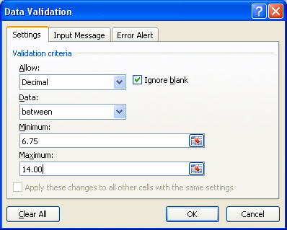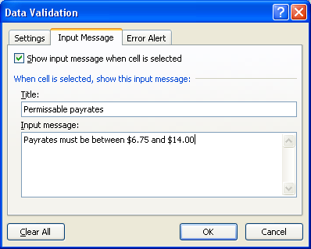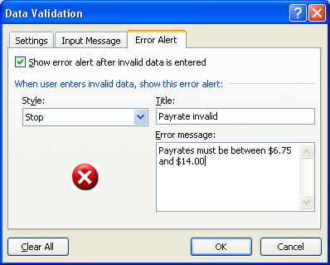

Rule 2: Hours worked must be between 0 and 40

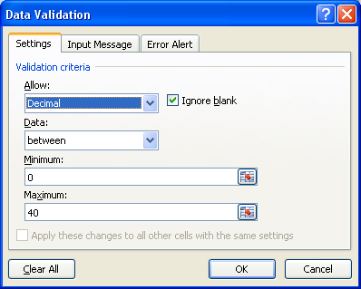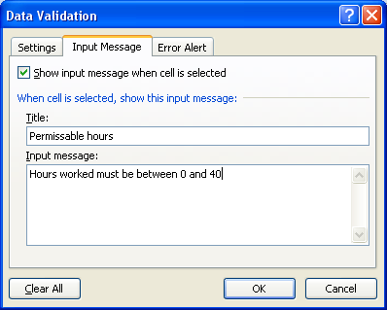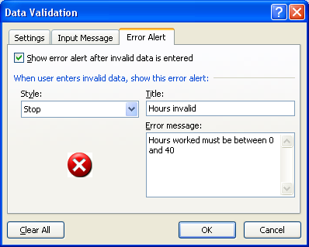

Rule 3: Overtime must be between 0 and 10

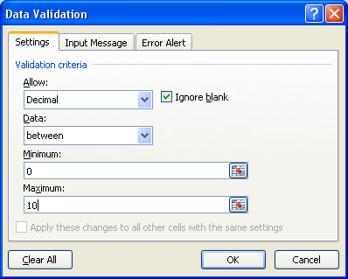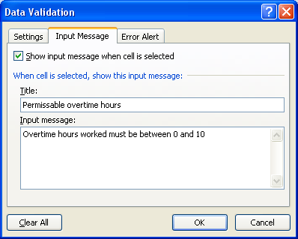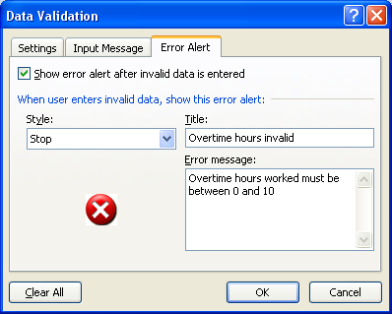

**e. Follow the instructions for using the formula auditing tool. Print out a screen shot showing use of the tool to circle invalid data (yours should be similar to Exhibit 9 in the article).**

Note: This is now another Data Validation feature. To test it, first change all validation rules from Stop to Warning on the Error Alert screen. Then highlight the three columns of data and select the “Circle Invalid Data” option to get the following results:

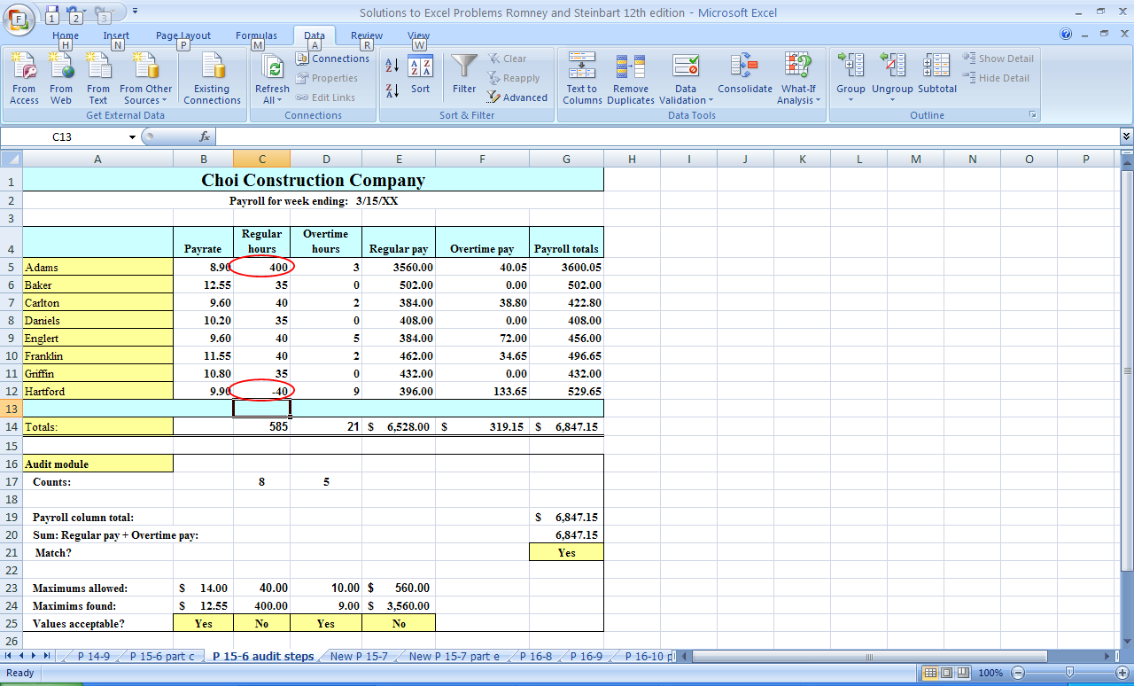

**f. Follow the instructions to run the “trace precedents” audit tool. Print screen shots that show the results, and save your work. How useful is this tool? What are its limitations, if any?**

The Trace Precedents tool is found on the formulas tab. It may help visually identify problems, but it may also be easy to overlook missing dots. (How easy is it to see that only the row for Adams has a dot in the regular hours column?)

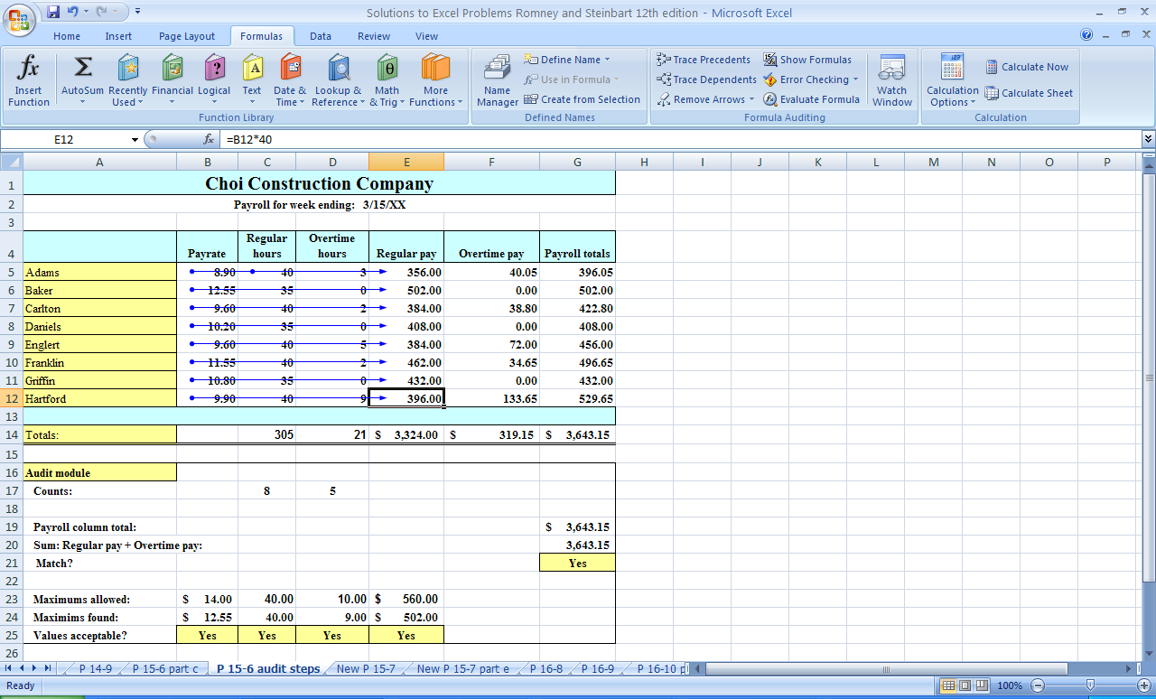

**g. Enter the following data for new employees (inserting new rows in proper order to maintain alphabetical listing of employees):**

**• Name = Able, payrate = 11.11, regular hours = 40, overtime hours = 5**

**• Name = Easton, payrate = 10.00, regular hours = 40, overtime hours = 0**

**• Name = Johnson, payrate = 12.00, regular hours = 35, overtime hours = 10**

**Which audit tests and validation rules change? Why? Print screen shots, and save your work.**

Several audit tests and validation rules changed because their parameters were established with the unadjusted cell references. The following audit tests and validation rules should be adjusted to include the new entries:

* All input validation rules
* All Control totals using the CountIf formula
* All formulas used to calculate totals, minimums, and maximums
* Also need to adjust the formulas for calculating pay for Easton and Johnson

**15.7 Excel Problem**

**Objective: Learn how to use the VLOOKUP function for payroll calculations.**

**a. Read the article “Make Excel a Little Smarter” by Lois S. Mahoney and Charles Kelliher in the *Journal of Accountancy* (July 2003). You can find a copy at www.aicpa.org.**

**b. Read the section titled “Data in Different Places” and create the spreadsheet illustrated in Exhibit 6. Print a screen shot of your work, and save your spreadsheet.**

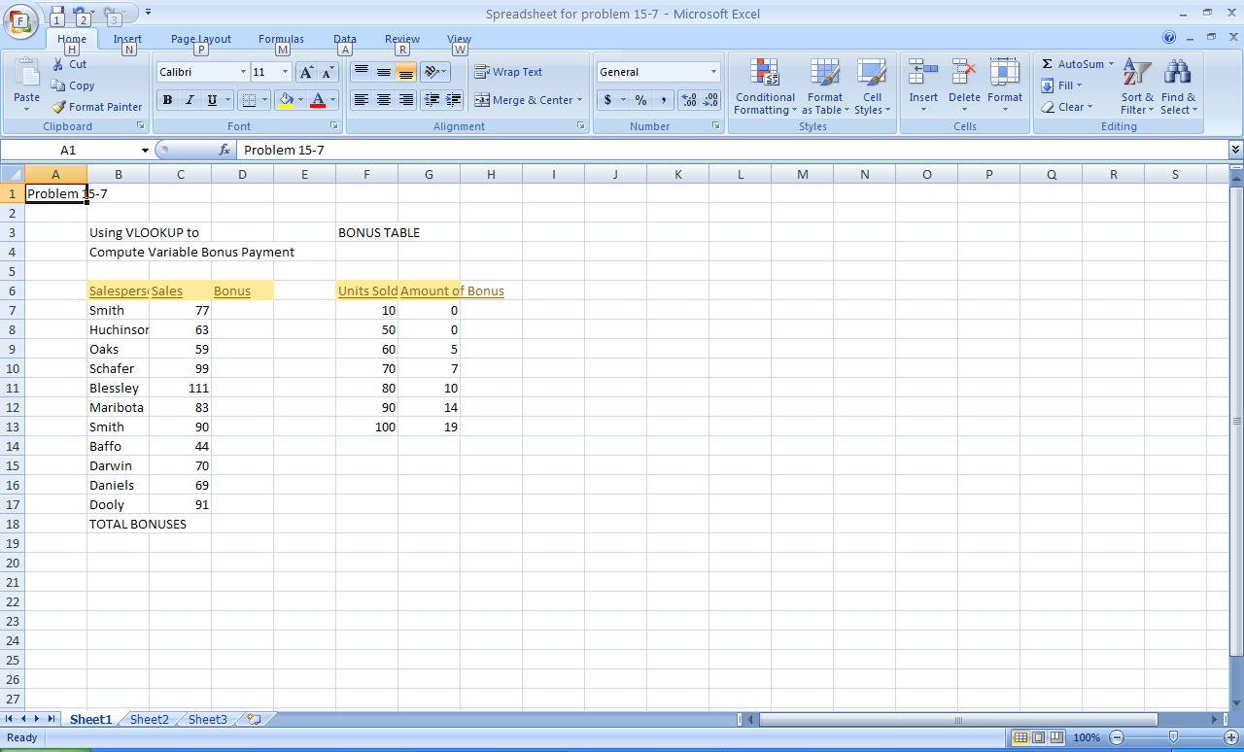

**c. Create a formula that calculates total bonuses. Also create a cell entry that indicates what that number represents. Print a screen shot of your work, and save it.**

In the Bonus column, click on the cell for the first Smith, choose the formulas tab, select “Lookup and Reference” and choose VLOOKUP. Then complete the window as follows:

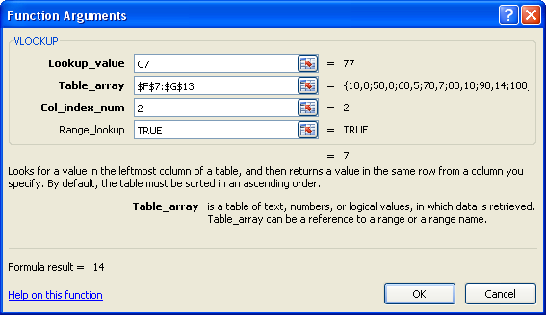

The result should be this formula: =VLOOKUP(C7,$F$7:$G$13,2,TRUE)

Then copy this formula down the column and you will get the following spreadsheet:

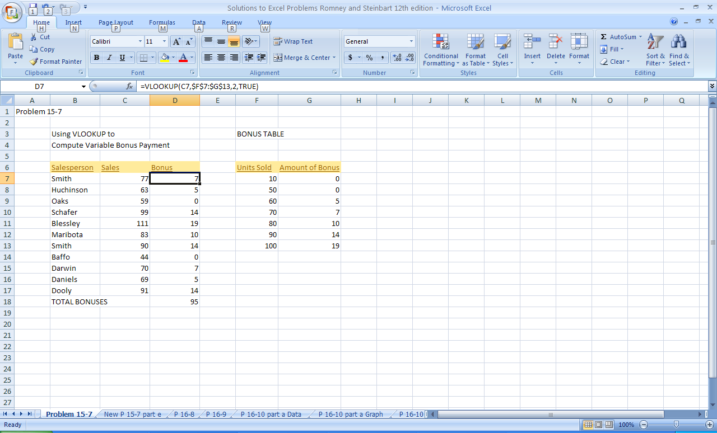

**d. Add the following data validation controls to your spreadsheet, including explanatory error messages. Save your work.**

**• Sales must be positive.**

**• Sales cannot exceed 125.**

**• Amount of bonus must be nonnegative.**

**• Amount of bonus cannot exceed 20% of unit sales.**

The data validation for sales is:

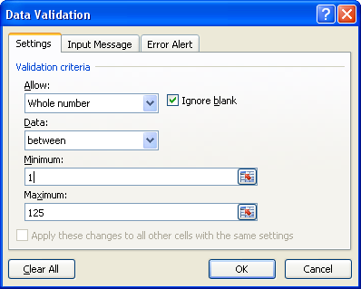

The data validation for the bonus is:

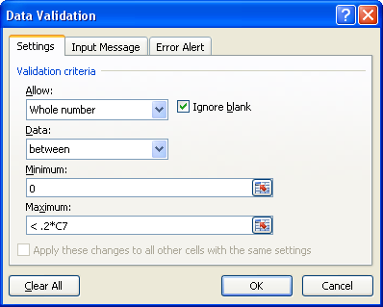

**e. Modify your worksheet by placing the sales data and resulting bonus on a different worksheet from the bonus table. Name your table array, and modify the VLOOKUP function accordingly. Then add another employee: Johnson, who sold 150 units. Print a screen shot of your new worksheet showing the bonuses for each employee, including Johnson. Save your work.**

New VLOOKUP formula: =VLOOKUP(B5,'Problem 15-7'!$F$7:$G$13,2,TRUE)

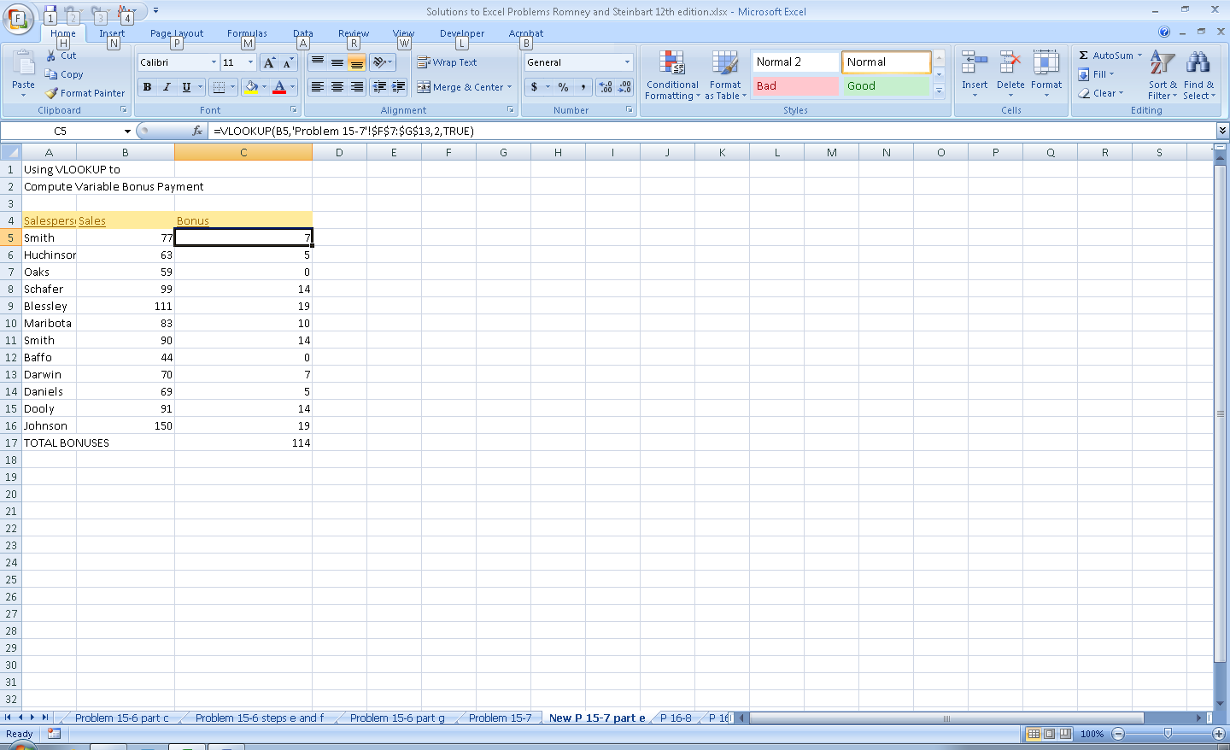

**15.8 The local community feels that secondary school education is a necessity in our society and that lack of education leads to a number of social problems. As a result, the local school board has decided to take action to reverse the rising dropout rate. The board has voted to provide funds to encourage students to remain in school and earn their high school diplomas. The idea is to treat secondary education like a job and pay students. The board, however, could not agree on the details for implementing this new plan. Consequently, you have been hired to devise a system to compensate students for staying in school and earning a diploma.**

**As you devise your compensation scheme, be sure it meets the following general control objectives for the payroll cycle:**

**• All personnel and payroll transactions are properly authorized.**

**• All employees are assigned to do productive work, and they do it efficiently and effectively.**

**• All transactions are accurately recorded and processed.**

**• Accurate records are maintained.**

**• All disbursements are proper.**

**Write a proposal that addresses these five questions:**

**a. How should the students be compensated (e.g., for attendance, grades)?**

**b. How and by whom will the payments be authorized?**

**c. How will the payments be processed?**

**d. How should the payments be made (e.g., in cash or other means)?**

**e. When will the payments be made?**

There is no one correct answer to this problem. Students should answer parts b, c, d and e as if they were developing a payroll system, regardless of how they answer part a. The following are some of the issues that need to be addressed:

* Who will have custody over records relating to student activity?
* Are controls in place to ensure that students actually receive their pay?
* What controls govern adding/deleting students from the database?
* How will attendance and grades be verified?
* How will the rewards be safeguarded? (e.g., if pay with cash, what controls will prevent employees from stealing the funds?)

**15.9 What is the purpose of each of the following control procedures (i.e., what threats is it designed to mitigate)?**

**a. Compare a listing of current and former employees to the payroll register.**

To make sure former employees are no longer on the payroll register and still drawing a paycheck.

**b. Reconciliation of labor costs (based on job-time ticket data) with payroll (based on time card data).**

To check for inaccurate or incomplete time data as well as errors in processing.

**c. Direct deposit of paychecks.**

To reduce the risk of theft of paychecks and to cut costs.

**d. Validity checks on Social Security numbers of all new employees added to the payroll master file.**

To prevent the addition of fictitious employees to the payroll.

**e. Cross-footing the payroll register.**

To check for inaccurate or incomplete payroll processing.

**f. Limit checks on hours worked for each time card.**

To prevent overpaying employees.

**g. Use of a fingerprint scanner in order for employees to record the time they started and the time they quit working each day.**

To ensure the validity of employee time and attendance data by preventing one employee from recording that another employee showed up for work when that person was really absent.

**h. Encryption of payroll data both when it is electronically sent to a payroll service bureau and while at rest in the HR/payroll database.**

To protect the confidentiality of payroll information.

**i. Establishing a separate payroll checking account and funding it as an imprest account.**

To limit the amount of funds at risk to the amount of the imprest fund; to make it easier to reconcile the payroll account and validate payroll expenses.

**j. Comparison of hash totals of employee numbers created prior to transmitting time-worked data to payroll provider with hash totals of employee numbers created by payroll provider when preparing paychecks.**

To ensure complete processing of all payroll transactions.

**k. Periodic reports of all changes to payroll database sent to each department manager.**

To detect unauthorized changes to the payroll master file.

**l.** **Providing employees with earnings statements every pay period.**

This is a detective control. Employees will likely notice and report errors in payroll calculations as well as mistakes in various withholdings, retirement contributions, etc.

**15.10 Excel Problem**

**Objective: Learn how to use text and array formulas to locate potential payroll problems.**

**a. Download the spreadsheet for this problem from the course Web site.**

**b. In column I, under the label “Ghost Employee?” write a function that compares the employee# in the timecards column to the employee# in the payroll master data column and displays the message: “Timecard employee# does not exist in master data” for any employee in the timecards columns who is not listed in the payroll master data columns. The function should leave the cell blank if the employee# in the timecards worksheet does exist in the payroll master file worksheet. (*Hint:* Use the ISNA and MATCH functions.)**

formula: =IF(ISNA(MATCH(A4,$E$4:$E$26,0)),"Timecard employee# does not exist in master data","")

The MATCH function compares the focal cell (in this case, the employee number in the timecard data from column A) to an array of values (in this case, the list of employee numbers in the payroll master data in column E) to look for an exact match (the value of the third argument is zero). If there is no match, the MATCH function returns the value N/A. The ISNA function returns the value true if that cell has the value N/A, and nothing otherwise. Therefore, the IF function will return the message that the employee number on the timecard does not exist in the master data if the MATCH function fails to find an exact match. The double quotes ensure that if the employee number does exist, then no message is returned.

**c. In column L, titled “Invalid SSN?” write a function to identify invalid Social Security numbers. Assume that Social Security numbers that begin with the digit 9 or that have the digits 00 for the middle two numbers are invalid. Your function should display a message that flags either of these two conditions or which displays nothing otherwise. (*Hint:* there are text functions that examine specific portions of a string, such as the left 3 characters, and there are also functions that convert text to numeric values.)**

formula: =IF(VALUE(MID(G4,5,2))=0,"SSN that with 00 as middle digits not valid",IF(VALUE(LEFT(G4,1))=9,"SSN that begin with 9xx are not valid",""))

Excel’s built-in text functions (MID and LEFT) are used here to parse social security numbers. The function MID takes three arguments: the first one indicates the cell to test (in this case, the social security numbers in column G); the second indicates the position to begin with (in this case, the fifth character which is the one immediately following the first hyphen in a social security number); and the third argument indicates how many digits to examine (in this case, 2, in order to check the middle two digits in a social security number). The LEFT function takes two arguments: the first one indicates the cell to test (in this case, the social security numbers in column G); the second indicates how many digits to examine (in this case, just the left-most digit).

The entire nested IF function then works as follows:

1. Test if the middle two digits are zero. If they are, return a message that a Social Security Number with the two middle digits of 00 is invalid.
2. If the two middle digits are not zero, then the second IF test is performed, which checks to see if the left-most digit is 9. If it is, then the formula returns the message “Social Security Numbers that begin with 9 are not valid”. If this test is also not true, then the social security number is valid and no message is displayed.

**d. In column P, titled “Missing Paycheck?” write a function to check whether a timecard exists for each employee in the master payroll data section of the worksheet. The formula should return either the message “No paycheck created for this employee” or display nothing.**

Formula**: =**IF(ISNA(MATCH(E4,$A$4:$A$25,0)),"No paycheck created for this employee","")

The MATCH function checks to see if the employee number in the master payroll data (column E) exists in the timecard data (column A). If it does, then the MATCH function is true. This means that the ISNA function is false. Therefore, the IF function displays nothing (the double quotes).

If the employee number in the master payroll data (column E) does not exist in the timecard data (column A) the MATCH function returns the value N/A. Therefore, the ISNA function is true, and the IF statement displays the message that “No paycheck created for this employee.”

The solution looks like this:

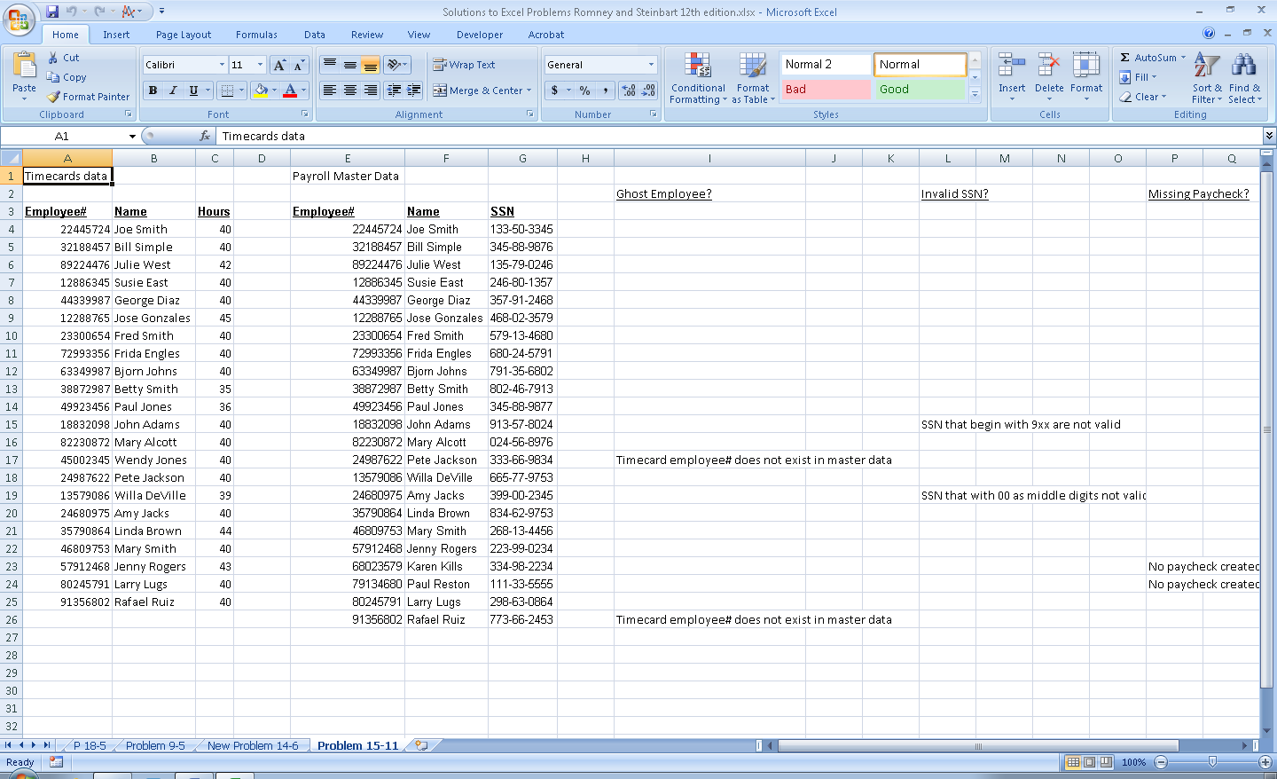

SUGGESTED ANSWERS TO THE CASES

**CASE 15-1 Research Report: HRM/Payroll Opportunities for CPAs**

**Payroll has traditionally been an accounting function and some CPAs have provided payroll processing services to their clients. Today, CPAs are finding additional new lucrative opportunities to provide not only payroll processing but also various HR services. Write a brief report that compares the provision of payroll and HR services by CPAs with that of national payroll providers. Perform the following research to collect the data for your report:**

1. **Read the articles “Be an HR Resource for Your Clients,” by Michael Hayes and “Hired Help: Finding the Right Consultant,” by Joanne Sammer, both of which were published in the November, 2006 issue of the *Journal of Accountancy.***
2. **Contact a local CPA firm that provides payroll and HR services and find out what types of services they perform and what types of clients they serve.**

Reports will of course vary from student to student; however, the following presents some points that should appear in a student’s report:

1. CPA’s naturally have the necessary skills to provide payroll and human resource (HR) services.
2. Although national payroll providers also provide the same services, CPA’s are in a better position to provide those services and recommend benefit consultants due to their detailed knowledge of their client’s business, operations, and internal needs.
3. Even if a CPA does not offer payroll/HR services, they are in good position to help their client’s choose the consultant for the work that is required.
4. Some of the payroll/HR services a CPA can offer are as follows:
   1. Payroll administration
   2. Benefits administration
   3. Retirement plan administration
   4. Human resource consulting
   5. Regulatory compliance
   6. Outsourcing
   7. Management recruiting
   8. CFO outsourcing/consulting
   9. Labor relations
   10. Acquisition/divestiture HR related consulting